International Online Copyright Office
INTEROCO
(European Union, Germany, Berlin)

WORK OF SCIENCE

OONE.World Subscription Model with Incentives for Drivers

INTEROCO Copyright Office – 2022

STRUCTURE OF DOCUMENT

I. ANNOTATION
II. BASIC DEFINITIONS
III. ANALYSIS OF CLOSEST ANALOGS
IV. RELEVANCE AND SUMMARY OF WORK
V. LEGAL BASIS
VI. SOURCES OF REFERENCES
VII. INFORMATION ABOUT THE EXPERT

Works of science as intellectual property (copyright) object are stipulated in:

1 | Berne Convention for the Protection of Literary and Artistic Works (1971)  Article 2. Protected Works:  (1) (1) The expression “literary and artistic works” shall include every production in the literary, scientific and artistic domain, whatever may be the mode or form of its expression, such as books, pamphlets and other writings; lectures, addresses, sermons and other works of the same nature; dramatic or dramatic-musical works; choreographic works and entertainments in dumb show; musical compositions with or without words; cinematographic works to which are assimilated works expressed by a process analogous to cinematography; works of drawing, painting, architecture, sculpture, engraving and lithography; photographic works to which are assimilated works expressed by a process analogous to photography; works of applied art; illustrations, maps, plans, sketches and three-dimensional works relative to geography, topography, architecture or science.
2 | United Arab Emirates  Federal Law No. 38 of 2021 On Copyrights and Neighboring Rights  Article 1. In applying the provisions of this law, the following words denote the definitions explained before each one of them, unless the context denotes otherwise: “The Work” - any created compilation, in the scope of letters, arts, sciences, whatsoever is its type, mode of expression, value or purpose.
3 | United Kingdom Copyright, Designs and Patents Act (1988)  Part I 'Copyright'. Chapter I, Article 1. Copyright and copyright works  (1) Copyright is a property right which subsists in accordance with this Part in the following descriptions of work: (a) original literary, dramatic, musical or artistic works; (b) sound recordings, films or broadcasts, and; (c) the typographical arrangement of published editions.  (2) In this Part "copyright work" means a work of any of those descriptions in which copyright subsists.  (3) Copyright does not subsist in a work unless the requirements of this Part with respect to qualification for copyright protection are met (see section 153 and the provisions referred thereto).  Article 143 (b) section 60  Abstracts of scientific or technical articles

According to above mentioned laws in the UK and UAE work of science, as an object of copyright, should:
- Be the result of creative activity.
- Exist in any objective form.

Considered a work of science – OONE.World Subscription Model with Incentives for Drivers meets to the definition of an object of copyright according to:
- Section 2 (Works under protection) of the Federal Law Number 38 of 2021 of the United Arab Emirates on “Copyright and Neighbouring Rights";
- Chapter I, Articles 1, 143 of United Kingdom Copyright, Designs and Patents Act (1988) Part I ‘Copyright’.

The result of creative activity, innovation, relevance, scope of work of science - OONE.World Subscription Model with Incentives for Drivers is listed in this publication and confirmed by a certificate of deposit of copyright works.

The study of objective form of current work of science through materials research and examination of the object on the criteria for copyright eligibility held:

Intellectual Property Expert,  Authorized Representative  of INTEROCO Copyright Office  (signature, stamp) | Dr. Sandjar Muminov

I. ANNOTATION

Nowadays, subscription models are used in nearly every industry. It is the backbone of a company’s revenue. In addition, it allows businesses to lock customers in for an extended time.

Technically, the work of science – OONE.World Subscription Model with Incentives for Drivers is developed primarily based on AWS services (Amazon Smart Services). The mobile app will initially be available for IOS and Android. Developed with React.

FUNCTIONALITY

The app is free to download. User registration is carried out using email, if desired, the user can enable 2FA (Two-factor authentication), for this he needs to add a phone number.

The application contains 3 main sections: Wallet, Main Screen and Speedometer, Personal information Wallet (Includes 2 subsections and about 11 buttons).

1. Wallet

On the first screen of the Wallet section, below, all operations (trips) for accruing a token are displayed. Display of past trips in the format: Minsk - Moscow, Start of trip: September 8, 2023, 11:43 + 14.905 ESPD.

On the second screen from the top, the balance of ESPD tokens is displayed (the value from the first screen is duplicated). This screen is designed to conveniently send/receive ESPD tokens, as well as exchange for the BNB network token.

There are no withdrawal/exchange restrictions. The entire list of operations on the BNB wallet is available to the user by swiping down.

2. Main screen and speedometer (Include 1 subsection, and about 7 buttons)

The main screen contains the following information:
- The countdown of the time elapsed since the start of the trip

- The number of accrued ESPD tokens (In real time - hereinafter referred to as RRW)

- Counting the total number of kilometers traveled (RRV)

- Countdown credited by the application (yellow and green mode) the number of kilometers traveled (RRV)

- Counter of CO2 not emitted into the atmosphere due to fuel economy (РРВ)

- The speedometer is a double pie chart, where the outer circle describes the current requirements of the application for the user's speed on the road. And the inner circle reflects the actual situation. Inside the circle, the current speed of movement and traffic rules in force on this section of the road are indicated. Depending on the speed mode of the mode, the circle is painted inside and outside in one of three colors: green, yellow, or red.

- Trip end button
To end the trip, you must hold the button for 3 seconds, during this time the progress indicator is filled and, as a result, the trip ends with a short vibration.
- Information button describing detailed user interaction with the application in the main screen section, trip, and other.

3. Personal information (Includes 1 subsection and about 10 buttons)

- Rating (formed as an arithmetic average of 30 days, in which each new day replaces the last one. The information icon explains this)
- Photo, upload new, crop, and more
-Make and model of car, engine size, type of fuel
-Name/Surname, age, phone, mail
-Subscription Information (Price Plan, Expiration, Reminder, Payment Methods, Subscription Cancellation, Company Contact for Premium Enterprise)
-Settings: notifications and password change
-Support service containing answers to the most frequently asked questions and for stage 1 the opportunity to send an email to help@oone.world, stage 2 is planned to create its own call-center
-SOS button. When you click on which, the user goes to the stage 1 assistant bot, which allows you to solve the current situation: a problem with a car, feeling unwell, a threat to life, a chat. For stage 2, it is planned to create an internal messenger and form its own active community.

WEB VERSION

In addition to the mobile application, users will have access to a website with a personal account and information about the project.

A personal account is required for the category of Premium Enterprise users, a format of work in which a company purchases subscriptions for its employees.

The personal account is designed in a way that is most suitable for administering large groups of users. In addition to creating and deleting users in your personal account, you can use functions such as two-level analytics (personal and general), filter by specified parameters, search, location tracking, notifications, and payment.

In addition to the personal account, it is planned to place information about the project, user agreement and white paper on the site.

II. BASIC DEFINITIONS

Work of Science | is an object of intellectual property, registered as copyright work according to the Berne Convention for the Protection of Literary and Artistic Works.
Incentive | In general, incentives are anything that persuade a person to alter their behavior. It is emphasized that incentives matter by the basic law of economists and the laws of behavior, which state that higher incentives amount to greater levels of effort and therefore, higher levels of performance.
Subscription | A subscription is a product or service which is paid for periodically, rather than all at once. Subscriptions fees are usually charged for a consistent time, typically in weeks, months, or years.

III. ANALYSIS OF CLOSEST ANALOGUES
Analogue1

UNIVERSAL SUBSCRIPTION AND CRYPTOCURRENCY PAYMENT MANAGEMENT PLATFORMS AND METHODS OF USE
PATENT No. US20190332691A1

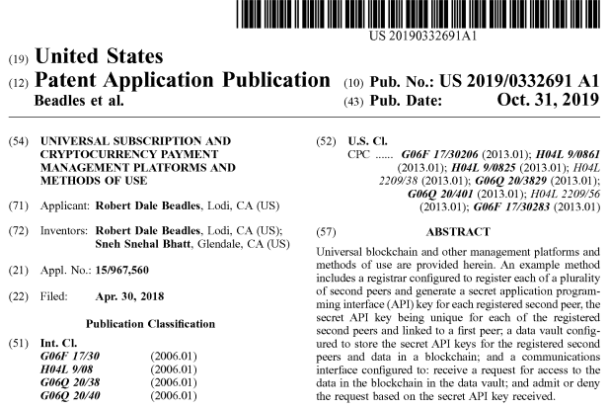

Description

FIELD OF THE PRESENT DISCLOSURE
Embodiments relate to systems and methods for universal management of services and/or transactions and, in particular but not exclusively, to platforms that provide seamless integration with digital subscription services and/or cryptocurrency transaction services. Additionally, or alternatively, embodiments of the present disclosure are directed to blockchain technologies, and more specifically, but not by limitation, to platforms that provide cohesive and universal interface for transactions requiring access to data stored in a vault or repository such as blockchain data. These systems and methods implement unique security features allowing for real-time activation and deactivation of vault or repository access in some embodiments.

SUMMARY
A system of one or more computers can be configured to perform particular operations or actions by virtue of having software, firmware, hardware, or a combination of them installed on the system that in operation causes or cause the system to perform the actions. One or more computer programs can be configured to perform operations or actions by virtue of including instructions that, when executed by data processing apparatus, cause the apparatus to perform the actions.

BRIEF DESCRIPTION OF THE DRAWINGS
FIG. 1A is a schematic diagram of a system that can be used to practice aspects of the present disclosure according to some embodiments.

FIG. 1B is a schematic diagram of computing devices running client-side applications that access the system of FIG. 1A according to some embodiments.

FIG. 2 is a schematic diagram of an example system that can be used to practice aspects of the present disclosure according to some embodiments.

FIG. 3 illustrates an example graphical user interface (GUI) that comprises toggles for selectively activating and deactivating API keys.

FIG. 4 is a schematic diagram of an example system and data flow of an embodiment of the present disclosure.

FIG. 5 is a schematic diagram of an example system and data flow of an embodiment of the present disclosure.

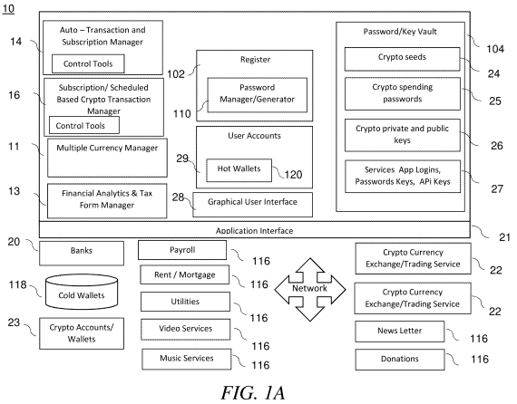 | 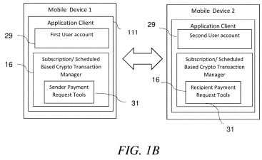

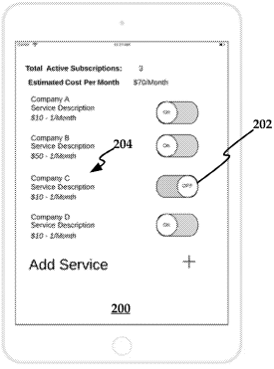 | 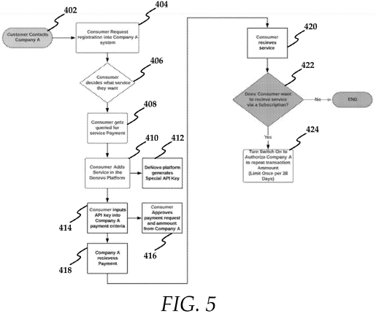
FIG. 6 is a flow diagram of an embodiment of the present disclosure.
FIG. 7 illustrates an example graphical user interface (GUI) that allows a user to enter an API key and select payment terms.
FIG. 8 illustrates an example graphical user interface (GUI) that allows a user (either consumer or merchant) to create a payment request for either an ad hoc or subscription payment.
FIG. 9 is a flow diagram of another embodiment of the present disclosure.

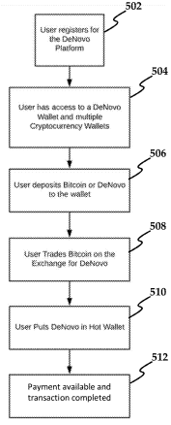 | 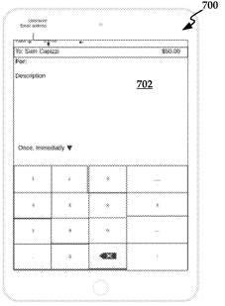 | 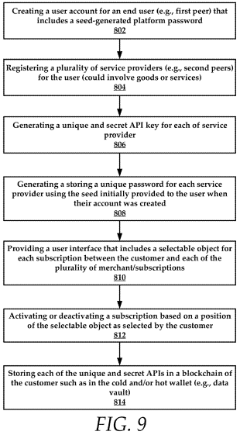

FIGS. 10-11 collectively illustrate graphical representation of an example platform and deployment method.
FIG. 12 is a diagrammatic representation of an example platform and deployment process.
FIG. 13 is a schematic diagram of an example computing machine that can be used to implement aspects of the present disclosure.
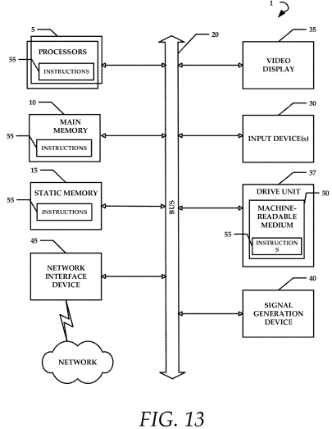
FIG. 14 illustrates a diagrammatic representation of an example recurring or scheduled system transaction in which the system uses multi signature private key leasing-lending according to some embodiments.

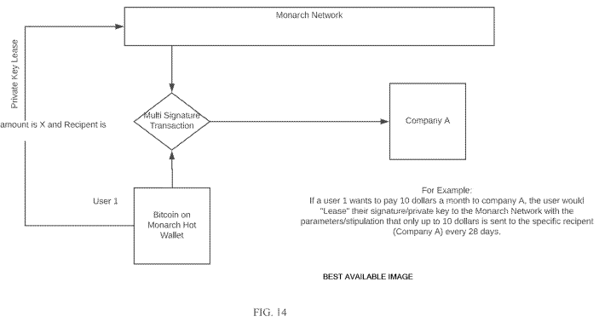

CLAIM (30)
1. A method of managing a plurality of cryptocurrency transactions, the method comprising:
a) generating a graphical user interface for a cryptocurrency management application of a computing system, the graphical user interface comprising cryptocurrency transaction management tools that provide a user, having a first user account registered with said cryptocurrency management application, with a list of a plurality of currencies which include a plurality of cryptocurrency accounts, in combination with a plurality of services/users accounts, wherein the graphical user interface is further configured to allow the user to interact with the plurality of services/users accounts through user input into the graphical user interface, the user being allowed to at least one of transact from any of the plurality of cryptocurrency accounts through the cryptocurrency transaction management tools, or exchange between the plurality of currencies;
b) storing in said computing system a plurality of password/keys for allowing said cryptocurrency management application to automatically interact and transact between said first user account and each one of said plurality of services/user accounts;
c) receiving, in an interface of the cryptocurrency management application, instructions to perform a cryptocurrency transaction between the first user account and a selected one of said plurality of services/user accounts using any one or more of the plurality of cryptocurrency accounts; and
d) performing, by the computing system, the cryptocurrency transaction between the first user account and the selected service/user account using particular passwords/keys of said plurality of passwords/keys for transacting between said first user account and the selected one of said plurality of services/user accounts without said passwords/keys being provided by said user via said graphical user interface for the purpose of executing the transaction.

2. The method of claim 1, wherein said password/keys comprise any one or combination of cryptographic seed(s), cryptographic private key(s), cryptographic public key(s), cryptocurrency account spending password(s), password(s)/key(s), and background information for allowing said first user account and at least one of said plurality of services/user accounts to automatically interact and transact with one another.
3. The method of claim 2, wherein the step (b) further comprises: storing in a password vault said passwords/keys cryptographically on a block chain.
4. The method of claim 3, further comprising before performing step (d) retrieving said password/keys from said password vault.
5. The method of claim 3, further comprising before performing step (b) automatically generating, by the computing system, the password/key using a password generator of the system, in response to a user registering, by the computing system, with at least one of said plurality of services/user accounts and/or said cryptocurrency management application.
6. The method of claim 2, wherein the first user account is an internal user account in the cryptocurrency management application or an external user account.
7. (canceled)
8. The method of claim 1, wherein step c) includes receiving instructions in the graphical user interface to schedule a cryptocurrency transaction or a recurring cryptocurrency transaction between the first user account and the selected service/user account and wherein step d) includes performing automatically, by the computing system, the cryptocurrency transaction or a recurring cryptocurrency transaction between the first user account and the selected service/user account according to a schedule.
9. The method of claim 8, wherein performing automatically, by the computing system, the cryptocurrency transaction or a recurring cryptocurrency transaction between the first user account and the selected service/user account according to said schedule comprises automatically managing, by the computing system, a private key and a public key associated with one of the plurality of cryptocurrency accounts, to perform the transactions between the one of the plurality of cryptocurrency accounts and the selected service/user account.
10. The method of claim 9, wherein performing automatically, by the computing system, the cryptocurrency transaction, or a recurring cryptocurrency transaction between the first user account and the selected service/user account according to said schedule includes:
managing, by the computing system, a payment in a first currency from the plurality of currencies;
exchanging, by the computing system, with a cryptocurrency exchange the payment in the first currency to a payment in a second currency different from the first currency; and
paying, by the computing system, the selected service/user in the second currency.
11. The method of claim 10, wherein the first currency is FIAT and the second currency is cryptocurrency or wherein the first currency is cryptocurrency and the second currency is FIAT, or wherein the first currency is a first cryptocurrency and the second currency is a second cryptocurrency.
12. The method of claim 10, wherein the first currency from the plurality of currencies is one of the plurality of cryptocurrencies selected from any of coins, tokens or altcoins.
13. The method of claim 12, wherein said tokens are created and distributed by a subscription management application.
14. The method of claim 12, wherein the coins, tokens or altcoins are at least partially backed by a commodity or physical asset.
15. The method of claim 14, wherein the commodity or physical asset is physical silver.
16. The method of claim 10, wherein exchanging, by the computing system, with a cryptocurrency exchange the payment in the first currency to payment in a second currency different from the first currency comprises: monitoring a plurality of cryptocurrency exchanges to determine best prices for buying said first currency and selling in said second currency; and based on best prices, exchanging with one of the plurality of cryptocurrency exchanges the payment in the first currency to payment in the first currency.
17. (canceled)
18. The method of claim 10, wherein exchanging, by the computing system, with a cryptocurrency exchange the payment in the first currency to payment in a second currency comprises using, by the computing system, the private key and public key associated with the user crypto currency account to send the payment in the first currency to a cryptocurrency management application account being controlled independently from the first user account; and using, by the computing system, the private key and public key associated with the cryptocurrency management application account to convert in the cryptocurrency management application account the payment in the first currency to the payment the second currency via the cryptocurrency exchange.
19. The method of claim 1,
wherein step c) includes receiving electronically an email request, a crypto currency management application network request, or other online request from at least one of said plurality of the services/users accounts registered with said crypto currency management application to initiate at least one transaction or recurring transaction between the first user account and the selected one of the plurality of services/user accounts; and
wherein step d) includes performing automatically, by the computing system, the transaction or recurring transaction between the first user account and the selected service/user account according to the request in response to receiving in said crypto currency management application authorisation from said user account to proceed.
21-30. (canceled)
31. A system, comprising:
a processor; and
a memory for storing executable instructions, the processor executing the instructions to:
a) generate a graphical user interface for a cryptocurrency management application of a computing system, the graphical user interface comprising cryptocurrency transaction management tools that provide a user, having a first user account registered with said cryptocurrency management application, with a list of a plurality of currencies which include a plurality of cryptocurrency accounts, in combination with a plurality of services/users accounts, wherein the graphical user interface is further configured to allow the user to interact with the plurality of services/users accounts through user input into the graphical user interface, the user being allowed to at least one of transact from any of the plurality of cryptocurrency accounts through the cryptocurrency transaction management tools, or exchange between the plurality of currencies;
b) store in said computing system a plurality of password/keys for allowing said cryptocurrency management application to automatically interact and transact between said first user account and each one of said plurality of services/user accounts;
c) receive, in an interface of the cryptocurrency management application, instructions to perform a cryptocurrency transaction between the first user account and a selected one of said plurality of services/user accounts;
d) perform, by the computing system, the transaction between the first user account and the selected service/user account using particular passwords/keys of said plurality of passwords/keys for transacting between said first user account and the selected one of said plurality of services/user accounts without said passwords/keys being provided by said user via said graphical user interface for the purpose of executing the transaction; and
e) repeat steps c) to d) for at least one other selected one of said plurality of services/users.
32. The system of claim 31, wherein said password/keys comprise any one or combination of cryptographic seed(s), cryptographic private key(s), cryptographic public key(s), and cryptocurrency account spending password, password/key, and background information for allowing said first user account and at least one of said plurality of services/user accounts to automatically interact and transact with one another.
33. A computer-readable medium including contents that are configured to cause a computing system to managing a plurality of cryptocurrency transactions by performing a method comprising:
a) generating a graphical user interface for a cryptocurrency management application of a computing system, the graphical user interface comprising cryptocurrency transaction management tools that provide a user, having a first user account registered with said cryptocurrency management application, with a list of a plurality of currencies which include a plurality of cryptocurrency accounts, in combination with a plurality of services/users accounts, wherein the graphical user interface is further configured to allow the user to interact with the plurality of services/users accounts through user input into the graphical user interface, the user being allowed to at least one of transact from any of the plurality of cryptocurrency accounts through the cryptocurrency transaction management tools, or exchange between the plurality of currencies;
b) storing in said computing system a plurality of password/keys for allowing said cryptocurrency management application to automatically interact and transact between said first user account and each one of said plurality of services/user accounts;
c) receiving, in an interface of the cryptocurrency management application, instructions to perform a cryptocurrency transaction between the first user account and a selected one of said plurality of services/user accounts;
d) performing, by the computing system, the transaction between the first user account and the selected service/user account using particular passwords/keys of said plurality of passwords/keys for transacting between said first user account and the selected one of said plurality of services/user accounts without said passwords/keys being provided by said user via said graphical user interface for the purpose of executing the transaction; and
e) repeating steps c) to d) for at least one other selected one of said plurality of services/users.
34. The medium of claim 33, wherein said password/keys comprise any one or combination of cryptographic seed(s), cryptographic private key(s), cryptographic public key(s), cryptocurrency account spending password(s), password(s)/key(s), and background information for allowing said first user account and at least one of said plurality of services/user accounts to automatically interact and transact with one another.
35. The medium of claim 34, wherein the step (b) further comprises: storing in a password vault said passwords/keys cryptographically on a block chain.
36. The medium of claim 35, further comprising before performing step (d) retrieving said password/keys from said password vault.
37. The medium of claim 35, further comprising before performing step (b) automatically generating, by the computing system, the password/key using a password generator of the system, in response to a user registering, by the computing system, with at least one of said plurality of services/user accounts and/or said cryptocurrency management application.
38. The medium of claim 34, wherein the user account is cryptocurrency account.
39. The medium of claim 38, wherein step c) includes receiving instructions in the user interface to schedule a cryptocurrency transaction or a recurring cryptocurrency transaction between the first user account and the selected service/user account and wherein step d) includes performing automatically, by the computing system, the cryptocurrency transaction or a recurring cryptocurrency transaction between the first user account and the selected service/user account according to said schedule.
40. The medium of claim 39, wherein performing automatically, by the computing system, the cryptocurrency transaction or a recurring cryptocurrency transaction between the first user account and the selected service/user account according to said schedule comprises automatically managing, by the computing system, the private key and the public key associated with the user cryptocurrency account, to perform the transactions between the user cryptocurrency account and the selected service/user account.
Analogue 2

DYNAMIC OBJECT UPDATE SUBSCRIPTIONS BASED ON USER INTERACTIONS WITH AN INTERFACE

PATENT NO. US10972795B2

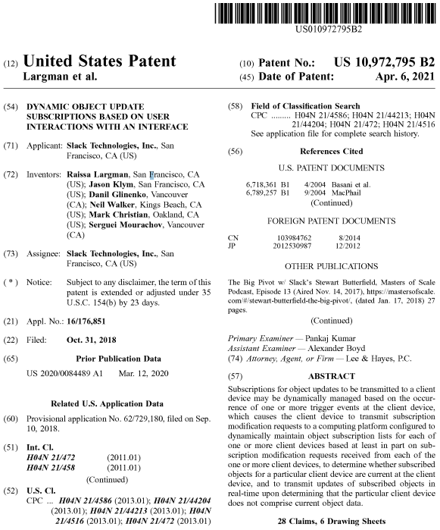

Description

CROSS-REFERENCE TO RELATED APPLICATIONS
This patent application claims priority from U.S. Provisional Appl. Ser. No. 62/729,180, filed Sep. 10, 2018, which is incorporated herein by reference in its entirety.

BACKGROUND
Systems have been provided for disseminating published updates to objects among a plurality of client devices via an at least partially centralized messaging system.
Through applied effort, ingenuity, and innovation many deficiencies of such systems have been solved by developing solutions that are in accordance with the embodiments of the present invention, many examples of which are described in detail herein.

BRIEF SUMMARY
Maintaining dynamic topic subscriptions configured for managing content transmission for client devices may significantly decrease the amount of data transmitted over a network from a message distribution system (e.g., such as a group-based communication platform) to individual client devices. To maintain desired user functionality and real-time updates of topics (e.g., objects) of interest to a user of a particular client device, the subscriptions may be dynamically adjusted based on user interactions with an interface of the client device. For example, the client device may be configured to request subscriptions for object updates relating to objects currently visible within a client device interface.

BRIEF DESCRIPTION OF THE SEVERAL VIEWS OF THE DRAWINGS
FIG. 1 shows a schematic view of a group-based communication platform in communication with client devices according to another embodiment.
FIG. 2 shows a schematic view of a message distribution server according to one embodiment.

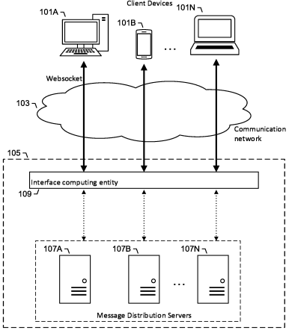 | 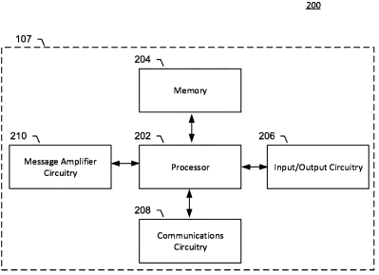

FIG. 3 shows a schematic view of an interface computing entity according to one embodiment.
FIG. 4 shows a schematic view of data transmission interactions between display windows of a group-based communication interface, according to one embodiment.

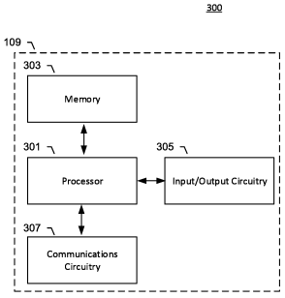 | 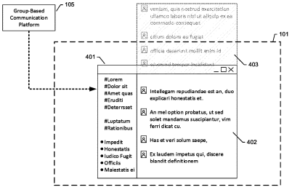

FIGS. 5-6 are flowcharts illustrating the functionality of various computing entities according to various embodiments.

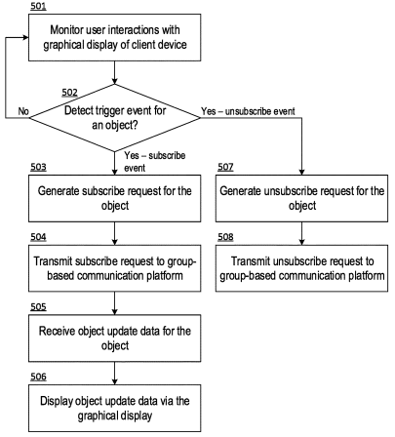 | 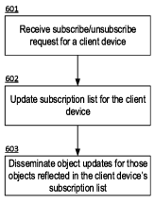

CLAIMS (28)
That which is claimed:
1. A client device for dynamically maintaining object updates stored on the client device, the client device comprising:
one or more memory storage areas for maintaining a local data store of stored object data for a plurality of objects;
one or more processors collectively configured to:
monitor user interaction with the plurality of objects;
detect one or more trigger events indicating a change in user interaction with one or more particular objects of the plurality of objects;
generate a subscription modification request for the one or more particular objects based at least in part on the one or more trigger events, wherein the subscription modification request comprises either a subscribe request to initiate a subscription relating to the one or more particular objects or an unsubscribe request to terminate a subscription relating to the one or more particular objects, and wherein a determination of whether the subscription modification request comprises the subscribe request or the unsubscribe request is based at least in part on whether the one or more particular objects are within a visible portion of a graphical user interface; and
transmit the subscription modification request to a remote computing platform to request a modification of object data transmitted to the client device relating to the one or more particular objects.

2. The client device of claim 1, wherein the one or more trigger events comprise moving the one or more particular objects between the visible portion and a hidden portion of the graphical user interface.
3. The client device of claim 1, wherein the one or more trigger events comprise moving the one or more particular objects across a boundary of the visible portion of the graphical user interface.
4. The client device of claim 1, wherein, upon detecting movement of the one or more particular objects from a hidden portion to the visible portion of the graphical user interface, the subscription modification request is determined to be the subscribe request.
5. The client device of claim 1, wherein, upon detecting movement of the one or more particular objects from the visible portion to a hidden portion of the graphical user interface, the subscription modification request is determined to be the unsubscribe request.
6. The client device of claim 1, wherein the subscription modification request includes at least one of a request identifier, a subscribe type associated with message routing or object type, or information associated with the one or more particular objects.
7. The client device of claim 1, wherein the subscription modification request includes a version identifier indicating a version of the stored object data.
8. The client device of claim 1, wherein one or more processors are collectively configured further to receive an update to the stored object data responsive to transmitting the subscription modification request to the remote computing platform.
9. The client device of claim 1, wherein the one or more trigger events are detected based at least in part on connectivity between the client device and the remote computing platform.
10. The client device of claim 1, wherein the plurality of objects comprise at least one of a user, a file, or a topic.
11. A computer-implemented method comprising:
storing, in a data storage associated with a client device, stored object data associated with one or more objects;
monitoring user interaction with the one or more objects;
detecting a trigger event indicating a change in user interaction with an object of the one or more objects;
generating a subscription modification request for the object based at least in part on the trigger event, wherein the subscription modification request comprises either a subscribe request to initiate a subscription relating to the object or an unsubscribe request to terminate a subscription relating to the object, and wherein a determination of whether the subscription modification request comprises the subscribe request or the unsubscribe request is based at least in part on whether the object is within a visible portion of a graphical user interface; and
transmitting the subscription modification request to a remote computing platform to request a modification of new object data transmitted to the client device relating to the object.

12. The computer-implemented method of claim 11, wherein the trigger event comprises moving the object between the visible portion and a hidden portion of the graphical user interface.
13. The computer-implemented method of claim 11, wherein the trigger event comprises moving the object across a boundary of the visible portion of the graphical user interface.
14. The computer-implemented method of claim 11, wherein, upon detecting movement of the object from a hidden portion to the visible portion of the graphical user interface, the subscription modification request is determined to be the subscribe request.
15. The computer-implemented method of claim 11, upon detecting movement of the object from the visible portion to a hidden portion of the graphical user interface, the subscription modification request is determined to be the unsubscribe request.
16. The computer-implemented method of claim 11, wherein the subscription modification request includes at least one of a request identifier, a subscribe type associated with message routing or object type, or information associated with the object.
17. The computer-implemented method of claim 11, wherein the subscription modification request includes a version identifier indicating a version of the stored object data.
18. The computer-implemented method of claim 11, further comprising, receiving an update to the stored object data responsive to transmitting the subscription modification request to the remote computing platform.
19. The computer-implemented method of claim 11, wherein the object comprises a user, a file, or a topic.
20. One or more non-transitory computer-readable media storing instructions that when executed by one or more processors of a client device, cause the client device to perform operations comprising:
storing, in a data storage associated with the client device, stored object data associated with one or more objects;
monitoring user interaction with the one or more objects;
detecting a trigger event indicating a change in user interaction with an object of the one or more objects;
generating a subscription modification request for the object based at least in part on the trigger event, wherein the subscription modification request comprises either a subscribe request to initiate a subscription relating to the object or an unsubscribe request to terminate a subscription relating to the object, and wherein a determination of whether the subscription modification request comprises the subscribe request or the unsubscribe request is based at least in part on whether the object is within a visible portion of a graphical user interface; and
transmitting the subscription modification request to a remote computing platform to request a modification of new object data transmitted to the client device relating to the object.

21. The one or more non-transitory computer-readable media of claim 20, wherein the trigger event comprises moving the object between the visible portion and a hidden portion of the graphical user interface.
22. The one or more non-transitory computer-readable media of claim 20, wherein the trigger event comprises moving the object across a boundary of the visible portion of the graphical user interface.
23. The one or more non-transitory computer-readable media of claim 20, upon detecting movement of the object from a hidden portion to the visible portion of the graphical user interface, the subscription modification request is determined to be the subscribe request.
24. The one or more non-transitory computer-readable media of claim 20, upon detecting movement of the object from the visible portion to a hidden portion of the graphical user interface, the subscription modification request is determined to be the unsubscribe request.
25. The one or more non-transitory computer-readable media of claim 20, wherein the subscription modification request includes at least one of a request identifier, a subscribe type associated with message routing or object type, or information associated with the object.
26. The one or more non-transitory computer-readable media of claim 20, wherein the subscription modification request includes a version identifier indicating a version of the stored object data.
27. The one or more non-transitory computer-readable media of claim 20, the operations further comprising, receiving an update to the stored object data responsive to transmitting the subscription modification request to the remote computing platform.
28. The one or more non-transitory computer-readable media of claim 20, wherein the object comprises a user, a file, or a topic.

Analogue 3
SOCIAL NETWORK SITE THAT GIVES USERS THE ABILITY TO SEND AND RECEIVE CRYPTOCURRENCIES FROM ONE USER TO ANOTHER

PATENT NO. US20190362323A1
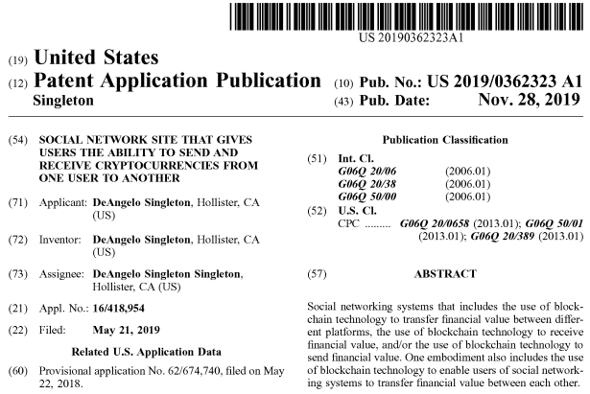

Description
CROSS-REFERENCE TO RELATED DOCUMENTS
The present application claims priority to provisional patent application No. 62/674,740, filed on May 22, 2018, the disclosure of which are incorporated herein at least by reference.

BACKGROUND OF THE INVENTION
1. Field of the Invention
The various embodiments described herein relate to social networking systems. In particular, the embodiments relate to blockchain technology being leveraged by social networking systems to provide financial value. Common forms of financial value that are based on blockchain technology include but are not limited to cryptocurrencies and digital assets.
2. Description of Related Art
Social networking systems have evolved tremendously since 2003. They currently enable users to interact with each other in several different ways. For example, a social networking system gives users the ability to send private messages, comment on post, like post, view videos, post pictures, and more. Despite all the evolutionary processes of social networking systems over the years, there are still limitations. One of the current restrictions of social networking systems is that the ability to send and receive financial value is limited to government-based currencies (e.g., US Dollar, Japanese yen, British pound).

BRIEF SUMMARY OF THE INVENTION
In one embodiment of the invention a social networking system that leverages blockchain technology to provide financial value is provided comprising the use of blockchain technology to transfer financial value between different platforms, the use of blockchain technology to receive financial value, and the use of blockchain technology to send financial value.
Also, in one embodiment social networking systems leverage blockchain technology to enable users to transfer financial value between each other. A common way to leverage blockchain technology includes, but is not limited to cryptocurrencies, also known as digital assets.

BRIEF DESCRIPTION OF THE DRAWINGS

FIG. 1 illustrates a social networking system that integrates blockchain based wallets, which gives the users the ability to send blockchain based financial value in accordance to one or more embodiments.

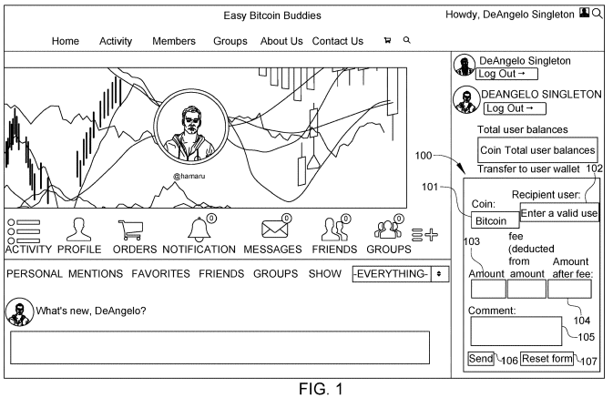

FIG. 2 illustrates an embodiment of a blockchain based wallet for social networking systems that would enable the users to store different types of blockchain based financial value and send them to another blockchain based wallet that is on a different platform than the social networking system. This can work in conjunction with FIG. 1.

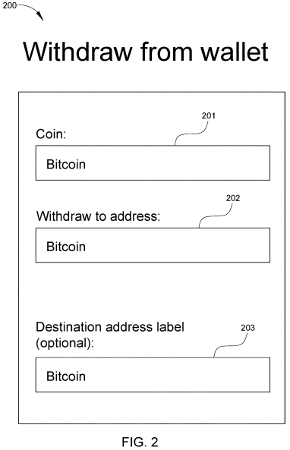 | 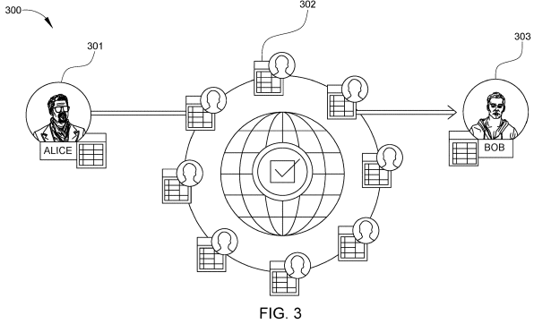

FIG. 3 is a process flow chart illustrating steps of social networking systems that utilize blockchain based technology to transfer financial value in one embodiment of the invention.

CLAIMS (2)
1. Social networking systems comprising:
a. The use of blockchain technology to transfer financial value between different platforms;
b. The use of blockchain technology to receive financial value;
c. The use of blockchain technology to send financial value.
2. Social networking systems that leverage blockchain technology to enable users to transfer financial value between each other.

IV. RELEVANCE AND SUMMARY OF WORK

The work of science - OONE.World Subscription Model with Incentives for Drivers is based on the idea of selling products for recurring revenue that entails a regular monthly or yearly fee. The primary aim is to retain existing customers rather than acquiring new customers.

Moreover, by having subscription services, it ensures a consistent source of recurring income. When a customer signs up for subscription services, they are implied to repeat business. Likewise, compounding growth of customer relationship is what makes subscription model so powerful. Thus, long term subscribers become more valuable to the business.

Furthermore, the work of science - OONE.World Subscription Model with Incentives for Drivers intends to build a stronger relationship with their customers. This is because the service team provides an excellent customer support, then in return customers learn to trust service team and become accustomed to working with the products.

OONE.World believes that this is an important factor whether customers will have to renew their subscription.

Consequently, OONE.World make its sure that all the data information provided by its subscribers are organized based on the standard principles and regulations.

DATA STORAGE AND ANALYTICS

Data storage is organized according to BigData principles and standards. The security and safety of information, as well as the technical stability of the project, are ensured by the fundamental principles of Amazon Best Practices, as well as the presence of duplicate volatility zones and flexible flows, and much more. Multi-level statistics and analytics are technically thought out and included in the project, while the implementation of the most complex analytical modules is planned for stage 2.

PAYMENT SYSTEM

At this stage, TELR (UAE) was chosen as the payment system, as one of the most understandable and adaptive for the starting region.

BLOCKCHAIN
The application is the first such large-scale move-to-earn project, where to earn an internal ESPD token, the user must fulfill certain conditions. Network token of the BNB project.

GPS
Tracking the location of drivers is carried out not according to the principle of points A and B, but according to the principle of a specific segment:
highway P67, 37°25'19.07"N, 122°05'06.24.W, 54.513 km - highway M1, 38°22'11.01"N, 126°02'03.21.8, 12.871 km
which is undoubtedly much more difficult, both in terms of implementation and in terms of storing huge amounts of personal information, but only such an approach will make it possible to realize the mission and strategic goals of the project: to help the environment by reducing CO2 emissions through fuel economy and reduce mortality among drivers. After all, without detailed information about the location of the driver, the application loses the ability to adapt to constantly changing traffic conditions, traffic rules, and so on.

TARIFF PLANS:

Subscriptions and motivation system

At this stage, there are 3 types of subscription: demo, premium, premium enterprise:

Demo - It is a free mode in which the user gets the opportunity to earn a significantly smaller amount of ESPD tokens compared to the basic one. Necessary to demonstrate all the features and benefits of the product.

Premium & Premium Enterprise

Full-fledged modes that include all the advantages and capabilities of the project, accrual of ESPD - the maximum

Demo (the accrual of tokens is carried out in a volume commensurate with Premium, Premium E, but within the test network. Test tokens are an analogue of game tokens. They are of no value. The plan is necessary for demonstrating the product, it is limited by mileage: 4000 km).

Premium - a full-fledged personal tariff.

Premium Enterprise - a full-fledged corporate tariff.

The target audience of this work of science – OONE.World Subscription Model with Incentives for Drivers are:
1. Truck owners/car owners
2. Private drivers and companies

V. LEGAL BASIS

Examination of the current the work of science – OONE.World Subscription Model with Incentives for Drivers was held by the Intellectual Property Expert Dr. Sandjar Muminov based on following international (WIPO) and the normative legal acts of the United Kingdom and United Arab Emirates:

1. Berne Convention for the Protection of Literary and Artistic Works of 9 September 1886 in Paris, complemented by 4 May 1896, revised in Berlin on 13 November 1908. Supplemented in Bern on March 20, 1914, and revised in Rome on June 2, 1928, in Brussels on June 26, 1948, in Stockholm on July 14, 1967, and in Paris on 24 July 1971, as amended September 28, 1979 (the UAE acceded to the Berne Convention in 2004)

2. The Federal Law Number 38 of 2021 of the United Arab Emirates “On Copyright and Neighboring Rights”.

3. The Federal Law Number 7 of 2008 of the United Arab Emirates on “The National Centre for Documentation and Research”.

4. The Federal Law Number 5 of 2012 (as amended) of the United Arab Emirates “On Combating Cybercrimes”.

5. The Federal Law Number 8 of 1984 of the United Arab Emirates "Concerning Commercial Companies”.

6. The Federal Law Number 3 of 1983 of the United Arab Emirates “On the Federal Judiciary Authority”.

7. The Federal Law Number 31 of 2006 of the United Arab Emirates “Pertaining to the Industrial Regulation and Protection of Patents, Industrial Drawings, and Designs”.

8. The Federal Law Number 18 of the United Arab Emirates “Concerning Commercial Transactions Law”.

9. The Ministerial Order № 133 of 2004 “On copyright collective”.

10. The Ministerial Resolution No. 411 of 1993 “On control over the intellectual works protected under UAE Federal Law no. 40 of 1992 “On copyrights and author’s rights”.
11. United Kingdom Copyright, Designs and Patents Act (1988)

12. United Kingdom Copyright, Designs and Patents Act (1988) Part I 'Copyright' Chapter I, Article 1. and Article 143

13. United Kingdom Arbitration Act 1996 (Chapter 23, updated up to January 27, 2021)

14. United Kingdom Competition Act 1998 (Chapter 41, updated up to March 26, 2021)

VI. SOURCES OF REFERENCES

1. PATENT NO. US20190332691A1 – UNIVERSAL SUBSCRIPTION AND CRYPTOCURRENCY PAYMENT MANAGEMENT PLATFORMS AND METHODS OF USE

2. PATENT NO. US10972795B2 – DYNAMIC OBJECT UPDATE SUBSCRIPTIONS BASED ON USER INTERACTIONS WITH AN INTERFACE

3. PATENT NO. US20190362323A1 – SOCIAL NETWORK SITE THAT GIVES USERS THE ABILITY TO SEND AND RECEIVE CRYPTOCURRENCIES FROM ONE USER TO ANOTHER

4. WIKIPEDIA - www.wikipedia.org - a multilingual, web-based, free-content encyclopedia project supported by the Wikimedia Foundation and based on a model of openly editable content.

VII. INFORMATION ABOUT THE EXPERT

Dr. Sandjar Muminov has 25 years’ experience in the intellectual property industry. His professional merits and achievements include:
- Eurasian Commissioner on Law Supremacy and Intellectual Property of EECO (Eurasian Economic Cooperation Organization), Head Offices in Russia, China and UAE, regional offices in 50 countries (www.eurasianeconomic.org)
- President of SANDJAR GROUP Business Consortium (GCC, Dubai, UAE)
- Expert of Dubai Silicon Oasis Authority
- Speaker of the University of Dubai (UAE)
- Authorized Expert of INTEROCO Copyright Office (Germany)
- Member of International Intellectual Property Law Association (USA)
- and others.

Expert Specializations of Dr. Sandjar Muminov:
- Private advisor on all issues concerning IP legal protection (patent, commercial
& Copyright law)
- Startup and investments projects
- Commercialization & capitalization of intellectual property
- Protection of copyright, know-how, trade secrets, etc.
In 2018 and 2019, Dr. Sandjar Muminov was recognized as a World TOP-5 Intellectual Property Expert (International Intellectual Property Law Association, US-UK).


