International Online Copyright Office
INTEROCO
(European Union, Germany, Berlin)

WORK OF SCIENCE

OONE.World Business-Concept
of Logistic and IT Solutions
for Vehicles Efficiency Monitoring

INTEROCO Copyright Office – 2022

STRUCTURE OF DOCUMENT

I. ANNOTATION
II. BASIC DEFINITIONS
III. ANALYSIS OF CLOSEST ANALOGUES
IV. RELEVANCE AND SUMMARY OF WORK
V. LEGAL BASIS
VI. SOURCES OF REFERENCES
VII. INFORMATION ABOUT THE EXPERT

Works of science as intellectual property (copyright) object are stipulated in:

1 | Berne Convention for the Protection of Literary and Artistic Works (1971)  Article 2. Protected Works:  (1) (1) The expression “literary and artistic works” shall include every production in the literary, scientific and artistic domain, whatever may be the mode or form of its expression, such as books, pamphlets and other writings; lectures, addresses, sermons and other works of the same nature; dramatic or dramatic-musical works; choreographic works and entertainments in dumb show; musical compositions with or without words; cinematographic works to which are assimilated works expressed by a process analogous to cinematography; works of drawing, painting, architecture, sculpture, engraving and lithography; photographic works to which are assimilated works expressed by a process analogous to photography; works of applied art; illustrations, maps, plans, sketches and three-dimensional works relative to geography, topography, architecture or science.
2 | United Arab Emirates  Federal Law No. 38 of 2021 On Copyrights and Neighboring Rights  Article 1. In applying the provisions of this law, the following words denote the definitions explained before each one of them, unless the context denotes otherwise: “The Work” - any created compilation, in the scope of letters, arts, sciences, whatsoever is its type, mode of expression, value or purpose.
3 | United Kingdom Copyright, Designs and Patents Act (1988)  Part I 'Copyright'. Chapter I, Article 1. Copyright and copyright works  (1) Copyright is a property right which subsists in accordance with this Part in the following descriptions of work: (a) original literary, dramatic, musical or artistic works; (b) sound recordings, films or broadcasts, and; (c) the typographical arrangement of published editions.  (2) In this Part "copyright work" means a work of any of those descriptions in which copyright subsists.  (3) Copyright does not subsist in a work unless the requirements of this Part with respect to qualification for copyright protection are met (see section 153 and the provisions referred thereto).  Article 143 (b) section 60  Abstracts of scientific or technical articles

According to above mentioned laws in the UK and UAE work of science, as an object of copyright, should:
- Be the result of creative activity.
- Exist in any objective form.

Considered a work of science – OONE.World Business-Concept of Logistic and IT Solutions for Vehicles Efficiency Monitoring meets to the definition of an object of copyright according to:
- Section 2 (Works under protection) of the Federal Law Number 38 of 2021 of the United Arab Emirates on “Copyright and Neighbouring Rights";
- Chapter I, Articles 1, 143 of United Kingdom Copyright, Designs and Patents Act (1988) Part I ‘Copyright’.

The result of creative activity, innovation, relevance, scope of work of science - OONE.World Business-Concept of Logistic and IT Solutions for Vehicles Efficiency Monitoring is listed in this publication and confirmed by a certificate of deposit of copyright works.

The study of objective form of current work of science through materials research and examination of the object on the criteria for copyright eligibility held:

Intellectual Property Expert,  Authorized Representative  of INTEROCO Copyright Office  (signature, stamp) | Dr. Sandjar Muminov

I. ANNOTATION

These days, the rising cost of fuel has been hurting private individuals as well as businesses and has been a significant pain point. Hence, it is the need of businesses as well as private car owners to manage their fuel efficiency to bring down their operational expenses and personal expenses, respectively. This can be achieved using efficient fuel management schemes and better fuel monitoring.

Likewise, climate change is rapidly becoming known as a tangible issue that must be addressed to avoid major environmental consequences in the future. Thus, improving vehicle fuel economy would lower CO₂ emissions.

Moreover, one of the first things that driving institutions teach is road safety. It is vital to instil the importance of safe driving right from the beginning of training as unsafe driving does not only affect one person but also everyone on the road along with them.

Being on the road can be very dangerous if the proper precautions are not taken. That is why incentivising safe driving is a great idea. However, putting emphasis on the importance of driver’s safety is the primary goal and giving drivers a safety incentive is an excellent way of doing so.

In addition, incentivizing drivers is a great way to get more drivers on the right page and doing the right thing. Placing an incentive can really motivate people, particularly drivers in this project, to do what they are being incentivized to do.

Consequently, it is the mission of the work of science – OONE.World Business-Concept of Logistic and IT Solutions for Vehicles Efficiency Monitoring to help the environment by reducing CO₂ emissions through fuel economy and reduce mortality rates among drivers by incentivizing safe and efficient driving – all through their mobile device.

Likewise, the work of science – OONE.World Business-Concept of Logistic and IT Solutions for Vehicles Efficiency Monitoring objectives are for:

1. Savings
Drivers save fuel by adhering to a recommended speed and proper driving style

2. Ecology
Reducing carbon dioxide emissions by lowering fuel consumption

3. Safety
Reducing critical situations by incentivizing proper driving and introducing interactive emergency alerts

II. BASIC DEFINITIONS

Work of Science | is an object of intellectual property, registered as copyright work according to the Berne Convention for the Protection of Literary and Artistic Works.
Logistics | is generally the detailed organization and implementation of a complex operation. In a general business sense, logistics is the management of the flow of things between the point of origin and the point of consumption to meet the requirements of customers or corporations.
Carbon dioxide (chemical formula CO₂) | is a chemical compound made up of molecules that each have one carbon atom covalently double bonded to two oxygen atoms, found in the gas state at room temperature.
Fuel efficiency | is a form of thermal efficiency, meaning the ratio of effort to result of a process that converts chemical potential energy contained in a carrier (fuel) into kinetic energy or work.
Ecology | is the study of the relationships between living organisms, including humans, and their physical environment.
Speed limit | is a legal limit on how fast a road vehicle can be driven.
Road safety | is safety in using roads. Most years, traffic collisions kill about a million people worldwide. There are ways to make this less common, so roads will be safer for motor traffic, cyclists, and pedestrians. It involves rules such as speed limits and those about drinking and driving, and control systems such as traffic lights and crossings.
Move-to-earn | is a concept in cryptocurrency in which users earn rewards for walking and other fitness activities.
Gamification | is making an activity that isn't a game (a playful or competitive activity) more like a game. The word comes from "game" and "-ification", a suffix meaning "The process of becoming". Gamification is about implementing game design elements and game rules in real life. The use of gamification solutions helps to increase the involvement of users or employees.
Blockchain wallet | is a digital wallet that allows users to store and manage their Bitcoin, Ether, and other cryptocurrencies. A blockchain wallet allows transfers in cryptocurrencies and the ability to convert them back into a user's local currency.

III. ANALYSIS OF CLOSEST ANALOGUES
Analogue1

SYSTEM FOR ASSISTING FUEL-EFFICIENT DRIVING
Patent No. US20090281715A1
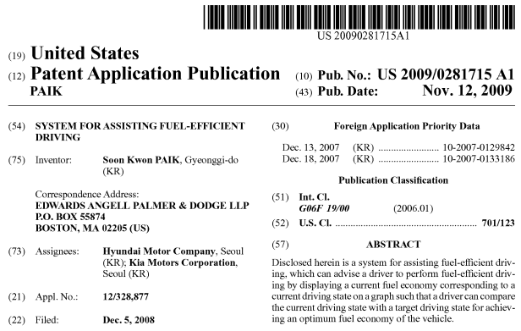

Description

CROSS-REFERENCE TO RELATED APPLICATIONS
This application claims under 35 U.S.C. §119(a) priority to Korean Application No. 10-2007-0133186, filed on Dec. 18, 2007, the disclosure of which is incorporated herein by reference in its entirety.

BACKGROUND
1. Technical Field
The present invention relates to a system for assisting fuel-efficient driving that assists a driver in achieving optimum fuel economy while driving a vehicle.

2. Related Art
Due to the rise in oil prices and environmental concerns, vehicle manufacturers have conducted intensive research to improve fuel efficiency of vehicles. Vehicle fuel efficiency depends not only on vehicle engine and transmission tuning technologies but also drivers' driving habits, such as a rapid deceleration habit or a rapid braking habit.

SUMMARY
The present invention provides a system for assisting fuel-efficient driving that can advise a driver to perform fuel-efficient driving by displaying a current fuel economy corresponding to a current driving state on a graph such that a driver can compare the current driving state with a target driving state for achieving an optimum fuel economy of the vehicle.

It is understood that the term “vehicle” or “vehicular” or other similar term as used herein is inclusive of motor vehicles in general such as passenger automobiles including sports utility vehicles (SUV), buses, trucks, various commercial vehicles, watercraft including a variety of boats and ships, aircraft, and the like, and includes hybrid vehicles, electric vehicles, plug-in hybrid electric vehicles, hydrogen-powered vehicles and other alternative fuel vehicles (e.g. fuels derived from resources other than petroleum). As referred to herein, a hybrid vehicle is a vehicle that has two or more sources of power, for example both gasoline-powered and electric-powered vehicles.

BRIEF DESCRIPTION OF THE DRAWINGS

FIG. 1 is a block diagram of a system for assisting fuel-efficient driving according to an embodiment of the present invention.

FIG. 2 is a view showing an example of economical driving information displayed according to the present invention.

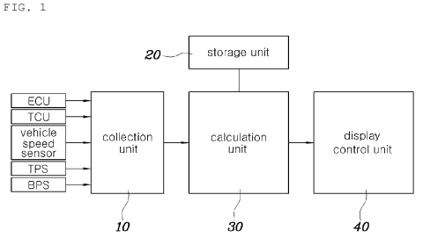 | 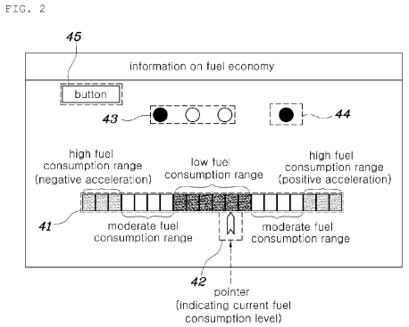

FIG. 3 is a view showing another example of economical driving information displayed according to the present invention.

FIG. 4 is a flowchart of the operation of a system for assisting fuel-efficient according to an embodiment of the present invention.

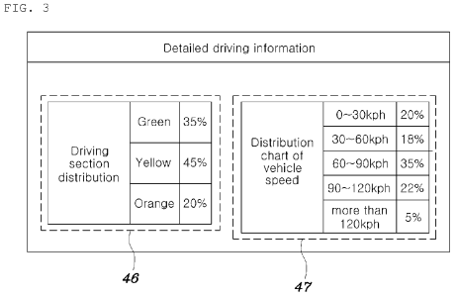 | 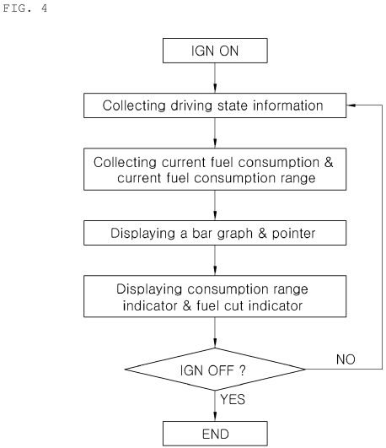

FIGS. 5A and 5B are flowcharts of the operation of a system for assisting fuel-efficient according to an embodiment of the present invention, respectively.
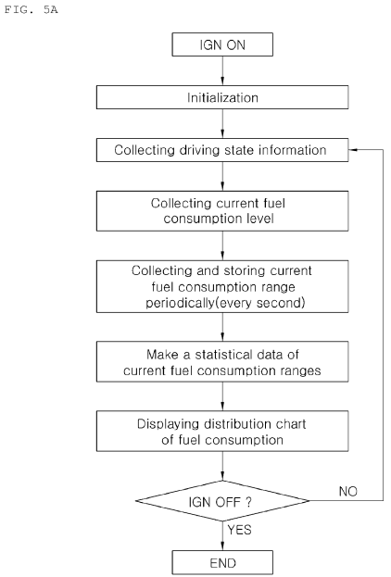 | 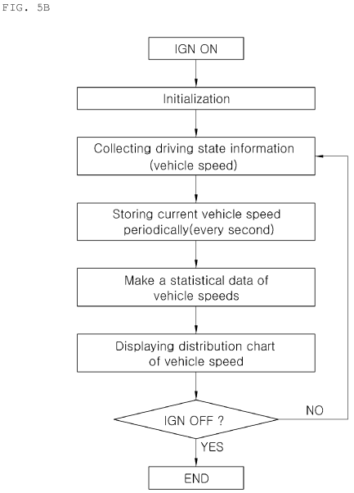
Claims (8)

1. A system for assisting fuel-efficient driving, comprising:
a collection unit for collecting driving state information of a vehicle;
a storage unit for storing a fuel consumption map over a variety of driving conditions, wherein the fuel consumption map classifies the driving conditions into several groups depending on fuel consumption levels thereof; and
a calculation unit for calculating a current fuel consumption level and a target driving condition for achieving an optimal fuel consumption level of the vehicle, based on the information from the collection unit and the fuel consumption map; and
a display control unit for graphically displaying the current fuel consumption level and the optimal fuel consumption level on a display such that a driver can compare the current fuel consumption level with the optimal fuel consumption level so as to pursue the target driving condition.

2. The system for assisting fuel-efficient driving as set forth in claim 1, wherein: the groups comprises a low fuel consumption range, a moderate fuel consumption range and a high fuel consumption range; the fuel consumption ranges are visualized as a bar graph on the display such that fuel consumption levels in the fuel consumption ranges can be compared with each other; and the current fuel consumption level is displayed on the bar graph as an pointer and the pointer moves in accordance with changes of the current fuel consumption level responding to acceleration changes of the vehicle.

3. The system for assisting fuel-efficient driving as set forth in claim 2, wherein regions or width of the fuel consumption ranges in the bar graph can be changed depending on the current driving state.

4. The system for assisting fuel-efficient driving as set forth in claim 2, wherein the display control unit further displays a current fuel consumption range where the current fuel consumption level is among the fuel consumption ranges.

5. The system for assisting fuel-efficient driving as set forth in claim 2, wherein the calculation unit periodically stores a current fuel consumption range where the current fuel consumption level is among the fuel consumption ranges while the driver drives the vehicle and makes a statistical data for the stored current fuel consumption ranges, and wherein the display control unit is operable to display this statistical data on the display upon demand from the driver.

6. The system for assisting fuel-efficient driving as set forth in claim 2, wherein the calculation unit periodically stores a current vehicle speed while the driver drives the vehicle and makes a statistical data for stored current vehicle speeds, and wherein the display control unit is operable to display this statistical data on the display upon demand from the driver.

7. The system for assisting fuel-efficient driving as set forth in claim 1, wherein the display control unit further displays whether or not fuel is cut.

8. The system for assisting fuel-efficient driving as set forth in claim 1, wherein the driving state information collected by the collection unit comprises at least one of a vehicle speed, a brake pedal position value, a TPS value, a transmission gear position, a engine RPM, and whether or not fuel is cut.

Analogue 2

FUEL USE EFFICIENCY SYSTEM FOR A VEHICLE FOR ASSISTING THE DRIVER TO IMPROVE FUEL ECONOMY

PATENT NO. US6092021A

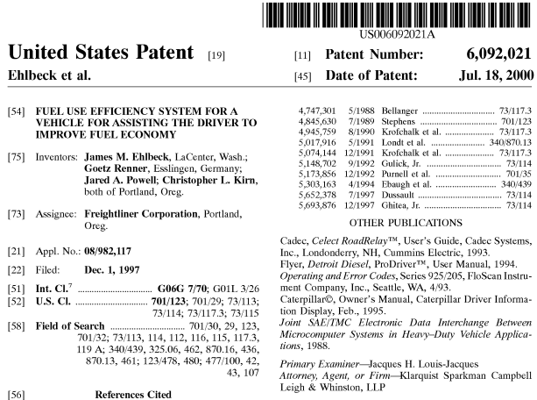

Abstract
A fuel efficiency monitoring and display system for a vehicle dynamically evaluates vehicle performance parameters to detect conditions that cause excessive fuel consumption. The conditions include increased aerodynamic drag due to excessive speed, high RPM, braking and accelerating, excessive idling, and rapid throttle movements. The system dynamically estimates gross vehicle weight, roadway grade and drag factor from monitored parameters and uses these estimates to detect inefficient fuel use. The system indicates to the driver when inefficient fuel use is detected. For example, it displays a measure of excess fuel consumed and messages indicating actions that can be taken to improve fuel economy in response to detecting inefficient fuel use.

Description

TECHNICAL FIELD
The invention relates to a fuel efficiency indicator in a vehicle, and more specifically relates to a system for dynamically detecting inefficient driving actions and indicating information about excess fuel consumption to the driver.

BACKGROUND OF THE INVENTION
With rising fuel costs, an important design goal of vehicle information systems is to provide drivers, and especially drivers of long-haul trucks, with information about fuel economy during operation of the vehicle. Many vehicles display a measure of fuel economy such as the gas mileage in miles per gallon. While this information is helpful, it does not give the driver specific feedback on how specific driving actions impact fuel economy. In addition, it fails to provide a measure of excess fuel consumption due to specific types of driving actions. Drivers are less likely to get information that can help them improve fuel economy from these fuel economy measures, and thus, are more likely to ignore them.
Modern motor vehicles are typically equipped with a variety of onboard computers for measuring and recording vehicle performance and diagnostic data. These devices provide a great deal of information about the performance of the vehicle during operation. The problem is not lack of information, but rather, evaluating it and conveying it to the driver in a useful fashion. There is a need for a fuel efficiency indicator that uses this data to assist the driver to operate the vehicle more efficiently and take actions that avoid excess fuel consumption.

SUMMARY OF THE INVENTION
The invention provides a fuel efficiency system and related method that indicate when the driver is operating the vehicle inefficiently. This system provides feedback to the driver when the vehicle is consuming excess fuel due to inefficient driving actions. It monitors vehicle performance data and dynamically analyzes the data to determine when the driver's actions result in inefficient fuel use. When the system detects a condition that causes the vehicle to consume excess fuel, it indicates the presence of the condition to the driver.

BRIEF DESCRIPTION OF THE DRAWINGS

FIG. 1 is a block diagram illustrating the system architecture in a truck for one embodiment of the invention.

FIG. 2 is a block diagram illustrating the engine electronic control unit (ECU) in more detail.

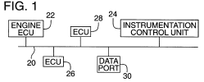 | 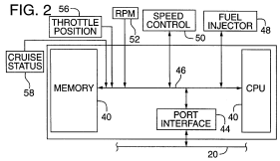

FIG. 3 is a functional block diagram illustrating the architecture of the instrumentation control unit (ICU).
FIG. 4 is a diagram of a display format generated by the ICU in FIG. 3 to display normal driving messages.
FIG. 5 is another diagram of a display format generated by the ICU to indicate inefficient driving conditions and suggest an action to improve fuel efficiency.
FIG. 6 is a flow diagram illustrating modules used to compute and display information about inefficient driving conditions in one embodiment of the invention.

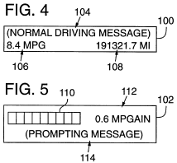 | 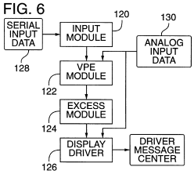

FIGS. 7A and 7B are a flow diagram illustrating an implementation of the Vehicle Parameter Estimation Module of FIG. 6.

FIG. 8 is a block diagram depicting a parameter sub-module in the excess module shown in FIG. 6.
FIGS. 9A and 9B are a flow diagram of the speed sub-module in the excess module for detecting inefficient fuel use due to speeding.
FIG. 10 is a flow diagram of an RPM sub-module in the excess module for detecting inefficient fuel use due to operating the vehicle at a high RPM.
FIG. 11 is a flow diagram of an idling sub-module in the excess module for detecting inefficient fuel use due to excessive idling.
FIGS. 12A-C are a flow diagram of a braking/accelerating sub-module in the excess module for detecting inefficient fuel use due to frequent braking and accelerating conditions (i.e., fuel lost due to changes in kinetic energy of the vehicle).
FIG. 13 is a flow diagram of a throttle sub-module in the excess module for detecting inefficient fuel use due to rapid throttle movement.

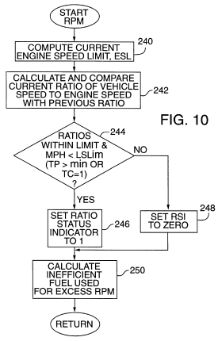 | 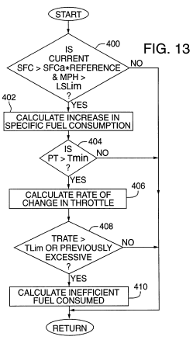
FIG. 14 is a flow diagram of a total sub-module in the excess module for accumulating fuel consumption values.
FIG. 15 is a flow diagram of a display sub-module in the excess module for determining whether to display a message regarding inefficient fuel use for an inefficient driving action evaluated in the excess module.
FIG. 16 is a flow diagram of an average sub-module in the excess module for filtering selected variables.

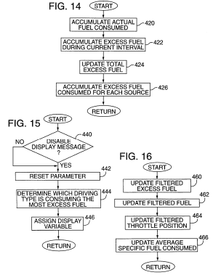
CLAIMS (54)
We claim:
1. A method for assisting a driver of a vehicle to improve fuel economy while operating the vehicle on a roadway, the method comprising:
collecting vehicle performance data during operation of the vehicle;
during operation of the vehicle, monitoring for two or more conditions in which the vehicle is consuming excess fuel;
during operation of the vehicle, detecting from the vehicle performance data whether at least one of the conditions exist in which the vehicle is consuming excess fuel; and
during operation of the vehicle, indicating to the driver that excess fuel is being consumed due to the detected condition and a cause of the detected condition.
2. The method of claim 1 wherein the condition comprises one or more of the following conditions: increased aerodynamic drag due to excessive vehicle speed, operating at high RPM, excessive idling, changes in kinetic energy due to braking or accelerating, or rapid throttle movement.
3. The method of claim 1 further including:
displaying a message to the driver indicating a driving action that will improve fuel economy.
4. The method of claim 1 wherein the condition comprises excessive speed.
5. The method of claim 4 wherein the step of detecting the excessive speed condition includes:
comparing current vehicle speed to a reference speed.
6. The method of claim 5 wherein the reference speed is dynamically updated based on recent speed readings of the vehicle.
7. The method of claim 1 further including:
computing excess fuel consumed due to increased aerodynamic drag.
8. The method of claim 7 further including:
dynamically estimating the aerodynamic drag factor of the vehicle.
9. The method of claim 7 further including:
indicating the excess fuel consumed due to increased aerodynamic drag to the driver.
10. The method of claim 1 wherein the condition comprises high engine RPM.
11. The method of claim 10 wherein the high engine RPM condition is detected by comparing current RPM of the vehicle with a reference RPM that is dependent on a dynamically determined horsepower of the vehicle.
12. The method of claim 10 wherein the step of detecting the high engine RPM condition includes:
determining whether the driver is shifting the vehicle during a predetermined monitoring period;
when it is determined that the driver is shifting during the predetermined monitoring period, determining that the high engine RPM condition is not satisfied to avoid indicating that excessive fuel is being consumed due to high engine RPM.
13. The method of claim 10 further including:
computing excess fuel consumed due to high engine RPM.
14. The method of claim 13 wherein the excess fuel consumed is proportional to an amount by which current engine RPM exceeds a calculated engine speed limit.
15. The method of claim 13 further including:
indicating the excess fuel consumed due to high engine RPM to the driver during operation of the vehicle.
16. The method of claim 1 wherein the condition comprises a braked speed change that results in a loss of kinetic energy of the vehicle.
17. The method of claim 16 further including:
determining elapsed time between applying brake and throttle to evaluate whether excess fuel is being consumed.
18. The method of claim 16 further including:
determining rate of increase of vehicle speed after a brake event to evaluate whether excess fuel is being consumed.
19. The method of claim 16 further including:
computing excess fuel consumed due to the braked speed change during operation of the vehicle.
20. The method of claim 19 wherein the excess fuel consumed is computed as a function of change in kinetic energy due to braking.
21. The method of claim 19 further including dynamically estimating gross vehicle weight and computing the excess fuel consumed based, at least in part, on the estimated gross vehicle weight.
22. The method of claim 19 further including:
indicating the excess fuel consumed due to the braked speed change to the driver during operation of the vehicle.
23. The method of claim 1 wherein the condition comprises excessive idling.
24. The method of claim 23 further including:
determining whether idling time exceeds a reference time.
25. The method of claim 23 further including:
computing excess fuel consumed due to excessive idling during operation of the vehicle.
26. The method of claim 25 further including:
indicating the excess fuel consumed due to excess idling to the driver.
27. The method of claim 1 wherein the condition comprises rapid throttle movement.
28. The method of claim 27 further including:
determining the rate of change of throttle position.
29. The method of claim 27 further including:
comparing specific fuel consumption with an average specific fuel consumption to evaluate whether rapid throttle movement resulted in consumption of excess fuel.
30. The method of claim 27 further including:
computing excess fuel consumed due to rapid throttle movement during operation of the vehicle.
31. The method of claim 30 further including:
indicating excess fuel consumed due to rapid throttle movement to the driver during operation of the vehicle.
32. The method of claim 1 further including dynamically estimating vehicle drag, and using the estimated vehicle drag to detect when changes in vehicle speed result in excess fuel consumption.
33. The method of claim 32 further including dynamically estimating grade of the roadway.
34. A computer readable medium having instructions for performing the steps of claim 1.
35. A fuel efficiency indicator for a vehicle, comprising:
an output device; and
an instrumentation control for receiving vehicle performance parameters monitored during operation of the vehicle, for detecting from the vehicle performance data whether a condition exists in which the vehicle is consuming excess fuel during operation of the vehicle, and for controlling the output device to indicate to the driver that excess fuel is being consumed, including indicating during operation of the vehicle a quantity of fuel consumed due to the detected condition.
36. The fuel efficiency indicator of claim 35 wherein the output device comprises a display device, and the instrumentation control unit is operable to produce a display of a measure of excess fuel consumed due to the detected condition.
37. The fuel efficiency indicator of claim 35 wherein the output device comprises a display device, and the instrumentation control unit is operable to produce a display of a message indicating the detected condition.
38. The fuel efficiency indicator of claim 37 wherein the message indicates a driver action to reduce excess fuel consumption resulting from the detected condition.
39. The fuel efficiency indicator of claim 37 wherein the condition comprises increased aerodynamic drag due to excessive vehicle speed.
40. The fuel efficiency indicator of claim 37 wherein the condition comprises operating at high RPM.
41. The fuel efficiency indicator of claim 37 wherein the condition comprises excessive idling.
42. The fuel efficiency indicator of claim 37 wherein the condition comprises changes in kinetic energy due to braking or accelerating.
43. The fuel efficiency indicator of claim 37 wherein the condition comprises rapid throttle movement.
44. A fuel efficiency indicator for a vehicle, comprising:
a display device; and
an instrumentation control unit in communication with the display device, the instrumentation control unit operable to receive vehicle performance parameters, operable to detect from the vehicle performance data whether a condition exists in which the vehicle is consuming excess fuel, and operable to control the output device to indicate to the driver that excess fuel is being consumed in response to detecting the condition, to indicate a message indicating a driver action to reduce excess fuel consumption due to the detected condition, and to display a measure of excess fuel consumed due to the detected action.
45. A method for assisting a driver of a vehicle to improve fuel economy while operating the vehicle on a roadway, the method comprising:
collecting vehicle performance data during operation of the vehicle;
during operation of the vehicle, monitoring for two or more conditions in which the vehicle is consuming excess fuel;
during operation of the vehicle, detecting from the vehicle performance data whether at least one of the conditions exist in which the vehicle is consuming excess fuel;
measuring fuel consumption attributable to a detected condition in which the vehicle is consuming excess fuel; and
during operation of the vehicle, indicating to the driver that excess fuel is being consumed due to the detected condition, within a predefined period of detecting the condition and a cause of the detected condition.
46. The method of claim 45 wherein the predefined period is less than a second.
47. The method of claim 45 wherein the predefined period is less than 300 milliseconds.
48. The method of claim 45 wherein the indicating step includes displaying a prompting message indicating the type of condition to the driver.
49. The method of claim 48 further including: displaying an indicator of a quantity of excess fuel or fuel efficiency loss due to the detected condition.
50. The method of claim 45 wherein the condition includes one or more of the following:
increased aerodynamic drag due to excessive vehicle speed, operating at high RPM, excessive idling, changes in kinetic energy due to braking or accelerating, or rapid throttle movement.
51. The method of claim 45 wherein the detecting step includes monitoring for two or more of the following conditions:
increased aerodynamic drag due to excessive vehicle speed, operating at high RPM, excessive idling, changes in kinetic energy due to braking or accelerating, or rapid throttle movement.
52. The method of claim 51 further including: determining which of the two or more conditions has caused the most inefficient fuel use; wherein the indicating step includes indicating the condition that has caused the most inefficient fuel use.
53. The method of claim 52 further including:
if one or more of the conditions is detected, repeatedly updating a display with an indicator of the condition that has caused the most inefficient fuel use.
54. The method of claim 53 including:
filtering a display parameter to smooth fluctuations in the indicator.

Analogue 3
METHOD AND SYSTEM FOR CALCULATING EFFECTIVE FUEL ECONOMY

PATENT NO. US5578748A
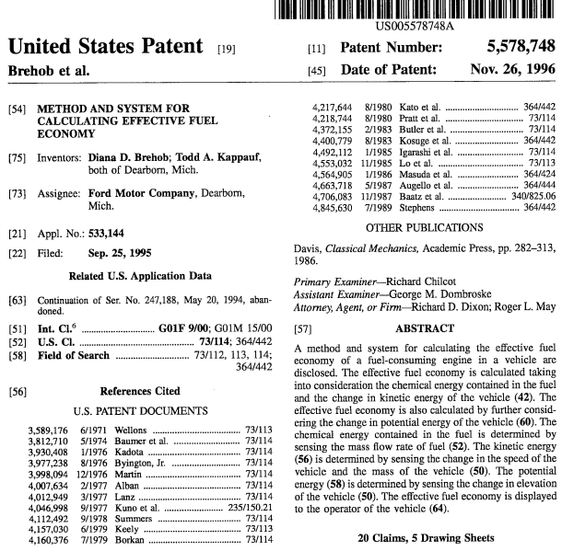

Description
This is a continuation of application Ser. No. 08/247,188, filed on May 20, 1994, now abandoned.
TECHNICAL FIELD
This invention relates to a method and system for calculating the fuel economy of a vehicle and more particularly to a method and system for calculating a fuel economy which is corrected for changes in the chemical energy of the fuel, changes in the kinetic energy of the vehicle, and changes in the potential energy thereof.
BACKGROUND ART
It is known in the art to measure engine fuel economy based on average vehicle speed and the average fuel flow over an interval of time. This type of measured fuel economy considers fuel energy to be the only type of energy associated with the vehicle. In reality, the vehicle can also store or consume kinetic and/or potential energy. The chemical energy stored in the fuel may be converted into kinetic energy which may be used later during a coast down.
In vehicles with deceleration fuel shutoff, prior art methods of determining fuel economy indicate that fuel economy is infinite during deceleration. However, the fuel energy stored as kinetic energy during the acceleration phase is now being consumed. Furthermore, the prior art does not distinguish between braking and coasting, both of which may indicate infinite fuel efficiency.
A method and apparatus for calculating corrected vehicle fuel economy is disclosed in U.S. Pat. No. 4,845,630, issued to Stephens. The method includes calculating the distance travelled by the vehicle, the fuel consumed by the engine, and the change of the kinetic energy of the vehicle. The change of kinetic energy is compensated by a weighting factor that modifies the kinetic energy term to account for the fuel that would be used at real engine and drivetrain efficiencies, which can only be determined experimentally. Therefore, the weighting factor must be predetermined and stored in a read-only memory. This system does not consider the potential energy of the vehicle.
The known prior art does not disclose a method of calculating fuel economy which balances the chemical energy contained in the fuel, and the kinetic and potential energy of the vehicle. In the prior art, a weighting factor is employed which considers that in converting chemical energy of the fuel into the shaft output, the efficiency is usually less than 25%. In comparison, potential energy can be converted into kinetic energy at a much higher efficiency. Therefore, the present invention calculates fuel economy based on an energy balance over the vehicle.
DISCLOSURE THE INVENTION
It is thus a general object of the present invention to provide a method and system for calculating the effective fuel economy (MPG_{eff}) by considering the chemical energy of the fuel and kinetic energy of a vehicle.

BRIEF DESCRIPTION OF THE DRAWINGS

FIG. 1 is a schematic block diagram of a system for measuring and displaying effective fuel economy made in accordance with the teachings of the preferred embodiment of this invention.

FIG. 2 is a functional block diagram of the method utilized in accordance with the present invention.
FIG. 3 is a detailed block diagram illustrating the sequence of steps performed in the method of the present invention.
FIG. 4 is a graph illustrating average vehicle speed at 1/2 second intervals during a moderate acceleration from a standstill.
FIG. 5 is a graph illustrating the difference between uncorrected fuel economy and the present invention during a moderate acceleration.
FIG. 6 is a graph illustrating average vehicle speed at 1/2 second intervals during a coast-down.
FIG. 7 is a graph illustrating the difference between uncorrected fuel economy and the present invention during a coast-down.

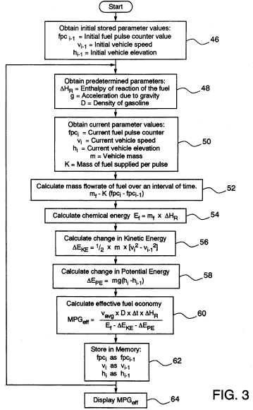 | 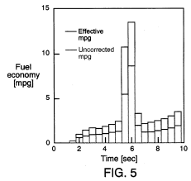  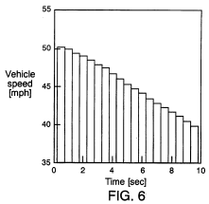
CLAIMS (20)
We claim:
1. A method for determining and displaying on a visual display the effective fuel economy (MPG_{eff}) of a fuel consuming engine during a time interval Δ_{t} in a vehicle, the method comprising:
providing a vehicle having a mass and said fuel consuming engine;
determining an enthalpy of reaction (ΔH_{R}) of the fuel, which represents the energy released per unit mass by combustion following actual injection of fuel into the engine;
determining an amount of chemical energy (E_{f}) contained in the fuel based on the enthalpy of reaction of the fuel;
sensing a vehicle speed at predetermined periods of time during the time interval and generating corresponding velocity signals (v_{i}, v_{i-1});
determining a change in kinetic energy (ΔE_{KE}) of the vehicle during the time interval based solely on the velocity signals and the mass of the vehicle;
determining a change in potential energy (ΔE_{PE}) of the vehicle;
determining the effective fuel economy of the vehicle based on the chemical energy, the change in kinetic energy and the change in potential energy;
generating an electrical signal for receipt by the visual display corresponding to the determined effective fuel economy; and
displaying the determined effective fuel economy.
2. The method of claim 1, wherein the mass of the vehicle is a preselected value.
3. The method of claim 1, wherein the step of determining ΔH_{R} comprises:
determining a mass fraction of alcohol contained in the fuel (X_{alcohol});
determining an enthalpy of reaction of alcohol (ΔH_{R}, alcohol);
determining an enthalpy of reaction of gasoline (ΔH_{R}, gasoline); and
determining ΔH_{R} in accordance with the formula:
ΔH.sub.R ={X.sub.alcohol ×ΔH.sub.R, alcohol }+{(1-X.sub.alcohol) ×ΔH.sub.R,gasoline }.
4. The method of claim 1 wherein the step of determining the change in the potential energy includes the step of determining a pitch of the vehicle (.O slashed.) with respect to a horizontal and wherein the change in potential energy is determined in accordance with the formula:
ΔE.sub.PE =m×g×v.sub.avg ×Δ.sub.t ×sin .O slashed.,
where g is acceleration due to gravity and v_{avg} is an average vehicle speed during the time interval.
5. The method as recited in claim 1 wherein the step of determining the amount of chemical energy contained in the fuel includes the step of determining a mass flow rate (m_{f}) of the fuel and wherein the amount of chemical energy is determined in accordance with the formula:
E.sub.f =m.sub.f ×ΔH.sub.R.
6. The method as recited in claim 5 wherein the vehicle includes fuel injector values which open and close to allow fuel to flow into the engine, and wherein the step of determining the mass flow rate of fuel includes the step of determining a duration of time when the fuel injector values are opened.
7. The method as recited in claim 1 wherein the step of determining the change in the potential energy includes the step of determining a change in height (h_{i} -h_{i-1}) of the vehicle above a datum plane during the time interval and wherein the change in potential energy is determined in accordance with the formula:
ΔE.sub.PE =m×g×(h.sub.i -h.sub.i-1),
where g is acceleration due to gravity.
8. The method as recited in claim 1 further comprising the step of determining a density (D) of the fuel, and wherein the effective fuel economy is determined in accordance with the formula: ##EQU9## where v_{avg} is an average vehicle speed during the time interval.
9. The method as recited in claim 1 wherein the step of providing the vehicle includes the step of sensing the mass of the vehicle.
10. For use with a vehicle having a mass and a fuel consuming engine, a system for determining and displaying the effective fuel economy of the fuel consuming engine during a time interval, the system comprising:
means for determining an enthalpy of reaction (ΔH_{R}) of the fuel, which represents the energy released per unit mass by combustion following actual injection of fuel into the engine;
means for determining an amount of chemical energy contained in the fuel based on the enthalpy of reaction of fuel;
a first sensor for sensing a vehicle speed at predetermined periods of time during the time interval and for generating corresponding velocity signals;
means for determining a change in kinetic energy of the vehicle during the time interval based solely on the velocity signals and the mass of the vehicle;
means for determining a change in potential energy of the vehicle;
means for determining the effective fuel economy based on the amount of chemical energy, the change in kinetic energy and the change in potential energy;
means for generating an electrical signal corresponding to the effective fuel economy; and
a display for displaying the effective fuel economy upon receipt of the electrical signal.

11. The system as recited in claim 10 wherein the means for determining the change in potential energy includes means for determining a pitch of the vehicle with respect to a horizontal.

12. The system as recited in claim 11 wherein the means for determining the pitch of the vehicle is an inclinometer.

13. The system as recited in claim 10 wherein the means for determining the change in the kinetic energy includes means for determining a mass of the vehicle.

14. The system as recited in claim 13 wherein the means for determining the mass of the vehicle is

15. The system as recited in claim 10 wherein the enthalpy of reaction of the fuel is a preselected value.

16. The system as recited in claim 10 wherein the means for determining the enthalpy of reaction of the fuel comprises:
means for determining a mass fraction of alcohol contained in the fuel;
means for determining an enthalpy of reaction of alcohol; and
means for determining an enthalpy of reaction of gasoline.

17. The system as recited in claim 10 wherein the means for determining the amount of chemical energy includes means for determining a mass flow rate of the fuel.

18. The system as recited in claim 10 wherein the means for determining the change in potential energy includes means for determining a change in height of the vehicle above a datum plane during the time interval.

19. The system as recited in claim 18 wherein the means for determining the change in height of the vehicle is an altimeter.
20. The system as recited in claim 18 wherein the means for determining the change in height of the vehicle is a navigation device.

IV. RELEVANCE AND SUMMARY OF WORK

The work of science – OONE.World Business-Concept of Logistic and IT Solutions for Vehicles Efficiency Monitoring’s mission is to help the environment by reducing CO2 emissions through fuel economy and reduce mortality rates among drivers by incentivizing safe and efficient driving – all through their mobile device.

Likewise, the work of science – OONE.World Business-Concept of Logistic and IT Solutions for Vehicles Efficiency Monitoring is for:

1. Savings
Drivers save fuel by adhering to a recommended speed and proper driving style

2. Ecology
Reducing carbon dioxide emissions by lowering fuel consumption

3. Safety
Reducing critical situations by incentivizing proper driving and introducing interactive emergency alerts

The work of science OONE.World Business-Concept of Logistic and IT Solutions for Vehicles Efficiency Monitoring uses an innovative incentive system, which provides benefits for adhering to a recommended driving speed and proper driving style. In addition, the work of science OONE.World Business-Concept of Logistic and IT Solutions for Vehicles Efficiency Monitoring is a fuse of technical, organizational, digital, and Web 3.0 (blockchain) solutions aimed at creating a community of drivers, adhering to a proper driving style. The Project uses a unique methodology of employing gamified blockchain solutions to incentivize drivers by accruing virtual assets.

FUNCTIONALITY
Once the mobile app is downloaded, the User goes through a series of simple steps to start earning from their journey times:

1. User registration
2. Subscription selection (Demo, Enterprise or Premium Enrerprise)
3. Profile setting (photo, vehicle details)
4. “Start Journey” >> “End Journey” >> “Collect Coins (ESPD)”

WEB-VERSION
In addition to the mobile application, users will have access to a website with a personal account and information about the project.

A personal account is required for the category of Premium Enterprise Users, a format of work whereby a company purchases subscriptions for its employees.

The personal account is designed in a way that is most suitable for administering large groups of Users. In addition to creating and deleting users in a personal account, a User can use functions such as two-level analytics (personal and general), filter by specified parameters, search, location tracking, notifications and payment.

Also, it is planned to place information about the project, User Agreement, and white paper on the website.

WAYS OF IMPLEMENTATION

The work of science OONE.World Business Concept of Logistic and IT Solutions for Vehicles Efficiency Monitoring uses the first large-scale move-to-earn mobile application, where to earn an internal ESPD token (a network token of the BNB project), the User must fulfill certain conditions and abide by driving rules recommended.

There are 3 types of subscriptions: Demo, Premium and Premium Enterprise.

There will be a demo version only to demonstrate all the features and benefits of the products and for the Users to get familiarized with the product.

Premium & Premium Enterprise are full-fledged modes, including all the advantages and capabilities of the project, with the maximum accrual of ESPD.

MECHANISM
The Project uses a unique methodology of employing gamified blockchain solutions to incentivize drivers by accruing virtual assets. Below are the three IP Sections:

- Wallet
ESPD - Game Token
Token Supply - 375.000.000.000 ESPD.

Circulation and storage on the game wallet within the application, no SEED phrase is required to create. Also, the application implements the BNB network token.

Displaying ESPD and BNB tokens in the wallet in 1.000 format

Game token ESPD +
Travel History (Screen 1)

On the first screen in the Wallet, below, all operations (journeys) for accruing tokens are displayed.
Display format: Minsk - Moscow, Journey Time: September 8, 2023, 11:43 am + 14.905 ESPD

Rating: Eco-Karma

Compliance with the application rules entails the accrual of rating points. The rating has 5 levels, 1 to 5.

The rating assigned drives the final calculation of driver's remuneration:
1 lvl +0%
2 lvl +5%
3 lvl +10%
4 lvl +20%

Rating calculation runs every day at 00:00
Game Token ESPD +
Exchange (Screen 2)

At the top of the second screen, the ESPD token balance is displayed (the value from the first screen is duplicated). The 2nd screen is designed for the User to conveniently send or receive ESPD tokens, as well as exchange them for the BNB network token.

There are no withdrawal or exchange restrictions. The entire list of operations on BNB wallet is available to the User by swiping down.

2. Homescreen

The main screen contains the following information:

- Countdown of the time elapsed since the journey start;
- The number of accrued ESPD tokens (In real time - hereinafter referred to as RT);
- The total number of kilometers traveled (RT)
- Countdown credited by the application (yellow and green modes) of the number of kilometers traveled (RT);
- Counter of CO2 not emitted into the atmosphere due to fuel economy (RT);
- The speedometer is a double pie chart, where the outer circle describes the current requirements of the application for the User's speed on the road. And the inner circle reflects the actual speed. Inside the circle, the current speed and traffic rules in force in this section of the road are indicated. Depending on the speed mode, the circle is painted inside and outside in one of three colors, green, yellow, or red.
- Journey End button
To end the journey, User should tap and hold the button for 3 seconds, the progress indicator is filled and the journey ends with a short vibration;
- Information button, detailing User interaction with the application in the main screen, Journey, and other.

3. Personal Information

- Rating (as an arithmetic average of 30 days, whereby each new day replaces the last one. The information icon explains this);
- Photo - upload a new one, crop, and more;
- Vehicle details - engine, fuel type;
- User’s full name, age, phone, mail
- Subscription Information (Price Plan, Expiration, Reminder, Payment Methods, Subscription Cancellation, Company Contact for Premium Enterprise)
- Settings: notifications and password change
- Support service containing answers to the most frequently asked questions and the opportunity to send an email to help@oone.world and call-center
- SOS button, tapping which, the User goes to the assistant bot, which helps solve the current situation: a problem with a car, feeling unwell, a threat to life, a chat. It is planned to create an internal messenger and form its own active community.

UNIQUENESS
The work of science OONE.World Business-Concept of Logistic and IT Solutions for Vehicles Efficiency Monitoring has three novelty features:

1. The use of an innovative incentive system in the form of benefits for adhering to a recommended driving speed and proper driving style;
2. The fuse of technical, organizational, digital, and Web 3.0 (blockchain) solutions aimed at creating a community of drivers, adhering to a proper driving style; and
3. A unique methodology for using gamified blockchain solutions to incentivize drivers by accruing virtual assets.

Furthermore, tracking the location of drivers is not carried out according to the principle of points A and B, but according to the principle of a specific segment:
road P67, 37°25'19.07"N, 122°05'06.24.W, 54.513 km - road M1, 38°22'11.01"N, 126°02'03.21.8, 12.871 km,
which is undoubtedly much more difficult, both in terms of implementation and in terms of storing huge amounts of personal information. But only this approach will make it possible to realize the mission and strategic goals of the project: to help the environment by reducing CO₂ emissions through fuel economy and reduce mortality rates among drivers. After all, without detailed information about the location of the driver, the application loses the ability to adapt to constantly changing traffic conditions, traffic rules, and so on.
The target audience of this work of science - OONE.World Business-Concept of Logistic and IT Solutions for Vehicles Efficiency Monitoring are:

1. Truck owners/car owners
2. Private drivers and companies
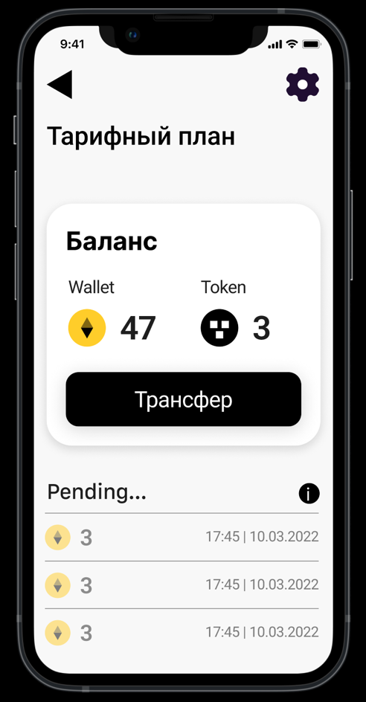
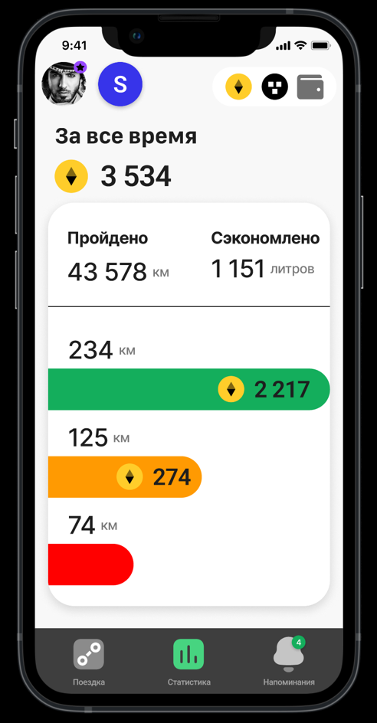


V. LEGAL BASIS

Examination of the current the work of science- OONE.World Business-Concept of Logistic and IT Solutions for Vehicles Efficiency Monitoring was held by the Intellectual Property Expert Dr. Sandjar Muminov based on following international (WIPO) and the normative legal acts of the United Kingdom and United Arab Emirates:

1. Berne Convention for the Protection of Literary and Artistic Works of 9 September 1886 in Paris, complemented by 4 May 1896, revised in Berlin on 13 November 1908. Supplemented in Bern on March 20, 1914, and revised in Rome on June 2, 1928, in Brussels on June 26, 1948, in Stockholm on July 14, 1967, and in Paris on 24 July 1971, as amended September 28, 1979 (the UAE acceded to the Berne Convention in 2004)

2. The Federal Law Number 38 of 2021 of the United Arab Emirates “On Copyright and Neighboring Rights”.

3. The Federal Law Number 7 of 2008 of the United Arab Emirates on “The National Centre for Documentation and Research”.

4. The Federal Law Number 5 of 2012 (as amended) of the United Arab Emirates “On Combating Cybercrimes”.

5. The Federal Law Number 8 of 1984 of the United Arab Emirates "Concerning Commercial Companies”.

6. The Federal Law Number 3 of 1983 of the United Arab Emirates “On the Federal Judiciary Authority”.

7. The Federal Law Number 31 of 2006 of the United Arab Emirates “Pertaining to the Industrial Regulation and Protection of Patents, Industrial Drawings, and Designs”.

8. The Federal Law Number 18 of the United Arab Emirates “Concerning Commercial Transactions Law”.

9. The Ministerial Order № 133 of 2004 “On copyright collective”.

10. The Ministerial Resolution No. 411 of 1993 “On control over the intellectual works protected under UAE Federal Law no. 40 of 1992 “On copyrights and author’s rights”.
11. United Kingdom Copyright, Designs and Patents Act (1988)

12. United Kingdom Copyright, Designs and Patents Act (1988) Part I 'Copyright' Chapter I, Article 1. and Article 143

13. United Kingdom Arbitration Act 1996 (Chapter 23, updated up to January 27, 2021)

14. United Kingdom Competition Act 1998 (Chapter 41, updated up to March 26, 2021)

VI. SOURCES OF REFERENCES

1. PATENT NO. US20090281715A1 – System for Assisting Fuel-Efficient Driving
2. PATENT NO. US6092021A – Fuel Use Efficiency System for a Vehicle for Assisting the Driver to Improve Fuel Economy
3. PATENT NO. US5578748A – Method and System for Calculating Effective Fuel Economy
4. WIKIPEDIA - www.wikipedia.org - a multilingual, web-based, free-content encyclopedia project supported by the Wikimedia Foundation and based on a model of openly editable content.

VII. INFORMATION ABOUT THE EXPERT

Dr. Sandjar Muminov has 25 years’ experience in the intellectual property industry. His professional merits and achievements include:
- Eurasian Commissioner on Law Supremacy and Intellectual Property of EECO (Eurasian Economic Cooperation Organization), Head Offices in Russia, China and UAE, regional offices in 50 countries (www.eurasianeconomic.org)
- President of SANDJAR GROUP Business Consortium (GCC, Dubai, UAE)
- Expert of Dubai Silicon Oasis Authority
- Speaker of the University of Dubai (UAE)
- Authorized Expert of INTEROCO Copyright Office (Germany)
- Member of International Intellectual Property Law Association (USA)
- and others.

Expert Specializations of Dr. Sandjar Muminov:
- Private advisor on all issues concerning IP legal protection (patent, commercial
& Copyright law)
- Startup and investments projects
- Commercialization & capitalization of intellectual property
- Protection of copyright, know-how, trade secrets, etc.
In 2018 and 2019, Dr. Sandjar Muminov was recognized as a World TOP-5 Intellectual Property Expert (International Intellectual Property Law Association, US-UK).
