International Online Copyright Office
INTEROCO
(European Union, Germany, Berlin)

WORK OF SCIENCE
OONE.World Concept of
Tokenomics, Blockchain,
and Smart Contracts

INTEROCO Copyright Office – 2022

STRUCTURE OF DOCUMENT

I. ANNOTATION
II. BASIC DEFINITIONS
III. ANALYSIS OF CLOSEST ANALOGS
IV. RELEVANCE AND SUMMARY OF WORK
V. LEGAL BASIS
VI. SOURCES OF REFERENCES
VII. INFORMATION ABOUT THE EXPERT

Works of science as intellectual property (copyright) object are stipulated in:

1 | Berne Convention for the Protection of Literary and Artistic Works (1971)  Article 2. Protected Works:  (1) (1) The expression “literary and artistic works” shall include every production in the literary, scientific and artistic domain, whatever may be the mode or form of its expression, such as books, pamphlets and other writings; lectures, addresses, sermons and other works of the same nature; dramatic or dramatic-musical works; choreographic works and entertainments in dumb show; musical compositions with or without words; cinematographic works to which are assimilated works expressed by a process analogous to cinematography; works of drawing, painting, architecture, sculpture, engraving and lithography; photographic works to which are assimilated works expressed by a process analogous to photography; works of applied art; illustrations, maps, plans, sketches and three-dimensional works relative to geography, topography, architecture or science.
2 | United Arab Emirates  Federal Law No. 38 of 2021 On Copyrights and Neighboring Rights  Article 1. In applying the provisions of this law, the following words denote the definitions explained before each one of them, unless the context denotes otherwise: “The Work” - any created compilation, in the scope of letters, arts, sciences, whatsoever is its type, mode of expression, value or purpose.
3 | United Kingdom Copyright, Designs and Patents Act (1988)  Part I 'Copyright'. Chapter I, Article 1. Copyright and copyright works  (1) Copyright is a property right which subsists in accordance with this Part in the following descriptions of work: (a) original literary, dramatic, musical or artistic works; (b) sound recordings, films or broadcasts, and; (c) the typographical arrangement of published editions.  (2) In this Part "copyright work" means a work of any of those descriptions in which copyright subsists.  (3) Copyright does not subsist in a work unless the requirements of this Part with respect to qualification for copyright protection are met (see section 153 and the provisions referred thereto).  Article 143 (b) section 60  Abstracts of scientific or technical articles

According to above mentioned laws in the UK and UAE work of science, as an object of copyright, should:
- Be the result of creative activity.
- Exist in any objective form.

The work of science considered – OONE.World Concept of Tokenomics, Blockchain, and Smart Contracts meets the definition of an object of copyright according to:

- Section 2 (Works under protection) of the Federal Law Number 38 of 2021 of the United Arab Emirates on “Copyright and Neighbouring Rights";
- Chapter I, Articles 1, 143 of United Kingdom Copyright, Designs and Patents Act (1988) Part I ‘Copyright’.

The result of creative activity, innovation, relevance, scope of work of science - OONE.World Concept of Tokenomics, Blockchain, and Smart Contracts is listed in this publication and confirmed by a certificate of deposit of copyright works.

The study of objective form of current work of science through materials research and examination of the object on the criteria for copyright eligibility held:

Intellectual Property Expert,  Authorized Representative  of INTEROCO Copyright Office  (signature, stamp) | Dr. Sandjar Muminov

I. ANNOTATION

In the Work of Science OONE.World Concept of Tokenomics, Blockchain, and Smart Contracts, the game tokens will have a general supply of 375kkk or unlimited quantity.

The game tokens in the Work of Science OONE.World Concept of Tokenomics, Blockchain, and Smart Contracts are exchangeable for BNB through a smart contract liquidity pool. This allows regulating the price of the token without having volatility in the market.

Purchase method

The game tokens in the Work of Science OONE.World Concept of Tokenomics, Blockchain, and Smart Contracts can be acquired in different ways.

First, they can be mined via the application by performing certain actions with an n number of tokens accrued; also, the tokens can be bought on the Dex through a smart contract; and finally, the User can become eligible for a Drop for rating or karma earned within the application.

Tokens Application

The game tokens in the Work of Science OONE.World Concept of Tokenomics, Blockchain, and Smart Contracts are applied across the 4 key activities:

- Exchange for BNB;

- Remuneration of active participants in the system;

- In-game mechanics (GameFi);

- Staking and providing liquidity for further governance token receipt.

BNB Coin Purchase Method

BNB Coins are used as the main asset for the exchange of game tokens in the Work of Science OONE.World Concept of Tokenomics, Blockchain, and Smart Contracts; and also BNB Coins are used for sale and purchase of game tokens and payment of commissions before the release of the ECO blockchain.

BNB Coins can be purchased within CEX or DEX frameworks, and also a small amount of BNB Coins can be airdropped to cover transaction fees

II. BASIC DEFINITIONS

Work of Science | is an object of intellectual property, registered as copyright work according to the Berne Convention for the Protection of Literary and Artistic Works.
Tokenomics | Tokenomics, an abbreviation of token and economics, is the all-encompassing science of the elements that make a cryptocurrency valuable and have economic value. This includes safeguarding its supply and use.
Blockchain | is a type of Digital Ledger Technology (DLT) that consists of growing list of records, called blocks, that are securely linked together using cryptography. Each block contains a cryptographic hash of the previous block, a timestamp, and transaction data (generally represented as a Merkle tree, where data nodes are represented by leafs).
Smart Contract | is a computer program or a transaction protocol that is intended to automatically execute, control or document legally relevant events and actions according to the terms of a contract or an agreement. The objectives of smart contracts are the reduction of need for trusted intermediators, arbitrations costs, fraud losses, as well as the reduction of malicious and accidental exceptions. Smart contracts are commonly associated with cryptocurrencies, and the smart contracts introduced by Ethereum are generally considered a fundamental building block for decentralized finance (DeFi) applications.

III. ANALYSIS OF CLOSEST ANALOGUES
Analogue1

BLOCKCHAIN-BASED PROGRAM REVIEW SYSTEM, METHOD, COMPUTING DEVICE AND STORAGE MEDIUM
PATENT No. US10922652B2

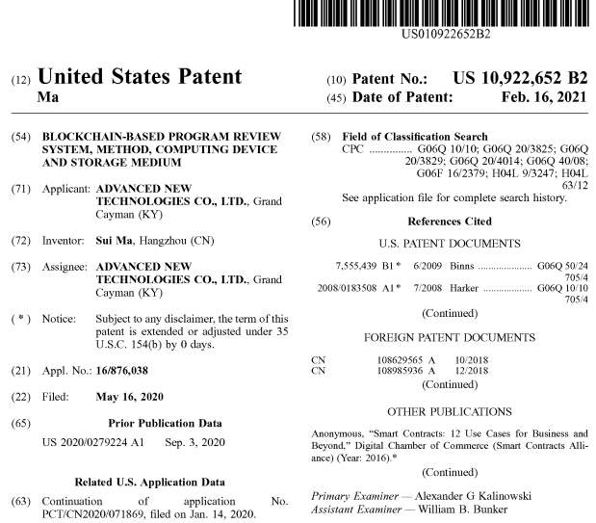

Abstract

The specification provides a blockchain-based application review system, method, and storage medium. The blockchain-based application review system comprises: a requesting client, a transaction end, and a blockchain node. The requesting client sends a program purchasing application to the transaction end; the transaction end receives the program purchasing application, determines product information of the target program according to identification information of the target program, and sends a program admission review application to the blockchain node based on identification information of the user and the product information of the target program; the blockchain node receives the program admission review application, executes a program admission review task when an execution condition of a first smart contract is satisfied, generates a corresponding review result, and sends the review result to the transaction end; and the transaction end receives the review result and sends the review result to the requesting client.

Description

CROSS REFERENCE TO RELATED APPLICATIONS
The present application is a continuation application of International Patent Application No. PCT/CN2020/071869, filed on Jan. 14, 2020, which claims priority to Chinese Patent Application No. 201910305949.5, filed on Apr. 16, 2019. The entire content of the above referenced applications is incorporated herein by reference.

TECHNICAL FIELD
The specification relates to the field of Internet technologies, and in particular, to a blockchain-based service purchasing/program enrollment review system, method, computing device and storage medium.

BACKGROUND
Along with the continuous economic development, insurance has become an important component of life. Insurance underwriting is a process by an insurance company to review, approve and select a risk of an insurance application from an insured. After a user sends an insurance application to an insurance company, the insurance company needs to perform underwriting for the user to achieve long-term underwriting profits.

In the current technologies, due to the development of the Internet, many insurance companies have realized, to a certain extent, automatic underwriting through a system. Namely, an underwriting rule is preset, and the system automatically determines whether a user satisfies the rule. However, since different companies or organizations playing different roles in the Internet system possess data of users in different fields, it takes a long time for an insurance company to collect these data, and moreover, it is impossible to ensure that the collected data is always true data that has not been tempered with. As a result, it is impossible to guarantee that underwriting results obtained from automatic underwriting through the system are accurate.

SUMMARY
In view of this, embodiments of the specification provide a blockchain-based program joining (or a service purchasing, a service enrolling) application review system, method, computing device and storage medium, to solve the technical defects of the current technologies.

BRIEF DESCRIPTION OF THE DRAWINGS

FIG. 1 is a schematic diagram of a blockchain-based application review system according to some embodiments of the present application.
FIG. 2 is a structural block diagram of a computing device according to some embodiment

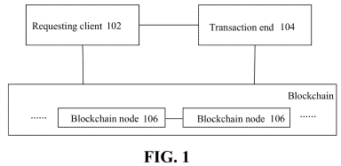 | 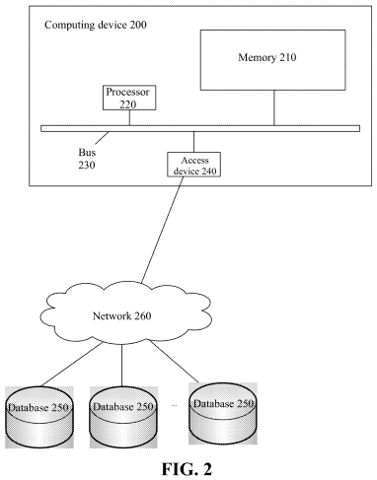
FIG. 3 is a flow chart of a blockchain-based application review method according to some embodiments of the present application.
FIG. 4 is a schematic diagram of interactions using the blockchain-based application review method in an application scenario of an insurance program according to some embodiments of the present application.
FIG. 5 is a flow chart of a user score assessment process in the blockchain-based application review method according to some embodiments of the present application.

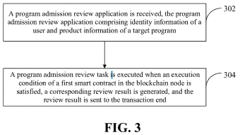  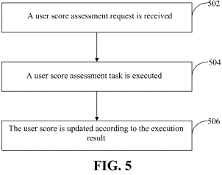 | 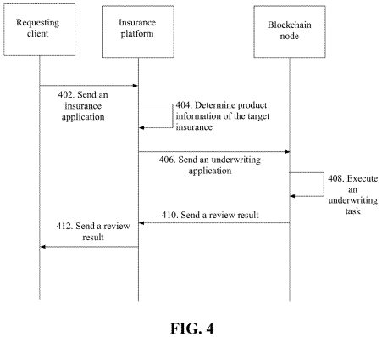
CLAIM (20)
The invention claimed is:
1. A computer-implemented method for blockchain-based product-purchasing application review, wherein the application review comprises automatically underwriting a product to be purchased by a user, comprising:
obtaining, by a blockchain node of a blockchain network providing a distributed data storage and comprising a plurality of blockchain nodes, a plurality of underwriting rules associated with a plurality of products offered for sale by a plurality of product providers, each underwriting rule comprising a user score required for user eligibility to purchase a corresponding product, wherein each blockchain node of the blockchain network comprises a data structure for storing and validating transactions associated with users of the network, wherein the blockchain node is in electronic communication with one or more transaction end computing devices associated with one or more providers which in turn is in electronic communication with a computing device associated with the user;
constructing, by the blockchain node, a first smart contract based on the plurality of underwriting rules associated with the plurality of products and the plurality of providers;
obtaining, by the blockchain node, a plurality of assessment rules associated with the plurality of providers to calculate an initial user score of the user based on historical transaction data of the user;
constructing, by the blockchain node, a second smart contract based on the plurality of assessment rules;
signing, by the blockchain node, the first smart contract and the second smart contract respectively with a private key of the blockchain node and submitting the signed first smart contract and the signed second smart contract to the blockchain network;
after the first smart contract and the second smart contract are validated based on a public key of the blockchain node, broadcasting, by the blockchain node, the first smart contract and the second smart contract to the blockchain network;
receiving, by the blockchain node, transaction data of the user from a third party service provider, wherein the receiving comprises receiving a request from the third party service provider to update the initial user score based on the received transaction data, wherein the user's transaction data is different at least in part from the user's historical transaction data;
determining, by the blockchain node executing the second smart contract, an updated user score for the user based on the user's transaction data;
storing, by the blockchain node, the updated user score of the user in the blockchain network, wherein the user score of the user is indexed based on identification information of the user, wherein the user score is continually updated and stored as new transaction data is received by the blockchain node from a third party service provider;
receiving, by the blockchain node, from the transaction end, a first product-purchasing application review request comprising the identification information of the user and first product information of a first target product offered for sale by a first provider, wherein the first product-purchasing application review request is received by the transaction end from the user computing device;
retrieving, by the blockchain node, the updated user score of the user based on the identification information of the user in the first product-purchasing application review request;
generating, by the blockchain node executing the first smart contract, a first review result based on the retrieved updated user score of the user and the first product information of the first target product in the first product-purchasing application review request;
communicating the first review result to the transaction end which in turn notifies the user computing device;
receiving, by the blockchain node, a second product-purchasing application review request comprising the identification information of the user and second product information of a second target product, wherein the second target product is offered for sale by a second provider different from the first provider;
retrieving, by the blockchain node, the updated user score based on the identification information of the user in the second product-purchasing application review request;
generating, by the blockchain node executing the first smart contract, a second review result based on the retrieved updated user score of the user and the second product information of the second target product in the second product-purchasing application review request; and
communicating the second review result to the transaction end which in turn notifies the user computing device.

2. The method according to claim 1, wherein broadcasting the second smart contract to the blockchain network comprises:
consolidating the second smart contract into a block and broadcasting the block to the blockchain network.

3. The method according to claim 2, wherein determining the updated user score for the user based on the user's transaction data comprises:
determining if an execution condition of the second smart contract is satisfied;
if so, automatically processing the user's transaction data according to the one or more assessment rules to generate a user-score change for the user, wherein the user-score change implies an amplitude of score increase or score decrease;
retrieving the initial user score of the user from the blockchain network;
determining the updated user score of the user based on the initial user score and the user-score change; and
storing the updated user score in the blockchain network, the updated user score being retrievable based on the identification information of the user.
4. The method according to claim 1, further comprising:
determining if the first product information of the first target product satisfies an execution condition of the first smart contract.

5. The method according to claim 1, wherein generating the first review result based on the retrieved updated user score of the user and the first product information of the first target product in the first product-purchasing application review request comprises:
determining, by the blockchain node executing the first smart contract, the user score required to purchase the first target product based on the first product information of the first target product in the first product-purchasing application review request; and
generating, by the blockchain node executing the first smart contract, the first review result based on a comparison of the retrieved updated user score with the user score required to purchase the first target product.

6. The method according to claim 1, wherein the method further comprises:
monitoring whether a state machine, an event and/or a trigger condition in the first smart contract satisfies a preset execution condition, and if yes, an execution condition of the first smart contract is satisfied.

7. The method according to claim 1, wherein the method further comprises:
monitoring whether a state machine, an entity and/or a trigger condition in the second smart contract satisfies a preset execution condition, and if yes, an execution condition of the second smart contract is satisfied.

8. The method according to claim 1, wherein the first review result comprises an approval, and the method further comprises:
sending a purchasing request to a server of the first provider, the purchasing request comprising the identification information of the user and an identification information of the first target product; and
receiving a purchase confirmation from the server of the first provider.

9. The method according to claim 1, wherein the
first review result comprises a rejection.
10. A system for blockchain-based product-purchasing application review, wherein the application review comprises automatically underwriting a product to be purchased by a user, the system comprising: a processor and a non-transitory computer-readable storage medium storing instructions executable by the processor to cause the system to perform operations comprising:
obtaining, by a blockchain node of a blockchain network providing a distributed data storage and comprising a plurality of blockchain nodes, a plurality of underwriting rules associated with a plurality of products offered for sale by a plurality of product providers, each underwriting rule comprising a user score required for user eligibility to purchase a corresponding product, wherein each blockchain node of the blockchain network comprises a data structure for storing and validating transactions associated with users of the network, wherein the blockchain node is in electronic communication with one or more transaction end computing devices associated with one or more providers which in turn is in electronic communication with a computing device associated with the user;
constructing, by the blockchain node, a first smart contract based on the plurality of underwriting rules associated with the plurality of products and the plurality of providers;
obtaining, by the blockchain node, a plurality of assessment rules associated with the plurality of providers to calculate an initial user score of the user based on historical transaction data of the user;
constructing, by the blockchain node, a second smart contract based on the plurality of assessment rules;
signing, by the blockchain node, the first smart contract and the second smart contract respectively with a private key of the blockchain node and submitting the signed first smart contract and the signed second smart contract to the blockchain network;
after the first smart contract and the second smart contract are validated based on a public key of the blockchain node, broadcasting, by the blockchain node, the first smart contract and the second smart contract to the blockchain network;
receiving, by the blockchain node, transaction data of the user from a third party service provider, wherein the receiving comprises receiving a request from the third party service provider to update the initial user score based on the received transaction data, wherein the user's transaction data is different at least in part from the user's historical transaction data;
determining, by the blockchain node executing the second smart contract, an updated user score for the user based on the user's transaction data;
storing, by the blockchain node, the updated user score of the user in the blockchain network, wherein the user score of the user is indexed based on identification information of the user, wherein the user score is continually updated and stored as new transaction data is received by the blockchain node from a third party service provider;
receiving, by the blockchain node, from the transaction end, a first product-purchasing application review request comprising the identification information of the user and first product information of a first target product offered for sale by a first provider, wherein the first product-purchasing application review request is received by the transaction end from the user computing device;
retrieving, by the blockchain node, the updated user score of the user based on the identification information of the user in the product-purchasing application review request;
generating, by the blockchain node executing the first smart contract, a first review result based on the retrieved updated user score of the user and the first product information of the first target product in the first product-purchasing application review request;
communicating the first review result to the transaction end which in turn notifies the user computing device;
receiving, by the blockchain node, a second product-purchasing application review request comprising the identification information of the user and second product information of a second target product, wherein the second target product is offered for sale by a second provider different from the first provider;
retrieving, by the blockchain node, the updated user score based on the identification information of the user in the second product-purchasing application review request;
generating, by the blockchain node executing the first smart contract, a second review result based on the retrieved updated user score of the user and the second product information of the second target product in the second product-purchasing application review request; and
communicating the second review result to the transaction end which in turn notifies the user computing device.
11. The system of claim 10, wherein broadcasting the second smart contract to the blockchain network comprises:
consolidating the second smart contract into a block and broadcasting the block to the blockchain network.
12. The system of claim 10, wherein determining the updated user score for the user based on the user's transaction data comprises:
determining if an execution condition of the second smart contract is satisfied;
if so, automatically processing the user's transaction data according to the one or more
assessment rules to generate a user-score change for the user, wherein the user-score change implies an amplitude of score increase or score decrease;
retrieving the initial user score of the user from the blockchain network;
determining the updated user score of the user based on the initial user score and the user-score change; and
storing the updated user score in the blockchain network, the updated user score being retrievable based on the identification information of the user.
13. The system of claim 10, wherein generating the first review result based on the retrieved updated user score of the user and the first product information of the first target product in the first product-purchasing application review request comprises:
determining, by the blockchain node executing the first smart contract, the user score required to purchase the first target product based on the first product information of the first target product in the first product-purchasing application review request; and
generating, by the blockchain node executing the first smart contract, the first review result based on a comparison of the retrieved updated user score with the user score required to purchase the first target product.
14. The system of claim 10, wherein the first review result comprises an approval, and the operations further comprise:
sending a purchasing request to a server of the first provider, the purchasing request comprising the identification information of the user and an identification information of the first target product; and
receiving a purchase confirmation from the server of the first provider.
15. The system of claim 10, wherein the first review result comprises a rejection.
16. A non-transitory computer-readable storage medium for blockchain-based product-purchasing application review, wherein the application review comprises automatically underwriting a product to be purchased by a user, the non-transitory computer-readable medium configured with instructions executable by one or more processors to cause the one or more processors to perform operations comprising:
obtaining, by a blockchain node of a blockchain network providing a distributed data storage and comprising a plurality of blockchain nodes, a plurality of underwriting rules associated with a plurality of products offered for sale by a plurality of product providers, each underwriting rule comprising a user score required for user eligibility to purchase a corresponding product, wherein each blockchain node of the blockchain network comprises a data structure for storing and validating transactions associated with users of the network, wherein the blockchain node is in electronic communication with one or more transaction end computing devices associated with one or more providers which in turn is in electronic communication with a computing device associated with the user;
constructing, by the blockchain node, a first smart contract based on the plurality of underwriting rules associated with the plurality of products and the plurality of providers;
obtaining, by the blockchain node, a plurality of assessment rules associated with the plurality of providers to calculate an initial user score of the user based on historical transaction data of the user;
constructing, by the blockchain node, a second smart contract based on the plurality of assessment rules;
signing, by the blockchain node, the first smart contract and the second smart contract respectively with a private key of the blockchain node and submitting the signed first smart contract and the signed second smart contract to the blockchain network;
after the first smart contract and the second smart contract are validated based on a public key of the blockchain node, broadcasting, by the blockchain node, the first smart contract and the second smart contract to the blockchain network;
receiving, by the blockchain node, transaction data of the user from a third party service provider, wherein the receiving comprises receiving a request from the third party service provider to update the initial user score based on the received transaction data, wherein the user's transaction data is different at least in part from the user's historical transaction data;
determining, by the blockchain node executing the second smart contract, an updated user score for the user based on the user's transaction data;
storing, by the blockchain node, the updated user score of the user in the blockchain network, wherein the user score of the user is indexed based on identification information of the user, wherein the user score is continually updated and stored as new transaction data is received by the blockchain node from a third party service provider;
receiving, by the blockchain node, from the transaction end, a first product-purchasing application review request comprising the identification information of the user and first product information of a first target product offered for sale by a first provider, wherein the first product-purchasing application review request is received by the transaction end from the user computing device;
retrieving, by the blockchain node, the updated user score of the user based on the identification information of the user in the first product-purchasing application review request;
generating, by the blockchain node executing the first smart contract, a first review result based on the retrieved updated user score of the user and the first product information of the first target product in the first product-purchasing application review request;
communicating the first review result to the transaction end which in turn notifies the user computing device;
receiving, by the blockchain node, a second product-purchasing application review request comprising the identification information of the user and second product information of a second target product, wherein the second target product is offered for sale by a second provider different from the first provider;
retrieving, by the blockchain node, the updated user score based on the identification information of the user in the second product-purchasing application review request;
generating, by the blockchain node executing the first smart contract, a second review result based on the retrieved updated user score of the user and the second product information of the second target product in the second product-purchasing application review request; and
communicating the second review result to the transaction end which in turn notifies the user computing device.
17. The non-transitory computer-readable storage medium of claim 16, wherein broadcasting the second smart contract to the blockchain network comprises:
consolidating the second smart contract into a block and broadcasting the block to the blockchain network.
18. The non-transitory computer-readable storage medium of claim 16, wherein determining the updated user score for the user based on the user's transaction data comprises:
determining if an execution condition of the second smart contract is satisfied;
if so, automatically processing the user's transaction data according to the one or more assessment rules to generate a user-score change for the user, wherein the user-score change implies an amplitude of score increase or score decrease;
retrieving the initial user score of the user from the blockchain network;
determining the updated user score of the user based on the initial user score and the user-score change; and
storing the updated user score in the blockchain network, the updated user score being retrievable based on the identification information of the user.
19. The non-transitory computer-readable storage medium of claim 16, wherein the first review result comprises an approval, and the operations further comprise:
sending a purchasing request to a server of the first provider, the purchasing request comprising the identification information of the user and an identification information of the first target product; and
receiving a purchase confirmation from the server of the first provider.
20. The non-transitory computer-readable storage medium of claim 16, wherein generating the first review result based on the retrieved updated user score of the user and the first product information of the first target product in the first product-purchasing application review request comprises:
determining, by the blockchain node executing the first smart contract, the user score required to purchase the first target product based on the first product information of the first target product in the first product-purchasing application review request; and
generating, by the blockchain node executing the first smart contract, the first review result based on a comparison of the retrieved updated user score with the user score required to purchase the first target product.

Analogue 2

BLOCKCHAIN METHODS, NODES, SYSTEMS, AND PRODUCTS

PATENT NO. US20210073212A1
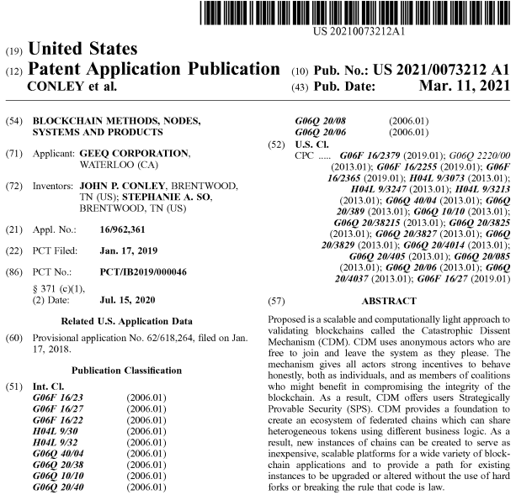
Description

CROSS-REFERENCE
This application claims, in respect of the United States, the domestic benefit of, and in respect of all other jurisdictions, priority to U.S. Provisional Application No. 62/618,264, filed Jan. 17, 2018, and entitled “Blockchain Methods, Nodes, Systems And Products”, the entire contents of which is incorporated herein by reference where permitted.

FIELD
The present disclosure relates to computers and computing including computer networks and distributed databases, and more particularly to blockchain methods, nodes, systems and products.

BACKGROUND
Traditional databases are maintained on private servers by central authorities who control access, grant permission to alter, update and delete records, and who are ultimately responsible for the accuracy of the data. Trusting such data is equivalent to trusting in both the honesty and the security competence of these central authorities.

Blockchains (or chains) are append-only, distributed ledgers. No central authority owns or controls the data. Users send requests to write new records to a set of decentralized, often anonymous, nodes who must come to a consensus on their validity. Nodes are computers on a network that participate in validating transactions and writing blocks of transactions to the chain. Depending on the blockchain and approach to validation, nodes are called miners, stakeholders, delegates, or voters, among other things. Humans (who we call agents) own these computers and make them available to the network. An agent may be the owner of several nodes, or may simply be a user who makes transactions on the blockchain but does not provide validation services.

Once a record is written to a block and committed to the chain, it becomes both immutable and no refutable. The cryptographic signatures and recursive hashing of blocks make it impossible to delete, alter, or claim that one never agreed to the contents of a record. If a blockchain is public and transactions are written in cleartext (as they are in Bitcoin), records in the chain can be independently verified by any user who wishes. If copies of the chain are stored in many places, it becomes almost impossible to censor or prevent access to the data it contains.

Blockchains allow agents to cooperate without the need to trust in the honesty or good behavior of one another or any third party. For example, Bitcoin's transaction protocol ensures that a sender has enough tokens in his account to cover a transfer and, once the transfer is made, the receiver can be secure in the knowledge that it cannot be reversed. Ethereum's smart contracts permit even more sophisticated interactions between users without the need for mutual trust. (It should be noted, however, that the Ethereum smart contracts have also led to a number of significant security issues. For example, on Jun. 17, 2016, a coding error in the smart contract supporting the DAO resulted in a theft of 3.4M ETH worth $53M. More recently (Nov. 6, 2017), a coding error in the Ethereum smart contract supporting Parity's multi-signature cryptocurrency wallets locked up accounts holding over 500 k ETH worth $150M.)

Unfortunately, the promise that blockchain holds to create decentralized and trustless ways to share information and improve distributed business processes is limited by several factors. Some approaches (Bitcoin and Ethereum, for example) have high transactions fees that are a consequence of their security models. Others (such as Hyperledger fabric, and Iota's tangle protocol) have lower transactions costs, but offer lower levels of security, have central points of failure, or depend on some degree of trust in the validators. The ability to scale to large numbers of transactions per second, fix bugs, and upgrade to better and more flexible protocols are also limited on existing blockchain platforms.

GeegChain™ offers a new approach to blockchain based on game theory and economic mechanism design. (GEEQ and the family of GEEQ marks, including GeeqChain, GeeqCoin, GeeqCoins, GeeqToken, GeeqTokens as well as Catastrophic Dissent Mechanism, CDM, Good Behaviour Bond, GBB, Good Behaviour Bonds, GBBs, Governing Smart Contract, GSC, Governing Smart Contracts, GSCs, Strategically Provable Security, SPS, Proof of Due Diligence, PoD, Proof of Honesty, PoH, Proof of Integrity, Pol, Society of Things, SoT and others are trade-marks of Geek Corporation. All rights are reserved and no license or other right of use is given. Though the subject matter herein disclosed is with reference to certain trademarks for convenience, no limitation to the teachings herein is expressed or implied such as any requirement to use of any of the trademarks to infringe any claim). GeeqChain is secure, cheap, fast, and scalable. It can be implemented with fully anonymous verifying nodes, no centralized points of trust or failure, and with any level of encryption and privacy protection desired. The protocol allows the creation of an ecosystem of federated chains that can safely share GeegCoins™, but which can support very different types of internal business logic. This makes GeeqChain suitable for a wide variety of use cases, allows for upgrades and bug fixes without breaking protocol or instituting hard forks, and offers an alternative to Ethereum's ERC20 standard for startups wishing to create new platforms in order to take advantage of blockchain's potential.
SUMMARY
GeeqChain is a scalable, inexpensive, computationally light, approach to validating blockchains using a new protocol called the Catastrophic Dissent Mechanism (CDM). The CDM uses anonymous actors who are free to join and leave the system as they please. The mechanism gives all actors strong incentives to behave honestly, both as individuals, and as members of coalitions who might benefit from compromising the integrity of the blockchain. If there is at least one honest node, it will write an honest block to a valid chain. Users are able to discover honest chains and will always choose it for their transactions. Dishonest chains become orphaned. In other words, GeeqChains protect the integrity of blocks and transactions using Proof of Honesty rather than Proof of Work or Proof of State. If even one node is honest, no tokens can be stolen from rational users. As a result, GeeqChain is 99% Byzantine Fault Tolerant (BFT) and achieves consensus by checking for lack of dissent rather than affirmatively trying to establish unanimity.

We further develop a communications protocol and a system of self-enforcing audits that imply that honest behavior on the part of all nodes is the only coalition-proof equilibrium of the validation mechanism. That is, even if nodes are free to communicate, collude, and conspire to act in unison, any self-interested coalition will find that honest behavior gives its members the highest possible payoff. As a result, the CDM creates a blockchain with Strategically Provable Security.

The CDM is a flexible protocol which allows new instances of GeeqChains to be created and then specialized in a number of ways. In particular, it is easy to construct federated instances of GeeqChains such that tokens can move across them all. This brings three key advantages to GeeqChain First, it is possible to split a GeeqChain into two or more federated instances and partition the user accounts among them. As a result, GeeqChain is infinitely scalable. If the transactions load becomes too large for one chain to handle, new federated instances can be created until each handles an efficient number of transactions per second. Federated instances can also be merged if transactions volume drops off. Second, new instances of federated chains that use protocols that are different from the basic CDM outlined here, or which contain upgrades or bug fixes, can be created. Users and validators can choose to remain on the original chain or migrate to the new one. As a result, improvements, alterations, and fixes can be implemented without breaking protocol or creating hard forks. In addition, this does not require a complicated governance structure to implement. Anyone can offer an alternative federated chain, and users and validators can vote with their feet if they agree it would be better to use the new chain than continue to use the original one. Finally, federated instances of GeeqChain can also work with tokens besides GeeqCoin, using many different types of business logic. As a result, GeeqChain offers a flexible alternative to Ethereum's ERC20 standard to build new blockchain platforms.

Perhaps the most important aspect of GeeqChain is that it offers this level of security and flexibility at extremely low cost. It is not burdened by large networks doing proof of work or stake-holders that need to be compensated for posting large bonds. Validating networks of arbitrary size can be used, but each node can still be run on a standard home computer using existing broadband connections. The cost of validating transactions on a 100 node network is less than 0.06¢ and scales up linearly with the number of nodes. This creates large potential for revenue in every application or, alternatively, opportunities to provide services on a large scale for much lower costs.
In conclusion, the GeeqChain platform using the CDM protocol solves the most significant outstanding problems facing Blockchain today. GeeqChain can scale to handle arbitrary numbers of transactions per second. GeeqChain can be deployed as a system of federated chains that share a common token or which interact with heterogeneous tokens using different business logic. GeeqChains can be upgraded or altered without the use of hard forks or breaking the rule that code is law. GeeqChain can be implemented with enough anonymity and decentralization to protect user privacy and satisfy most cryptoanarchists, or to comply with KYC, AML and other regulatory requirements. Finally, GeeqChain offers an unprecedented level of transaction verification security at a lower cost than any existing platform.

Unless otherwise expressed herein explicitly, the various subject matter taught herein is independent and may be practiced alone or in various combinations with each other, with minor apparent modifications as may be necessary. For example, aspects of the CDM protocol may be practiced with other network topologies other than a hub and spoke topology. While a random hub and spoke, topology is described to randomly share the burden of a hub and to provide security advantages, a non-random hub and spoke topology may be adopted. Various fee models may be adopted.

BRIEF DESCRIPTION OF SEVERAL DRAWINGS
FIG. 1 is an illustration of a network topology including a plurality of nodes in accordance with an example.
FIG. 2 is an illustration of a network topology including a plurality of nodes and three layers of hubs in accordance with an example.

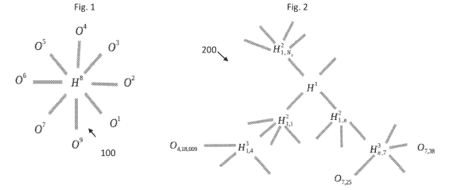

FIGS. 3A and 3B are an illustration of the major components of a Node Transactions Bundle (NTB) and a Hub Transactions Bundle (HTB) in accordance with an example.

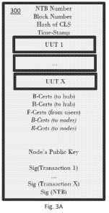 | 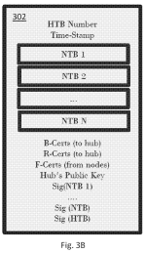

FIG. 5 is an illustration of the major components of a header created by a Block Commitment Smart Contract (BCSC) in accordance with an example.
FIG. 6 is an illustration of the major components of a certificate in accordance with an example.
FIG. 7 is an illustration of the major components of a Network Communication Smart Contract (NCSC) signature in accordance with an example.

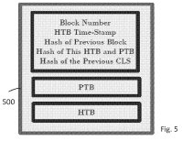 | 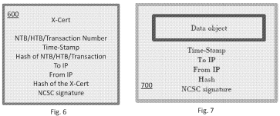
FIG. 8 is an illustration of the major components of a Token Account Record (TAR) in accordance with an example.
FIG. 9 is an illustration of the major components of an Active Node Record (ANR) in accordance with an example.
FIG. 10 is an illustration of the major components of a Smart Contract Record (SCR) in accordance with an example.
FIG. 12 is an illustration of the major components of a Simple Unverified User Transaction (UUT) in accordance with an example.
FIG. 15 is an illustration of the major components of a Data UUT in accordance with an example.

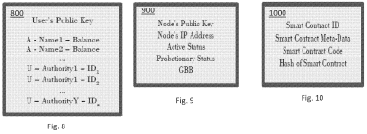  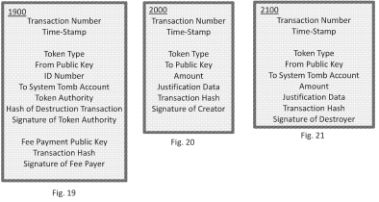 | 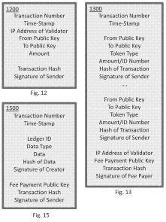

FIG. 19 is an illustration of the major components of a Unique Token Destruction UUT in accordance with an example.
FIG. 20 is an illustration of the major components of an Accounting Token Creation UUT in accordance with an example.
FIG. 21 is an illustration of the major components of an Accounting Token Destruction UUT in accordance with an example.
FIG. 22 is an illustration of the major components of an Outgoing Token Transfer UUT in accordance with an example.
FIG. 23 is an illustration of the major components of an Incoming Token Transfer UUT in accordance with an example.

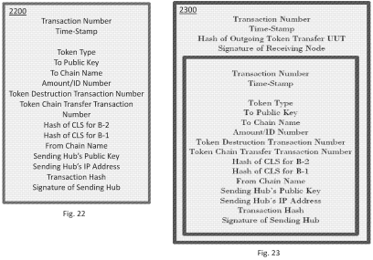 | 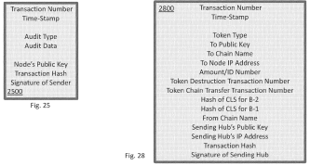

FIG. 24 is an illustration of the major components of an Active Node List UUT in accordance with an example.
FIG. 25 is an illustration of the major components of an Active UUT in accordance with an example.
FIG. 26 is an illustration of the major components of an Initial Token Generation Verified User Transaction (VUT) in accordance with an example.
FIG. 27 is an illustration of the major components of a Simple VUT in accordance with an example.
FIG. 28 is an illustration of the major components of an Outgoing Token Transfer VUT in accordance with an example.

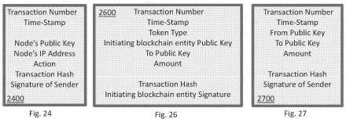

FIG. 32 is an illustration of the major components of a Good Behavior Bond (GBB) Distribution VUT in accordance with an example.
FIG. 33 is an illustration of the major components of an Audit VUT in accordance with an example.
FIG. 34 is an illustration of the major components of an Audit Reward VUT in accordance with an example.

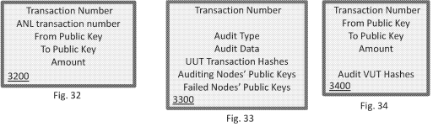

FIG. 35 is an illustration of the major components of a Committed Block Header (CBH) in accordance with an example.
FIG. 36 is an illustration of the major components of an Active Node List (ANL) in accordance with an example.
FIG. 37 is an illustration of the major components of a NTB with NCSC signature wrappers in accordance with an example.

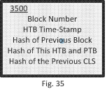  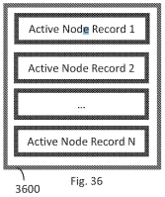 | 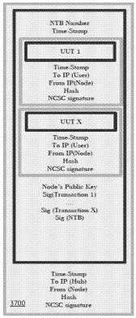

FIG. 38 is an illustration of the major components of a Full Verified Block (FVB) in accordance with an example.
FIG. 39 is an illustration of the major components of a Genesis Block (GBL) in accordance with an example.
FIG. 40 is an illustration of the major components of a Current Ledger State (CLS) in accordance with an example.

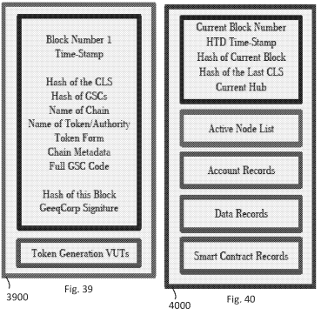

FIGS. 41-44 are flowcharts showing example operations.
FIG. 45 is a block diagram of a computing device.

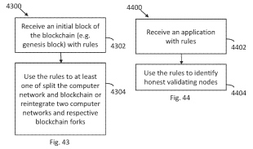 | 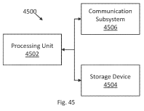

Analogue 3
TARGETED RESOURCE TOKEN GENERATION AND DEPLOYMENT

PATENT NO. US20180232762A1

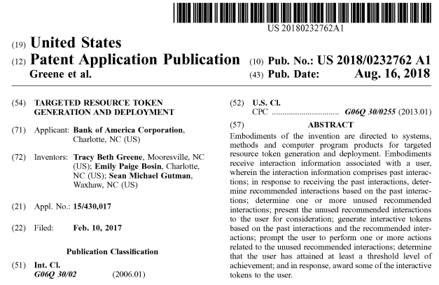

Description
BACKGROUND
When an entity sends a targeted purchase offer to a potential customer, there is a greater likelihood that the potential customer actually takes advantage of the purchase offer. By sending purchase offers to potential customers who will likely use the purchase offers and excluding those who will likely not use the purchase offers, an entity can save millions of dollars in sending out purchase offers to those who will likely not use the purchase offers. Therefore, there is a need for a system to produce targeted purchase offers.

BRIEF SUMMARY
The following presents a simplified summary of one or more embodiments of the invention to provide a basic understanding of such embodiments. This summary is not an extensive overview of all contemplated embodiments and is intended to neither identify key or critical elements of all embodiments, nor delineate the scope of any or all embodiments. Its sole purpose is to present some concepts of one or more embodiments in a simplified form as a prelude to the more detailed description that is presented later.

Embodiments of the present invention address these and/or other needs by providing an innovative system, method, and computer program product for interaction manipulation and implementation for resource storage, the system comprising: at least one memory device with computer-readable program code stored thereon; at least one communication device connected to a network; at least one processing device operatively coupled to the at least one memory device and the at least one communication device, wherein the processing device is configured to execute the computer-readable program code to: receive interaction information associated with a user, wherein the interaction information comprises past interactions; in response to receiving the past interactions, determine recommended interactions based on the past interactions; determine one or more unused recommended interactions; present the unused recommended interactions to the user for consideration; generate interactive tokens based on the past interactions and the recommended interactions; prompt the user to perform one or more actions related to the unused recommended interactions; determine that the user has attained at least a threshold level of achievement; and, in response, award some of the interactive tokens to the user.

BRIEF DESCRIPTION OF THE SEVERAL DRAWINGS
FIG. 1 is a flowchart illustrating a general process flow for implementing rule-based offer association, in accordance with embodiments of the present invention.
FIG. 2 is a flowchart illustrating a general process flow for queuing input information for performing rule-based offer association, in accordance with embodiments of the present invention.
FIG. 3 is a flowchart illustrating a general process flow for implementing an intelligent offer tool, in accordance with embodiments of the present invention.

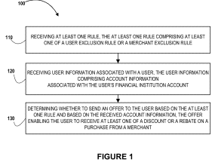 | 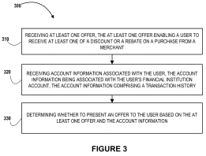

FIG. 4 is a block diagram illustrating technical components of a system for implementing the various processes described herein, in accordance with embodiments of the present invention.
FIG. 6 is a flowchart illustrating a general process flow for applying offers to purchase transactions at settlement, in accordance with embodiments of the present invention.
FIG. 7 is another flowchart illustrating a general process flow for enabling a user to determine whether a transaction qualifies for an offer, in accordance with embodiments of the present invention.
FIG. 8 is another flowchart illustrating a general process flow for responding to user transactions, in accordance with embodiments of the present invention.

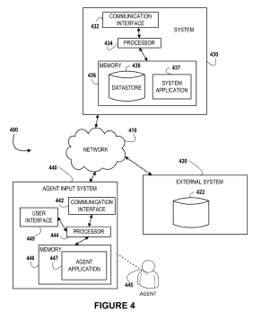 | 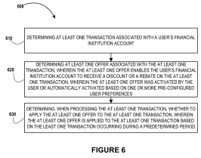  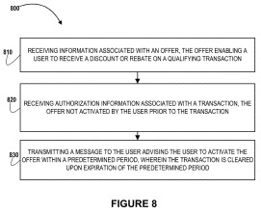

FIG. 9 is another flowchart illustrating a general process flow for initiating presentation of a rebate associated with a transaction, in accordance with embodiments of the present invention.
FIG. 10 is an exemplary user interface presenting a rebate associated with a transaction, in accordance with embodiments of the present invention.
FIG. 11 is a diagram of an environment for targeted resource generation and deployment are enabled according to embodiments of the invention.
FIG. 12 is a flowchart illustrating a process for targeted resource generation and deployment according to embodiments of the invention.

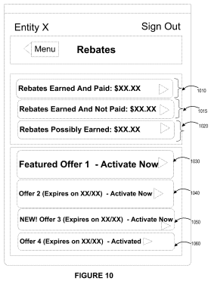 | 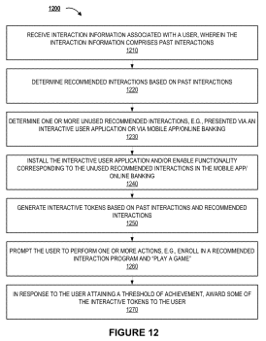

FIGS. 13A-13E are screenshots of mobile device interfaces for targeted resource generation and deployment according to embodiments of the invention.

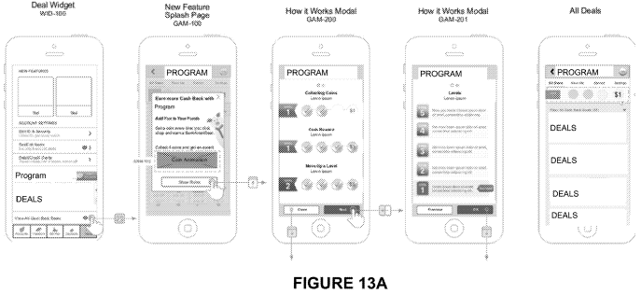
CLAIMS (20)
What is claimed is:
1. A system for targeted resource token generation and deployment, the system comprising:
at least one memory device with computer-readable program code stored thereon;
at least one communication device connected to a network;
at least one processing device operatively coupled to the at least one memory device and the at least one communication device, wherein the processing device is configured to execute the computer-readable program code to:
receive interaction information associated with a user, wherein the interaction information comprises past interactions;
in response to receiving the past interactions, determine recommended interactions based on the past interactions;
determine one or more unused recommended interactions;
present the unused recommended interactions to the user for consideration;
generate interactive tokens based on the past interactions and the recommended interactions;
prompt the user to perform one or more actions related to the unused recommended interactions;
determine that the user has attained at least a threshold level of achievement; and
in response, award some of the interactive tokens to the user.

2. The system of claim 1, wherein the processing device is further configured to execute the computer-readable program code to modify future user interactions including enrolling the user in at least one recommended interaction.

3. The system of claim 2, wherein the processing device is further configured to execute the computer-readable program code to:
generate and present a request for a confirmation the user wishes to enroll in the at least one recommended interaction;
receive the confirmation of the user's desire to enroll in the at least one recommended interaction from the user; and
based on receiving the confirmation, implement the enrollment.

4. The system of claim 1, wherein the processing device is further configured to execute the computer-readable program code to:
receive a user's instruction to redeem one or more deals; and
in response, award some of the interactive tokens to the user.
5. The system of claim 1, wherein the processing device is further configured to execute the computer-readable program code to:
present one or more programs to the user;
receive the user's input regarding the one or more programs; and
enable functionality corresponding to the unused recommended interactions for the user.

6. The system of claim 1, wherein performing the one or more actions comprises:
enrolling in one or more programs available to the user.

7. The system of claim 6, wherein the processing device is further configured to execute the computer-readable program code to:
determine a number of tokens awarded to the user exceeds a predetermined threshold; and
in response, determine that the user has unlocked an interactive game.

8. A computer program product for targeted resource token generation and deployment, the computer program product comprising at least one non-transitory computer readable medium having computer-readable program code portions embodied therein, the computer-readable program code portions comprising:
an executable portion configured for receiving interaction information associated with a user, wherein the interaction information comprises past interactions;
an executable portion configured for, in response to receiving the past interactions, determine recommended interactions based on the past interactions;
an executable portion configured for determining one or more unused recommended interactions;
an executable portion configured for presenting the unused recommended interactions to the user for consideration;
an executable portion configured for generating interactive tokens based on the past interactions and the recommended interactions;
an executable portion configured for prompting the user to perform one or more actions related to the unused recommended interactions;
an executable portion configured for determining that the user has attained at least a threshold level of achievement; and
an executable portion configured for, in response, awarding some of the interactive tokens to the user.

9. The computer program product of claim 8, wherein the computer-readable program code portions further comprise:
an executable portion configured for modifying future user interactions including enrolling the user in at least one recommended interaction.

10. The computer program product of claim 9, wherein the computer-readable program code portions further comprise:
an executable portion configured for generating and present a request for a confirmation the user wishes to enroll in the at least one recommended interaction;
an executable portion configured for receiving the confirmation of the user's desire to enroll in the at least one recommended interaction from the user; and
an executable portion configured for, based on receiving the confirmation, implementing the enrollment.

11. The computer program product of claim 8, wherein the computer-readable program code portions further comprise:
an executable portion configured for receiving a user's instruction to redeem one or more deals; and
an executable portion configured for, in response, awarding some of the interactive tokens to the user.

12. The computer program product of claim 8, wherein the computer-readable program code portions further comprise:
an executable portion configured for presenting one or more programs to the user;
an executable portion configured for receiving the user's input regarding the one or more programs; and
an executable portion configured for enabling functionality corresponding to the unused recommended interactions for the user.

13. The computer program product of claim 8, wherein the computer-readable program code portions further comprise:
an executable portion configured for enrolling in one or more programs available to the user.

14. The computer program product of claim 9, wherein the computer-readable program code portions further comprise:
an executable portion configured for determining a number of tokens awarded to the user exceeds a predetermined threshold; and
an executable portion configured for, in response, determine that the user has unlocked an interactive game.

15. A computer-implemented method for targeted resource token generation and deployment, the method comprising:
receiving interaction information associated with a user, wherein the interaction information comprises past interactions;
in response to receiving the past interactions, determining recommended interactions based on the past interactions;
determining one or more unused recommended interactions;
presenting the unused recommended interactions to the user for consideration;
generating interactive tokens based on the past interactions and the recommended interactions;
prompting the user to perform one or more actions related to the unused recommended interactions;
determining that the user has attained at least a threshold level of achievement; and
in response, awarding some of the interactive tokens to the user.

16. The method of claim 15, further comprising:
modifying future user interactions including enrolling the user in at least one recommended interaction.

17. The method of claim 16, further comprising:
generating and present a request for a confirmation the user wishes to enroll in the at least one recommended interaction;
receiving the confirmation of the user's desire to enroll in the at least one recommended interaction from the user; and
based on receiving the confirmation, implementing the enrollment.

18. The method of claim 15, further comprising:
receiving a user's instruction to redeem one or more deals; and
in response, awarding some of the interactive tokens to the user.

19. The method of claim 15, further comprising:
presenting one or more programs to the user;
receiving the user's input regarding the one or more programs; and
enabling functionality corresponding to the unused recommended interactions for the user.

20. The method of claim 15, wherein performing the one or more actions comprises:
enrolling in one or more programs available to the user.

IV. RELEVANCE AND SUMMARY OF WORK

Governance Token (later - own blockchain with Eco coin)

In the Work of Science OONE.World Concept of Tokenomics, Blockchain, and Smart Contracts, the game tokens work according to the green concept, helping to save the environment and make the world better. All ecosystem projects will be tied to the game tokens, and our team strives to save the planet's ecosystem by providing the community members with money. The game tokens price maintenance and price pump lever is deflation by burning.

The Governance Tokens in the Work of Science OONE.World Concept of Tokenomics, Blockchain, and Smart Contracts, will have a general supply of 1kkk.

Purchase methods for the Governance Tokens in the Work of Science OONE.World Concept of Tokenomics, Blockchain, and Smart Contracts are as follows:

- On the exchange;
- Game token staking;
- On token sale;
- Participation in project activities;
- Staking tokens at %;
- Through airdrops.

Application

The Governance Tokens in the Work of Science OONE.World Concept of Tokenomics, Blockchain, and Smart Contracts are applied for the following:
- Payment for subscriptions after appearing on CEX;
- Coverage of commissions in the ECO chain network;
- In the future, payment for goods and services in the applications of the ECO network;
- Staking at %;
- In the future, token stackers will be able to take part in DAO voting on further development of the ECOsystem and its projects;
- benefits for holders (% for mine, subscription discounts, etc.);
- Airdrop token holders of new Ecosystem projects (*new products of the company - a project for passenger cars and the more).

Burning

The supply of the Governance Tokens in the Work of Science OONE.World Concept of Tokenomics, Blockchain, and Smart Contracts is reduced in proportion to the reduction in emissions due to fuel the economy.

V. LEGAL BASIS

Examination of the current Work of Science – ‘OONE.World’ Concept of Tokenomics, Blockchain, and Smart Contracts was held by the Intellectual Property Expert Dr. Sandjar Muminov based on following international (WIPO) and the normative legal acts of the United Kingdom and United Arab Emirates:

1. Berne Convention for the Protection of Literary and Artistic Works of 9 September 1886 in Paris, complemented by 4 May 1896, revised in Berlin on 13 November 1908. Supplemented in Bern on March 20, 1914, and revised in Rome on June 2, 1928, in Brussels on June 26, 1948, in Stockholm on July 14, 1967, and in Paris on 24 July 1971, as amended September 28, 1979 (the UAE acceded to the Berne Convention in 2004)

2. The Federal Law Number 38 of 2021 of the United Arab Emirates “On Copyright and Neighboring Rights”.

3. The Federal Law Number 7 of 2008 of the United Arab Emirates on “The National Centre for Documentation and Research”.

4. The Federal Law Number 5 of 2012 (as amended) of the United Arab Emirates “On Combating Cybercrimes”.

5. The Federal Law Number 8 of 1984 of the United Arab Emirates "Concerning Commercial Companies”.

6. The Federal Law Number 3 of 1983 of the United Arab Emirates “On the Federal Judiciary Authority”.

7. The Federal Law Number 31 of 2006 of the United Arab Emirates “Pertaining to the Industrial Regulation and Protection of Patents, Industrial Drawings, and Designs”.

8. The Federal Law Number 18 of the United Arab Emirates “Concerning Commercial Transactions Law”.

9. The Ministerial Order № 133 of 2004 “On copyright collective”.

10. The Ministerial Resolution No. 411 of 1993 “On control over the intellectual works protected under UAE Federal Law no. 40 of 1992 “On copyrights and author’s rights”.
11. United Kingdom Copyright, Designs and Patents Act (1988)

12. United Kingdom Copyright, Designs and Patents Act (1988) Part I 'Copyright' Chapter I, Article 1. and Article 143

13. United Kingdom Arbitration Act 1996 (Chapter 23, updated up to January 27, 2021)

14. United Kingdom Competition Act 1998 (Chapter 41, updated up to March 26, 2021)

VI. SOURCES OF REFERENCES

1. PATENT NO. US10922652B2 – Blockchain-based Program Review System, Method, Computing Device and Storage Medium

2. PATENT NO. US20210073212A1 – Blockchain Methods, Nodes, Systems, and Products

3. PATENT NO. US20180232762A1 – Targeted Resource Token Generation and Deployment

4. WIKIPEDIA - www.wikipedia.org - a multilingual, web-based, free-content encyclopedia project supported by the Wikimedia Foundation and based on a model of openly editable content.

VII. INFORMATION ABOUT THE EXPERT

Dr. Sandjar Muminov has 25 years’ experience in the intellectual property industry. His professional merits and achievements include:
- Eurasian Commissioner on Law Supremacy and Intellectual Property of EECO (Eurasian Economic Cooperation Organization), Head Offices in Russia, China and UAE, regional offices in 50 countries (www.eurasianeconomic.org)
- President of SANDJAR GROUP Business Consortium (GCC, Dubai, UAE)
- Expert of Dubai Silicon Oasis Authority
- Speaker of the University of Dubai (UAE)
- Authorized Expert of INTEROCO Copyright Office (Germany)
- Member of International Intellectual Property Law Association (USA)
- and others.

Expert Specializations of Dr. Sandjar Muminov:
- Private advisor on all issues concerning IP legal protection (patent, commercial
& Copyright law)
- Startup and investments projects
- Commercialization & capitalization of intellectual property
- Protection of copyright, know-how, trade secrets, etc.
In 2018 and 2019, Dr. Sandjar Muminov was recognized as a World TOP-5 Intellectual Property Expert (International Intellectual Property Law Association, US-UK).


