International Online Copyright Office
INTEROCO
(European Union, Germany, Berlin)

WORK OF SCIENCE

VishuMoney Platform for Shopping and Reward Earning

INTEROCO Copyright Office – 2022

STRUCTURE OF DOCUMENT

I. ANNOTATION
II. BASIC DEFINITIONS
III. ANALYSIS OF CLOSEST ANALOGUES
IV. RELEVANCE AND SUMMARY OF WORK
V. LEGAL BASIS
VI. SOURCES OF REFERENCES
VII. INFORMATION ABOUT THE EXPERT

Works of science as intellectual property (copyright) object are stipulated in:

1 | Berne Convention for the Protection of Literary and Artistic Works (1971)  Article 2. Protected Works:  (1) (1) The expression “literary and artistic works” shall include every production in the literary, scientific and artistic domain, whatever may be the mode or form of its expression, such as books, pamphlets and other writings; lectures, addresses, sermons and other works of the same nature; dramatic or dramatic-musical works; choreographic works and entertainments in dumb show; musical compositions with or without words; cinematographic works to which are assimilated works expressed by a process analogous to cinematography; works of drawing, painting, architecture, sculpture, engraving and lithography; photographic works to which are assimilated works expressed by a process analogous to photography; works of applied art; illustrations, maps, plans, sketches and three-dimensional works relative to geography, topography, architecture or science.
2 | United Arab Emirates  Federal Law No. 38 of 2021 on Copyrights and Neighbouring Rights  Article 1. In applying the provisions of this law, the following words denote the definitions explained before each one of them, unless the context denotes otherwise: “The Work” - any created compilation, in the scope of letters, arts, sciences, whatsoever is its type, mode of expression, value or purpose.
3 | United Kingdom Copyright, Designs and Patents Act (1988)  Part I 'Copyright'. Chapter I, Article 1. Copyright and copyright works  (1) Copyright is a property right which subsists in accordance with this Part in the following descriptions of work: (a) original literary, dramatic, musical or artistic works; (b) sound recordings, films or broadcasts, and; (c) the typographical arrangement of published editions.  (2) In this Part "copyright work" means a work of any of those descriptions in which copyright subsists.  (3) Copyright does not subsist in a work unless the requirements of this Part with respect to qualification for copyright protection are met (see section 153 and the provisions referred thereto).  Article 143 (b) section 60  Abstracts of scientific or technical articles

According to above mentioned laws in the UK work of science, as an object of copyright, should:
- Be the result of creative activity.
- Exist in any objective form.

Considered a work of science – “VishuMoney Platform for Shopping and Reward Earning” meets to the definition of an object of copyright according to:

- Section 2 (Works under protection) of the Federal Law Number 38 of 2021 of the United Arab Emirates on "Copyright and Neighbouring Rights";
- Chapter I, Articles 1, 143 of United Kingdom Copyright, Designs and Patents Act (1988) Part I ‘Copyright’.

The result of creative activity, innovation, relevance, scope of work of science- “VishuMoney Platform for Shopping and Reward Earning” is listed in this publication and confirmed by a certificate of deposit of copyright works.

The study of objective form of current work of science through materials research and examination of the object on the criteria for copyright eligibility held:

Intellectual Property Expert,  Authorized Representative  of INTEROCO Copyright Office  (signature, stamp) | Dr. Sandjar Muminov

I. ANNOTATION

Globally, people encounter different problems with financial matters. A common man after a lot of hard work and efforts is unable to cater to all his needs. Others end up sacrificing dreams and focuses on making ends meet. With the rising inflation and unemployment, the avenue for formal income is no longer sufficient to earmark savings for future goals. Likewise, others have look for opportunities to earn an alternate or passive income with more than 90% ending up with debts rather than returns. So, as an escape, they spend a lot of time online trying to solve problems but rather just use technology to get over the shortcomings.

Thus, the establishment of VishuMoney. It was conceptualized upon realization that for anyone, money is the most crucial factor.

Thereby, VishuMoney has decided to assist everyone on two main needs. One that spends money and second that generates money. The first is obviously the shopping domain that ensures to reduce one’s bank balance and the second is earning money which enables consumers to raise one’s bank balance.

Thus, the birth of the work of science – “VishuMoney Platform for Shopping and Reward Earning”.

Moreover, VishuMoney’s vision is to be the first consumer platform, in Web3 for financial freedom. This is by using different types of income streams, by doing simple tasks like taking surveys, watching videos, listening to podcasts, playing games, people will be able to earn money.

Likewise, its mission is to uplift the average consumer to self sufficiency by providing avenues wherein they can harness the wealth, all while availing their essentials and aspirational needs.

Additionally, the work of science – “VishuMoney Platform for Shopping and Reward Earning” is a project by Prakyath Infotech IT Solutions. It was established with the prime aim of developing technology infrastructure to digitize and smoothen workflow of conventional large business entities. The company stands for innovation as a driving force, wherein they apply to overhaul businesses with out of the box solutions that fuel their growth and expansion in a colossal way.

II. BASIC DEFINITIONS

Work of Science | is an object of intellectual property, registered as copyright work according to the Berne Convention for the Protection of Literary and Artistic Works.
Financial independence/  Financial freedom | is the status of having enough income or wealth sufficient to pay one's living expenses for the rest of one's life without having to be employed or dependent on others.
Online shopping | is a form of electronic commerce which allows consumers to directly buy goods or services from a seller over the Internet using a web browser or a mobile app.
Online wallet | is a software or web service that allows users to store and control their online shopping information, such as logins, passwords, shipping address and credit card details. It also provides a method for consumers to purchase products from online retailers.
Online Shopping Rewards | Online shopping rewards are a type of loyalty program to e-commerce shoppers.  The advent of online shopping has resulted in the rapid development of many rewards programs that offer incentives for shopping. These programs may be points-based (redeemable for products or vouchers), cashback, airline frequent flyer-miles-based, hotel points, donations to charity, or even carbon offsets.
Coupon | In marketing, a coupon is a ticket or document that can be redeemed for a financial discount or rebate when purchasing a product.
Online to Offline (O2O) | is a phrase that is used in digital marketing to describe systems enticing consumers within a digital environment to make purchases of goods or services from physical businesses.  Also referred as "Offline to Online", indicating the two-way flow between the online and the physical world, especially retail and ecommerce, but also between brand marketing and shopper or point-of-sale marketing efforts to influence purchase decisions.

III. ANALYSIS OF CLOSEST ANALOGUES

Analogue1

SYSTEMS AND METHODS TO ENABLE OFFER AND REWARDS MARKETING, AND CUSTOMER RELATIOSHIP MANAGEMENT (CRM) NETWORK PLATFORM

Patent No. US20200051117A1
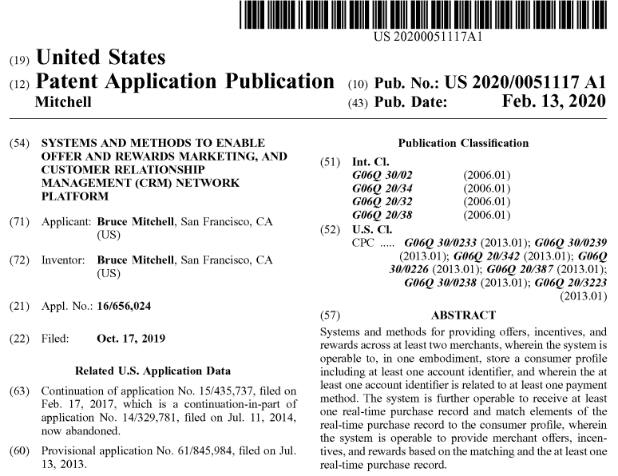
Description

CROSS REFERENCE TO RELATED APPLICATIONS
This application is related to and claims priority to and the benefit of one or more prior filed applications. This application is a continuation-in-part of U.S. application Ser. No. 15/435,737, filed Feb. 17, 2017, which is a continuation-in-part of U.S. application Ser. No. 14/329,781, filed Jul. 11, 2014, which claims the benefit of U.S. Provisional Application No. 61/845,984 filed Jul. 13, 2013, each of which is incorporated herein by reference in its entirety.

BACKGROUND OF THE INVENTION
1. Field of the Invention
The present invention relates to a cloud-based platform for enrolling accounts and administering one or more customer loyalty and rewards programs in electronic communications networks, and more particularly, systems and methods for providing and operating a customer loyalty and rewards platform including consumer or customer network-based and merchant-based registration and the management thereof.

2. Description of the Prior Art
Generally, prior art is known to provide digital loyalty and rewards system and methods. By way of example, relevant prior art includes the following U.S. patents and Publications:

U.S. Publication 2013/0073361 for “Methods and systems for offering targeted deals to customers and real-time automatic redemption thereof” filed on Sep. 20, 2012, describes wherein a customer can select from coupons to them, such as offers made to the customer (which may need to be purchased), vouchers purchased by the customer, and the like. A redemption choice is received from the cardholder indicating one or more coupons to ‘load’ onto the cardholder's card product. Information about offers, coupons, vouchers, etc., loaded onto a cardholder's card product can be stored in an offer deployment system. When the cardholder uses the card product to purchase a good or service, a transaction approval request is generated from at least one of a merchant, an acquirer, an association, a bank, and an issuer. The transaction approval request is processed wherein the step of processing comprises at least one of querying the offer deployment system which determines whether an offer loaded onto the cardholder's card product can be applied to the purchase. If so, the value of the offer is applied to the transaction. Preferably, offer value is applied to the amount of the transaction approval request before the request is received by the ultimate financial institution or card transaction processing system responsible for approving the transaction such that the amount of the transaction which must be approved is the purchase price of the good or service less the applied value of the offer. A receipt can be issued to the cardholder wherein the receipt indicates the purchase and use of the coupon.

U.S. Publication 2012/0191525 for “Systems and Methods to Facilitate Loyalty Reward Transactions” filed Jan. 23, 2012, describes wherein Reward communications can be processed as transactions over the communications system in a way similar to credit/debit transactions. The enhanced communications system allows simpler and/or more efficient implementation of complex loyalty programs, and provides new options for creating new loyalty programs. In one embodiment, a transaction handler for the processing of transactions on financial accounts, such as credit accounts, debit accounts, prepaid accounts, bank accounts, stored value accounts and the like, is configured to support transactions for crediting rewards to a reward account and/or transactions for redeeming rewards from a reward account.

U.S. Pat. No. 6,327,573 for “Multiple party reward system utilizing single account” filed Dec. 31, 1998, describes using one reward/loyalty card for multiple accounts and enabling a frequent shopper reward system capable of tracking performance data of a plurality of members or account holders linked to a single frequent shopper account. Additionally, the document discloses transacting with at least one of the present sub-account holders, calculating a reward level, allocating, to at least one of the present sub-account holders, at least a portion of the determined reward level, and updating the retrieved customer record.

U.S. Pat. No. 8,429,009 for “Universal Affinity System” filed Jul. 16, 2008, describes tracking loyalty/reward programs through the use of a third-party card or other medium. The system enables: a merchant to determine incentives, such as discounts, advertisements, or other offers, for a given customer or set of customers; uploaded these incentives to respective customer “personal account lockers”; and universal ID is encoded as a bar code, the bar code may be provided to a corresponding customer on a variety of different media, such as on an adhesive label that the customer may apply to another device or item, printed on a credit or debit card, printed on a key-chain card, or printed on any other device or item that a customer may be likely to carry with him or her.

U.S. Publication 2013/0054454 for “Wallet Service Enrollment Platform Apparatuses, Methods and Systems” filed Sep. 21, 2012, describes wherein a user may input username and password credentials into the wallet widget (e.g., 210) to get authenticated. The user may have control (e.g., create, view, manage, cancel, etc.) over the individual relationships and may configure permissions for each service they connect to. In one embodiment, the WSEP may allow approved services, issuers and merchants permissions to obtain various information relating to the user and wallet such as consumer profile 225, billing agreement 230, redemption 235, loyalty and rewards 240, coupons/offers 245, wish lists and stored items 250, merchant applications/widgets 255, Value Added Resellers (VAR)/Software-as-a-service (SaaS) commerce wallet plug-ins 260, analytics 265, account or points balance information 270, payments 275, and/or the like. In one implementation for example, the WSEP may manage which services can connect to the wallet. In a further implementation, the WSEP may pass along information from an approved and connected service such as a loyalty program (e.g., STAR WOODS POINTS program) to a merchant such that the merchant may provide the customer a special deal, offer or an opportunity to use or exchange points/currency when transacting. In one implementation, approved commerce services, issuers and merchants may be able to push information relating to any of the above to the wallet.

None of the prior art documents referenced herein or any known prior art provides the solutions to the longstanding unmet needs that are satisfied by the systems and methods of the loyalty platform of the present invention.

SUMMARY OF THE INVENTION
The present invention relates to systems and methods for providing and operating a customer loyalty and rewards platform including network-based and merchant-based registration and management, including mobile and electronic messaging, remote and local customer user registration options, enrollment, and credit, debit, and other electronic payment card account association with the customer loyalty and rewards platform.

The present invention further provides credit, debit, electronic payment, and/or card account enrollment automatically, as well as the functions of adding promotional, financing and/or discount offer(s), and/or other offers to a profile, adding cards, credit, debit, and other electronic payment card accounts or electronic payment accounts, redeeming promotional or discount offers, real-time automated functionality, providing data for a marketplace of vendors and customers, including account and activity data, providing a coalition network model, and combinations thereof.

In one embodiment, the present invention includes a system for providing offers, incentives, and rewards for at least two merchants comprising: a web tier hosted on a cloud network, wherein the web tier is in network communication with one or more consumer applications, merchant applications, or administrative applications; a network services tier hosted on the cloud network and providing a backend set of services, the backend set of services operable for real-time communication with at least one financial services server, wherein the backend set of services is operable to redeem an offer for a consumer account, redeem an incentive for the consumer account, or credit a reward to the consumer account; wherein the remote server computer is operable to store consumer information and at least one loyalty program enrollment associated with the consumer account, and wherein the consumer information includes an account identifier related to at least one payment method; wherein the remote server computer is operable to manage merchant offers, incentives, and rewards across at least two merchants for the consumer account; wherein the web tier is operable to receive a real-time purchase record with at least one corresponding consumer account number and a purchase amount, wherein the real-time purchase record further includes indication of a merchant, at least one purchased product or service, a corresponding device ID, and/or corresponding consumer contact information; wherein the remote server computer is operable to identify a corresponding user account by matching the corresponding consumer account number with the account identifier and/or by matching the corresponding device ID and/or the corresponding consumer contact information with the stored consumer information; wherein the remote server computer is operable to provide the merchant offers, incentives, or rewards based on the merchant of the real-time purchase record and the stored consumer information associated with the identified corresponding user account; wherein the merchant offers, incentives, or rewards include at least one financing offer, incentive or reward; and wherein upon acceptance of the at least one financing offer, the network services tier is operable to reimburse at least some amount of the purchase amount and charge the at least one payment method based on terms of the financing offer.

In another embodiment, the present invention includes a system for providing offers, incentives, and rewards for at least two merchants comprising: a web tier hosted on a cloud network, wherein the web tier is in network communication with one or more consumer applications, merchant applications, or administrative applications; a network services tier hosted on the cloud network and providing a backend set of services, the backend set of services operable for real-time communication with at least one financial services server, wherein the backend set of services is operable to redeem an offer for a consumer account, redeem an incentive for the consumer account, or credit a reward to the consumer account; wherein the remote server computer is operable to store consumer information and at least one loyalty program enrollment associated with the consumer account, and wherein the consumer information includes an account identifier; wherein the remote server computer is operable to communicate at least one offer, incentive, or reward based on the stored consumer information associated with the identified corresponding user account; wherein the remote server computer is operable to manage offers, incentives, and rewards across at least two offers, incentives, or rewards programs for the consumer account; wherein the remote server computer is operable to receive an indication of activation of the at least one offer, incentive, or reward; wherein the web tier is operable to receive a real-time purchase record with at least one corresponding consumer account number and a purchase amount, wherein the real-time purchase record further includes indication of a merchant, at least one purchased product or service, a corresponding device ID, and/or corresponding consumer contact information; wherein the remote server computer is operable to identify a corresponding user account by matching the corresponding consumer account number with the account identifier and/or by matching the corresponding device ID and/or the corresponding consumer contact information with the stored consumer information; and wherein the remote server computer is operable to redeem the at least one offer, incentive, or reward for the consumer account.

In yet another embodiment, the present invention includes a method for providing offers, incentives, and rewards for at least two merchants comprising: storing consumer information and at least one loyalty program enrollment associated with the consumer account, and wherein the consumer information includes an account identifier; managing offers, incentives, and rewards across at least two offers, incentives, or rewards programs for the consumer account; communicating at least one offer, incentive, or reward based on the stored consumer information associated with the identified corresponding user account; receiving an indication of activation of the at least one offer, incentive, or reward; receiving a real-time purchase record with at least one corresponding consumer account number and a purchase amount, wherein the real-time purchase record further includes indication of a merchant, at least one purchased product or service, a corresponding device ID, and/or corresponding consumer contact information; identifying a corresponding user account by matching the corresponding consumer account number with the account identifier and/or by matching the corresponding device ID and/or the corresponding consumer contact information with the stored consumer information; and redeeming the at least one offer, incentive, or reward for the consumer account.

These and other aspects of the present invention will become apparent to those skilled in the art after a reading of the following description of the preferred embodiment when considered with the drawings, as they support the claimed invention.

BRIEF DESCRIPTION OF SOME OF THE DRAWINGS
FIG. 1 is a schematic diagram of a virtualized computing system for embodiments of the invention.
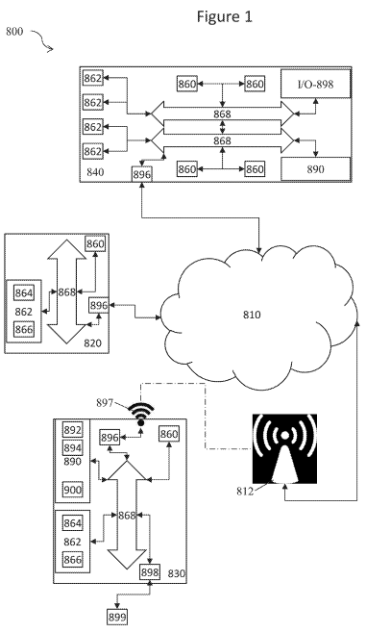
FIG. 2 illustrates a schematic diagram of one embodiment of the invention.
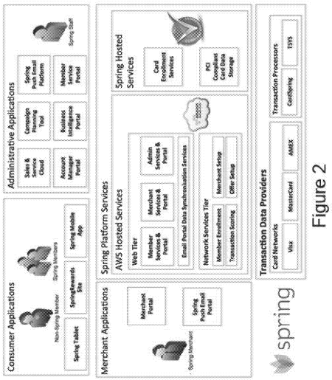

FIG. 3 illustrates a graphic user interface (GUI) diagram of an embodiment of the invention.
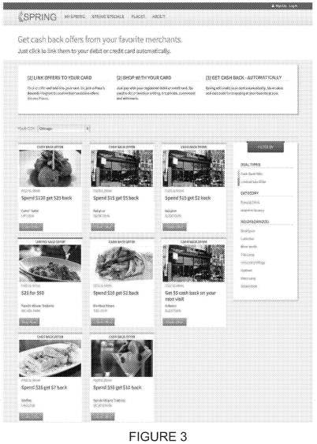
FIG. 4 illustrates another GUI diagram of an embodiment of the invention.
FIG. 5 illustrates another GUI diagram of an embodiment of the invention.
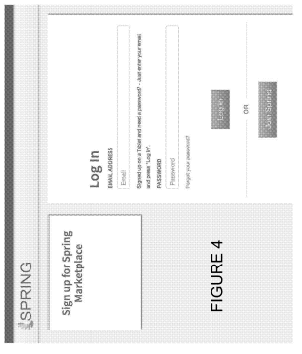 | 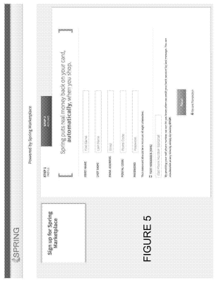

FIG. 6 illustrates another GUI diagram of an embodiment of the invention.
FIG. 7 illustrates another GUI diagram of an embodiment of the invention.
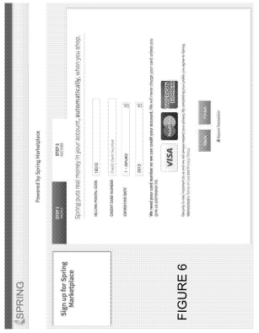 | 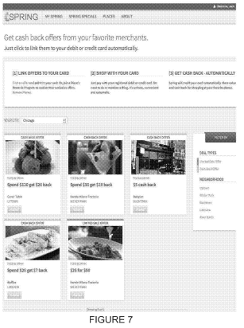
Claims (20)
The invention claimed is:
1. A system for providing offers, incentives, and rewards for at least two merchants comprising:
a web tier hosted on a cloud network, wherein the web tier is in network communication with one or more consumer applications, merchant applications, or administrative applications;
a network services tier hosted on the cloud network and providing a backend set of services, the backend set of services operable for real-time communication with at least one financial services server, wherein the backend set of services is operable to redeem an offer for a consumer account, redeem an incentive for the consumer account, or credit a reward to the consumer account;
wherein the remote server computer is operable to store consumer information and at least one loyalty program enrollment associated with the consumer account, and wherein the consumer information includes an account identifier related to at least one payment method;
wherein the remote server computer is operable to manage merchant offers, incentives, and rewards across at least two merchants for the consumer account;
wherein the web tier is operable to receive a real-time purchase record with at least one corresponding consumer account number and a purchase amount, wherein the real-time purchase record further includes indication of a merchant, at least one purchased product or service, a corresponding device ID, and/or corresponding consumer contact information;
wherein the remote server computer is operable to identify a corresponding user account by matching the corresponding consumer account number with the account identifier and/or by matching the corresponding device ID and/or the corresponding consumer contact information with the stored consumer information;
wherein the remote server computer is operable to provide the merchant offers, incentives, or rewards based on the merchant of the real-time purchase record and the stored consumer information associated with the identified corresponding user account;
wherein the merchant offers, incentives, or rewards include at least one financing offer, incentive or reward; and
wherein upon acceptance of the at least one financing offer, the network services tier is operable to reimburse at least some amount of the purchase amount and charge the at least one payment method based on terms of the financing offer.

2. The system of claim 1, wherein the financing offer is targeted based on the consumer information associated with the identified corresponding user account meeting pre-set criteria.

3. The system of claim 1, wherein the at least one device includes an application, wherein the application is operable to track and store location, browsing, and purchasing information for the at least one device;
wherein the application is further operable to construct a network activity record based on physical location, browsing, and purchasing information and transmit the network activity record to the remote server computer, the web tier, or the network service tier; and
wherein the remote server computer is further operable to update the consumer profile with the network activity record and provide the merchant offers, incentives, or rewards based on the network activity record.

4. The system of claim 1, wherein the web tier is operable to construct a network activity record and transmit the network activity record to the remote server computer, wherein the network activity record includes e-commerce webpage views, online purchases, online shopping cart additions, online searches, social media posts, and/or other social media interactions.

5. The system of claim 1, further including a tablet computer hosted at a physical commerce location, wherein the tablet computer is operable to receive the consumer information, including the account identifier related to at least one payment method, and transmit the consumer information to the remote server computer.
6. The system of claim 1, further comprising at least one wireless router, wherein the at least one wireless router is operable to construct a physical presence indicator for at least one device in network communication with the at least one wireless router and transmit the physical presence indicator to the remote server computer.

7. The system of claim 6, wherein the at least one wireless router is part of a network of routers, and wherein the routers of the network of routers are positioned throughout a physical commerce location.

8. The system of claim 1, wherein the network services tier is operable to reimburse and/or charge the at least one payment method in real time or near-real time.

9. The system of claim 1, wherein the account identifier related to the at least one payment method is a credit card number or debit card number.
10. A system for providing offers, incentives, and rewards for at least two merchants comprising:
a web tier hosted on a cloud network, wherein the web tier is in network communication with one or more consumer applications, merchant applications, or administrative applications;
a network services tier hosted on the cloud network and providing a backend set of services, the backend set of services operable for real-time communication with at least one financial services server, wherein the backend set of services is operable to redeem an offer for a consumer account, redeem an incentive for the consumer account, or credit a reward to the consumer account;
wherein the remote server computer is operable to store consumer information and at least one loyalty program enrollment associated with the consumer account, and wherein the consumer information includes an account identifier;
wherein the remote server computer is operable to communicate at least one offer, incentive, or reward based on the stored consumer information associated with the identified corresponding user account;
wherein the remote server computer is operable to manage offers, incentives, and rewards across at least two offers, incentives, or rewards programs for the consumer account;
wherein the remote server computer is operable to receive an indication of activation of the at least one offer, incentive, or reward;
wherein the web tier is operable to receive a real-time purchase record with at least one corresponding consumer account number and a purchase amount, wherein the real-time purchase record further includes indication of a merchant, at least one purchased product or service, a corresponding device ID, and/or corresponding consumer contact information;
wherein the remote server computer is operable to identify a corresponding user account by matching the corresponding consumer account number with the account identifier and/or by matching the corresponding device ID and/or the corresponding consumer contact information with the stored consumer information; and
wherein the remote server computer is operable to redeem the at least one offer, incentive, or reward for the consumer account.

11. The system of claim 10, wherein the at least one offer, incentive, or reward is targeted based on browsing history, physical location history, purchase history, and/or demographics of the consumer information associated with the consumer account.

12. The system of claim 10, wherein the network services tier is operable to debit or credit the at least one consumer account based on the at least one offer, incentive, or reward.

13. The system of claim 10, wherein the remote server computer is further operable to communicate, activate, and redeem offers, incentives, or rewards using an external rewards program or an external points program.

14. The system of claim 13, wherein the external rewards program or the external points program is associated with at least one payment method connected to the consumer account.
15. The system of claim 10, wherein the remote server computer is operable to attach at least one pre-purchased offer to the at least one account and redeem the at least one pre-purchased offer.

16. A method for providing offers, incentives, and rewards for at least two merchants comprising:
storing consumer information and at least one loyalty program enrollment associated with the consumer account, and wherein the consumer information includes an account identifier;
managing offers, incentives, and rewards across at least two offers, incentives, or rewards programs for the consumer account;
communicating at least one offer, incentive, or reward based on the stored consumer information associated with the identified corresponding user account;
receiving an indication of activation of the at least one offer, incentive, or reward;
receiving a real-time purchase record with at least one corresponding consumer account number and a purchase amount, wherein the real-time purchase record further includes indication of a merchant, at least one purchased product or service, a corresponding device ID, and/or corresponding consumer contact information;
identifying a corresponding user account by matching the corresponding consumer account number with the account identifier and/or by matching the corresponding device ID and/or the corresponding consumer contact information with the stored consumer information; and
redeeming the at least one offer, incentive, or reward for the consumer account.

17. The method of claim 16, further comprising a network services tier communicating with at least one financial services network and receiving the real-time purchase record via the financial services network.

18. The method of claim 17, further comprising reimbursing and/or charging at least one payment method in real time or near-real time.

19. The method of claim 16, further comprising charging and/or reimbursing at least one payment method using the account identifier, wherein the account identifier is a credit card number or debit card number.

20. The method of claim 16, wherein the communication of the at least one offer, incentive, or reward is targeted, and wherein the communication occurs before the corresponding user account has been identified or upon identification of the corresponding user account.

Analogue 2

SYSTEMS, METHODS AND PROCESSES TO IDENTIFY CROSS-BORDER TRANSACTIONS AND REWARD RELEVANT CARDHOLDERS WITH OFFERS

PATENT NO. US20150348083A1
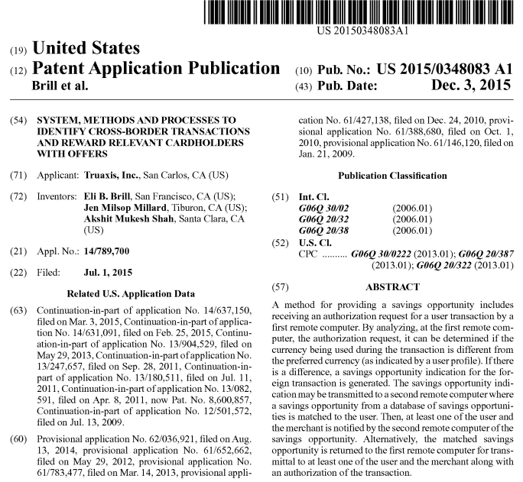

Description

CROSS-REFERENCE TO RELATED APPLICATIONS
This application is a continuation-in-part of, and claims the benefit of the filing date of U.S. patent application Ser. No. 14/637,150 (Docket No. BILL-0013-U01-N), filed on Mar. 3, 2015 and hereby incorporated by reference.

This application is a continuation-in-part of, and claims the benefit of the filing date of U.S. patent application Ser. No. 14/631,091 (Docket No. BILL-0010-U01-N), filed on Feb. 25, 2015 and hereby incorporated by reference, which claims the benefit of the following provisional application, which is hereby incorporated by reference in its entirety: U.S. Pat. Appl. 62/036,921, filed Aug. 13, 2014 (Docket No. BILL-0008-P01)

This application is also a continuation-in-part of, and claims the benefit of the filing date of U.S. patent application Ser. No. 13/904,529 (Docket No. BILL-0007-U01), filed on May 29, 2013 and hereby incorporated by reference, which claims the benefit of the following provisional applications, each of which is hereby incorporated by reference in its entirety:

U.S. Provisional Application No. 61/652,662, filed May 29, 2012 (Docket No. BILL-0006-P01); and U.S. Provisional Application No. 61/783,477, filed Mar. 14, 2013 (Docket No. BILL-0007-P01).

This application is also a continuation-in-part of, and claims the benefit of the filing date of U.S. patent application Ser. No. 13/247,657 (Docket No. BILL-0005-U01), filed on Sep. 28, 2011 and hereby incorporated by reference.

This application is also a continuation-in-part of, and claims the benefit of the filing date of U.S. patent application Ser. No. 13/180,511 (Docket No. BILL-0004-U01), filed on Jul. 11, 2011, which claims the benefit of the filing date of Provisional Application 61/427,138 (Docket No. BILL-0003-P01), filed on Dec. 24, 2010.

This application is also a continuation-in-part of, and claims the benefit of the filing date of U.S. patent application Ser. No. 13/082,591 (Docket No. BILL-0002-U01), filed on Apr. 8, 2011, which claims the benefit of the filing date of Provisional Appl. 61/388,680 (Docket No. BILL-0002-P01), filed on Oct. 1, 2010.

This application is also a continuation-in-part of, and claims the benefit of the filing date of U.S. patent application Ser. No. 12/501,572 (Docket No. BILL-0001-U01), filed on Jul. 13, 2009, which claims the benefit of the filing date of Provisional Appl. 61/146,120 (Docket No. BILL-0001-P01), filed on Jan. 21, 2009.

Each of the above applications is incorporated by reference in its entirety.

BACKGROUND
1. Field
The present disclosure is generally related to an in-statement rewards platform.

2. Description of the Related Art
While consumer comparison shopping for products is known, an unbiased way of comparison shopping for competing services is unavailable. Often a consumer may only be aware of some of the information related to a service provider's services, options, terms, conditions, costs, and the like. Also, the consumer may not be aware of how the service options change based on their particular usage characteristics. Thus, there remains a need for a consumer comparison shopping method that obtains actual or predicted service usage data from the consumer and service provider information in order to present the consumer with relevant alternative service offering options.

SUMMARY
In embodiments, methods and systems may help track consumer behavior and incentives. One embodiment is a method for tracking financial transactions. The method includes step of gathering transaction data from a plurality of user accounts by at least one computer, each user account a financial institution account at a financial institution and analyzing the transaction data for each user by the at least one computer for at least one criterion. The method also includes a step of providing a first savings opportunity to a first plurality of users whose transaction data meet the at least one criterion, the first savings opportunity provided in association with an online statement of the user's financial account, tracking a redemption of the savings opportunity by the first plurality of users whose transaction data met the at least one criterion, and tracking purchasing behavior for a period of time for the first plurality of users whose transaction data met the at least one criterion before and after the savings opportunity was provided.

In some of these embodiments, the transaction data comprises at least one of a merchant name, a merchant location, a transaction amount, a date of a transaction, a time of a transaction, a merchant category, a product category and a number of transactions. In some embodiments, there is a further step of tracking purchasing behavior of a second plurality of users whose transaction data met the at least one criterion, said second plurality of users not undertaking the savings opportunity. In some embodiments, there is a further step of tracking purchasing behavior of a second plurality of users whose transaction data met the at least one criterion, said second plurality of users provided with a second savings opportunity, said second savings opportunity different from said first savings opportunity. In some embodiments, there is a further step of gathering demographic data concerning each of the plurality of users, the demographic data including at least one of gender, age, ethnicity, an income level, an educational level, a shopping habit and a personal interest.

In embodiments, systems and methods may track the behavior of more than one group of consumers receiving different incentives. Another embodiment is a method for tracking financial transactions. The method includes steps of gathering transaction data from a plurality of user accounts by at least one computer, each user account a financial institution account at a financial institution, analyzing the transaction data for each user by the at least one computer for at least one criterion for a savings opportunity indication, and providing a first savings opportunity to a first plurality of users whose transaction data meet the at least one criterion. The method also includes steps of providing a second savings opportunity to a second plurality of users whose transaction data meet the at least one criterion, tracking a redemption of the savings opportunity by the first plurality of users and the second plurality of users, and tracking purchasing behavior of the first plurality of users and the second plurality of users for a period of time before and after the savings opportunity was provided.

In embodiments, methods and systems may comprise gathering transaction data from a user's financial account, analyzing the transaction data for a savings opportunity indication, matching a savings opportunity from a database of savings opportunities to the user based on the savings opportunity indication, and displaying the savings opportunity in association with a statement of a user's financial account. Further, a past response may be gathered to a savings opportunity indication and analyzing it, wherein the savings opportunity is based on both the analyzed transaction data and past response data. The statement may be an online statement, an online graphical user interface associated with the user's financial account, an online bill pay area, a dialog box associated with the user's financial account, an ATM receipt, a teller receipt, a mobile statement, a paper statement, and the like. The step of analyzing may comprise extracting at least one of a merchant name, a merchant category, a merchant location, a store number, a transaction amount, a transaction frequency, a zip code, a store category, a transaction description, and a total spending amount. The step of analyzing may comprise analyzing the transaction data for a savings opportunity indication relating to a merchant. The step of analyzing may comprise analyzing the transaction data for a savings opportunity indication relating to a market segment. The step of displaying the savings opportunity may comprise displaying the savings opportunity within a field of the statement where prior transaction data may be presented. The savings opportunity may be presented interweaved within the presented prior transaction data. The step of displaying the savings opportunity may comprise displaying the savings opportunity within a field of the statement not where prior transaction data may be presented. The user's financial account may be a credit card account, a bank account, a checking account, a savings account, a personal finance program account, a loan account, and the like. The step of analyzing may comprise anonymizing the transaction data.

In embodiments, methods and systems may comprise gathering transaction data from a user for a merchant from a user's financial account, where the user's financial account is a financial institution account that is maintained on behalf of the user; analyzing the transaction data to determine if an aspect of the transaction data meet a criteria set by the merchant; if the transaction data meet the criteria, matching a savings opportunity from the merchant to the user based on the analyzed transaction data; and enabling the user to redeem the savings opportunity during a subsequent transaction with the merchant. The criteria may comprise a total spending amount with the merchant, a number of transactions with the merchant, a number of transactions within a category, total spending during a period of time, a particular transaction, a particular set of transactions, a transaction at a particular merchant location, and the like. The financial account may be a bank account, a checking account, a savings account, a credit account, a personal finance program account, a loan account, and the like. Enabling may comprise automatic redemption upon presentation of a transaction card associated with the user's financial account. Enabling may comprise providing the user with a printed coupon, a bar code coupon presented on a mobile device, a credit on a merchant loyalty card, and the like. Analyzing may comprise anonymizing the financial transaction data. Analyzing may comprise extracting a merchant name, a merchant category, a merchant location, a transaction amount, a transaction frequency, a zip code, a store name, a store category, a store number, a transaction description, a purchase frequency, a total spending amount, and the like.

In embodiments, methods and systems may comprise embedding an executable script in a graphical user interface of a user's financial account, executing the executable script when the user accesses the user financial account, and using the executable script to: (1) gather transaction data from the user financial account and anonymize the transaction data before transmitting the anonymized transaction data to a server for analysis; and (2) transmit the transaction data to a third party application to be leveraged. The third party application may be a fraud detection application. The third party application may be a transaction analytics application. The third party application may be a marketing application. The third party application may be a social networking application. The executable script may be implemented in the JavaScript programming language.

In an aspect of the disclosure, a method for a conditional purchase may include receiving a conditional purchase offer for a good or service, wherein the conditional purchase offer specifies at least one of a desired discount and an offer price, comparing the conditional purchase offer with at least one of an inventory and a pricing information to determine if the conditional purchase offer is acceptable, if the conditional purchase offer is acceptable, optionally binding the customer to purchase the good or service, wherein binding comprises automatically charging a financial account of the user for the good or service, and if the conditional purchase offer is not acceptable, allowing the user to modify at least one of the discount and offer price.

A system and method for providing rewards through a user financial instrument includes gathering transaction data from a user's financial account, wherein the user's financial account is a financial institution account that is maintained on behalf of the user and analyzing the transaction data to determine a reward level. The savings opportunity from the merchant may be matched to the user based on the reward level. The user is enabled to redeem the savings opportunity during a subsequent transaction with the merchant. The system and method may further include allowing the merchant to set a criterion for determining the reward level. The criterion may relate to an amount spent with the merchant. The criterion may relate to a number of visits to the merchant. As the reward level improves, the matched savings opportunity may improve.

In an embodiment, a method for identifying group members may include identifying demographic characteristics of members of a group via market research, identifying purchasing behaviors of the members of the group via market research, correlating the identified demographic characteristics with the identified purchasing behaviors to identify merchants whom the members of the group tend to patronize, gathering transaction data from a financial account of a user at a financial institution for processing transactions between the user and a plurality of merchants and providers, clustering users using their transaction data with the identified merchants to from a plurality of clusters, analyzing the characteristics of each cluster and identifying at least one cluster that has the identified demographic characteristics, and presenting to the user in an online statement of the user's account a savings opportunity from a merchant seeking to contact members of the group when the characteristics suggest that the user belongs to the at least one cluster. The demographic characteristics of the members of the group may include at least one of gender; ethnicity; age or birthdate; family income; personal income; educational level; shopping preference; and a personal interest. The market research may include an organized effort to contact individual members of the group to gather information concerning at least one of: economic data; habits and practices of individual members of the group. Identifying merchants may include identifying sellers, retailers, manufacturers, establishments, on-line services for connecting buyers and sellers, on-line services using primarily mobile devices to connect buyers and sellers, and providers of goods and services patronized by members of the group. The identified merchants may include at least one of sellers, retailers, manufacturers, establishments, providers of goods and services, and completed transactions with selected merchants or providers. Analyzing may include analyzing transaction data for at least one of: an amount spent in a time period; an amount spent in a product or service category; one or more transactions with a particular merchant or provider of a good or a service; and an average amount spent per time periods over several time periods. The method may further include eliminating from the step of presenting, savings opportunities from merchants not patronized by the members of the group. The savings opportunity may be an invitation to an alternative provider of a good or a service previously purchased by the user and further comprising accepting a response from the user to the presentation of the savings opportunity by redirecting the user to information about the alternative provider. The method may further include identifying the purchasing behaviors of the members of the group from third party sources and verifying the purchasing behaviors of the members of the group via market research. The method may further include identifying merchants patronized by the members of the group from third party sources and verifying the purchasing behaviors of the members of the group via the analyzed transaction data.

In an aspect, a method of targeting users with an offer may include selecting at least one offer to present to a user by: applying at least one rule dictated by a merchant to a set of offers to be provided to a user, applying at least one rule dictated by a financial institution to the set of offers, and applying a filter to identify offers with the highest likelihood of being accepted by the user, and adjusting at least one of a minimum spending threshold, a discount amount, a duration of the campaign, and a category of the at least one offer prior to presentation to the user based on at least one characteristic of the user. The filter to identify offers with a highest likelihood of being accepted may be based on a predictive model of user purchase behavior developed using at least one of: data on one or more past user responses to one or more savings opportunities, public data relevant to the user, inferred data about the user, preferences selected from the group consisting of merchant category preferences, transaction category preferences, product category preferences, and merchant preferences, a geographic location, a seasonal variety, a spending level, and a change from an historic spending pattern. Adjusting the parameter may include calculating a spending trajectory based on a historic spending pattern and adjusting the at least one minimum spending threshold, discount amount, duration of the campaign, and category of offer and adjusting the parameter in accordance with the spending trajectory. Adjusting the parameter may be done in accordance with at least one segmentation criterion applied to the user. Adjusting may be completed in a time span selected from the group consisting of: less than about 10 sec, less than about 5 sec, less than about 1 second, or substantially instantaneously. Adjusting may be done in accordance with at least one input selected from the group consisting of: a spend trajectory, a user propensity model, user profile information or segmentation criteria, and a campaign goal. A rule may be applied to determine which of the inputs are used in adjusting. A weight may be applied to each of the selected inputs in adjusting.

In embodiments, the geographical location of the mobile device of the user is determined via a GPS system or a telecommunications network. The method may also include matching the geographical location of the mobile device of the user with a location of the merchant. The method may also include receiving a response to the matched savings opportunity from the user via a physical action of the user with the mobile device of the user. In embodiments, the method may also include filtering the savings opportunities in the database by one or more merchant-indicated conditions. The merchant-indicated condition may be at least one of a location of the merchant/payment, a type of merchant, an amount of the payment, a good or service purchased, a date of the transaction, and a time of the transaction. The method may also include receiving an indication from the user by at least one of the first and second remote computers for sharing the matched savings opportunity with at least one additional user, wherein sharing causes at least one of the first and second remote computers to generate a shared savings opportunity. In embodiments, the method includes detecting a geographical location of the at least one additional user. The geographical location of the at least one additional user is determined via a GPS system or a telecommunications network. In some embodiments, the shared savings opportunity indication depends on the geographical location of the mobile device of the user. The matched savings opportunity is at least one of printed on a receipt, displayed on a merchant user interface, and displayed on a mobile device user interface.

BRIEF DESCRIPTION OF SOME OF THE FIGURES
FIG. 1 depicts a block diagram of a consumer service comparison shopping system.
FIG. 2 depicts a flow diagram for comparing alternative service offerings.

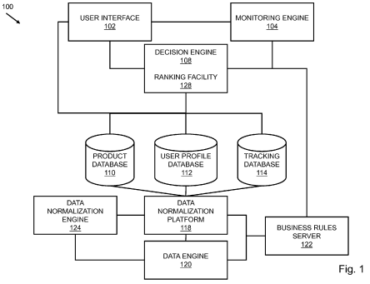 | 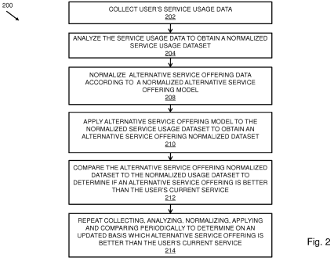

FIG. 3 depicts an alternative service offering model.
FIG. 4 depicts a flow diagram for comparing alternative credit card offerings.

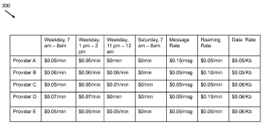 | 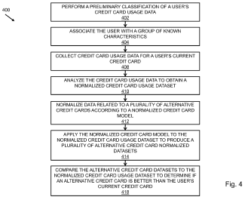
FIG. 5 depicts a flow diagram for comparing alternative credit card offerings according to a value of rewards.
FIG. 6 depicts a flow diagram for comparing insurance policies.

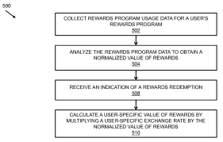 | 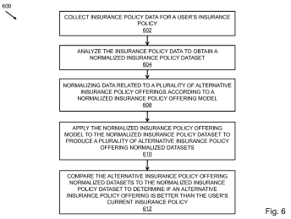

FIG. 7 depicts a flow diagram for comparing alternative service offerings and performing a billing error analysis.
FIG. 8 depicts a flow diagram for determining a personalized true cost of service offerings.
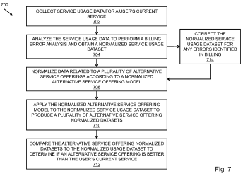 | 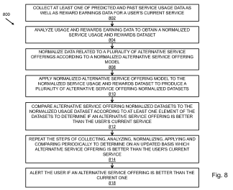
FIG. 9 depicts a flow diagram of a process for normalizing user data.
FIG. 10 depicts a flow diagram of a process for generating a normalized service usage model.
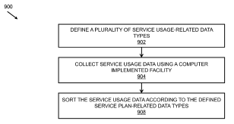 | 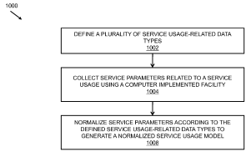

FIG. 11 depicts a flow diagram of a method for comparing alternative wireless service offerings.
FIG. 12 depicts a flow diagram of a method for comparing savings account offerings.

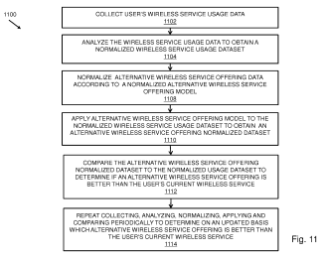 | 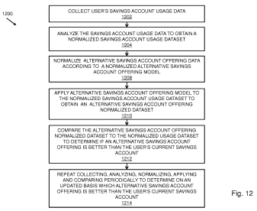
Claims (20)

What is claimed is:
1. A computer-implemented method for providing a savings opportunity, comprising:
receiving an authorization request from a merchant for a user transaction by a first remote computer;
accessing, at the first remote computer, a user profile including a preferred currency for transactions;
analyzing, at the first remote computer, the authorization request to determine if the currency being used is different than the preferred currency for a savings opportunity indication;
transmitting the savings opportunity indication to a second remote computer;
matching, at the second remote computer, a savings opportunity from a database of savings opportunities to the user based on the savings opportunity indication; and
notifying at least one of the user and the merchant, by the second remote computer, of the savings opportunity.

2. The method of claim 1, wherein the savings opportunity is for use during the current transaction.

3. The method of claim 1, wherein the savings opportunity is automatically applied to the current transaction.

4. The method of claim 1, wherein the savings opportunity is for a future transaction.

5. The method of claim 1, wherein the matched savings opportunity is at least one of printed on a receipt, displayed on a merchant user interface, and displayed on a mobile device user interface.

6. The method of claim 1, further comprising filtering the savings opportunities in the database by one or more merchant-indicated conditions.
7. The method of claim 6, wherein the merchant-indicated condition is at least one of a location of the merchant/payment, a type of merchant, an amount of the payment, a good or service purchased, a date of the transaction, and a time of the transaction.

8. The method of claim 1, further comprising receiving an indication from the user by at least one of the first and second remote computers for sharing the matched savings opportunity with at least one additional user, wherein sharing causes at least one of the first and second remote computers to generate a shared savings opportunity.

9. The method of claim 8, further comprising presenting an indication to redeem the shared savings opportunity to the at least one additional user; and tracking the sharing and redemption of the shared savings opportunity.

10. The method of claim 9, wherein the indication to redeem the shared savings opportunity is presented on a mobile device.

11. A computer-implemented method for providing a savings opportunity, comprising:
receiving an authorization request from a merchant for a user transaction by a first remote computer;
accessing, at the first remote computer, a user profile including a preferred currency for transactions;
analyzing, at the first remote computer, the authorization request to determine if the currency being used is different than the preferred currency for a savings opportunity indication;
transmitting the savings opportunity indication to a second remote computer;
matching, at the second remote computer, a savings opportunity from a database of savings opportunities to the user based on the savings opportunity indication; and
returning the matched savings opportunity to the first remote computer for transmittal to at least one of the user and the merchant along with an authorization of the transaction.

12. The method of claim 11, wherein the savings opportunity is for use during the current transaction.
13. The method of claim 11, wherein the savings opportunity is automatically applied to the current transaction.

14. The method of claim 11, wherein the savings opportunity is for a future transaction.

15. The method of claim 11, wherein the matched savings opportunity is at least one of printed on a receipt, displayed on a merchant user interface, and displayed on a mobile device user interface.

16. The method of claim 11, further comprising filtering the savings opportunities in the database by one or more merchant-indicated conditions.

17. The method of claim 16, wherein the merchant-indicated condition is at least one of a location of the merchant/payment, a type of merchant, an amount of the payment, a good or service purchased, a date of the transaction, and a time of the transaction.

18. The method of claim 11, further comprising receiving an indication from the user by at least one of the first and second remote computers for sharing the matched savings opportunity with at least one additional user, wherein sharing causes at least one of the first and second remote computers to generate a shared savings opportunity.

19. The method of claim 18, further comprising presenting an indication to redeem the shared savings opportunity to the at least one additional user; and tracking the sharing and redemption of the shared savings opportunity.

20. The method of claim 19, wherein the indication to redeem the shared savings opportunity is presented on a mobile device.

Analogue 3

SYSTEMS AND METHODS TO FACILITATE LOYALTY REWARD TRANSACTIONS
PATENT NO. US10007915B2
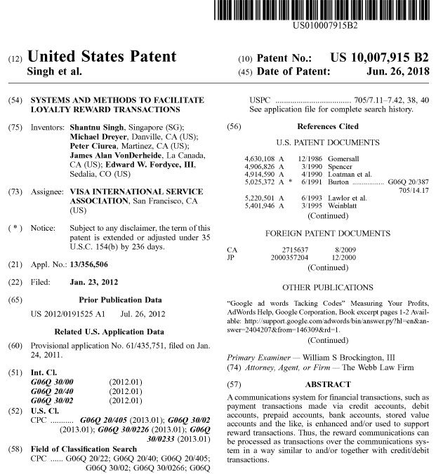
Description
RELATED APPLICATIONS
The present application claims priority to Prov. U.S. Pat. App. Ser. No. 61/435,751, filed Jan. 24, 2011 and entitled “Systems and Methods to Facilitate Loyalty Reward Transactions,” the disclosure of which is incorporated herein by reference.

The present application relates to U.S. patent application Ser. No. 12/896,632, filed Oct. 1, 2010 and entitled “Systems and Methods to Provide Loyalty Programs,” U.S. patent application Ser. No. 12/688,653, filed Jan. 15, 2010 and entitled “Incentives Associated with Linked Financial Accounts” and published as U.S. Pat. App. Pub. No. 2010/ 0211445, and U.S. patent application Ser. No. 12/431,476, filed Apr. 28, 2009 and entitled “Authorization System With Split Messaging” and published as U.S. Pat. App. Pub. No. 2009/0271262, the disclosures of which applications are hereby incorporated herein by reference.

FIELD OF THE TECHNOLOGY
At least some embodiments of the present disclosure relate to the processing of loyalty rewards, such as reward points generated via the use of credit cards, debit cards, prepaid cards, etc.

BACKGROUND
There are several marketing efforts related to offering incentives to promote certain customer spending behaviors. For example, a merchant may offer a loyalty program to provide rewards, such as a discount, rebate, gift, etc., to encourage customers to purchase from the merchant. For example, a credit card issuer may offer a loyalty program to encourage cardholders to use the credit card from the issuer. For example, merchants and issuers may cooperate to offer loyalty programs to promote their respective services and products. Reward programs have become increasingly sophisticated.
In one embodiment, a loyalty program maintains an account for a customer to accumulate benefits earned by the customer in connection with activities related to the loyalty program. For example, after the customer performs certain actions that satisfy the rules of the loyalty program, such as making a purchase from the merchant sponsoring the loyalty program, or making a payment using a credit card from the issuer providing the loyalty program, an amount of rewards are credited to the reward account of the customer.
Rewards can be quantified in various units, such as points, miles, stars, digital cash, etc. For convenience, the term “reward point” includes any unit that has been used, and may be used in the future, to quantify the rewards.
Some issuers have allowed/promoted the consolidation of rewards earned through customer relationships, such as hotels, airlines, oil companies, etc. These rewards are typically limited to the purchases made using the payment cards from the respective issuers. The amounts of the rewards are calculated based on the purchases charged on the payment cards. In some cases, some issuers may allow consolidation of reward points that are earned without making a purchase on the payment cards from the respective issuers. To consolidate rewards, the issuers and/or their partners in the loyalty program use files to exchange information about the rewards.
Issuers have used online catalogs or participating merchants for the redemption of the rewards accumulated in the reward account of a customer. For example, from an online catalog, a customer may request a gift, product or service for the price of a predetermined amount of reward points. For example, at a participating merchant, the customer may redeem an amount of reward points for a product or service.

BRIEF DESCRIPTION OF THE SEVERAL DRAWINGS

FIG. 1 illustrates a system to provide services based on transaction data according to one embodiment.
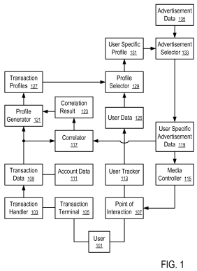
FIG. 2 illustrates the generation of an aggregated spending profile according to one embodiment.

FIG. 3 shows a method to generate an aggregated spending profile according to one embodiment.

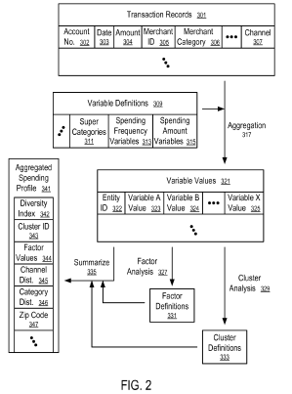 | 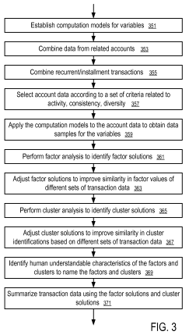
FIG. 4 shows a system to provide information based on transaction data according to one embodiment.
FIG. 5 illustrates a transaction terminal according to one embodiment.
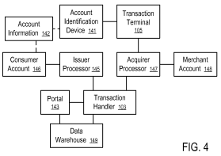 | 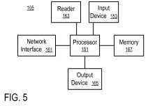

FIG. 6 illustrates an account identifying device according to one embodiment.
FIG. 7 illustrates a data processing system according to one embodiment.

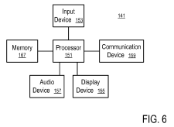 | 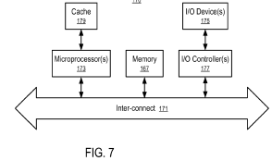
FIG. 8 shows the structure of account data for providing loyalty programs according to one embodiment.
FIG. 9 shows a system to obtain purchase details according to one embodiment.

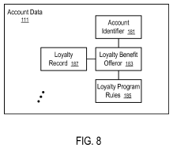 | 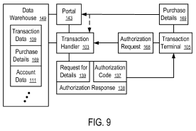

FIG. 10 shows a system to provide loyalty programs according to one embodiment.
FIG. 11 shows a method to administrate a loyalty program according to one embodiment.

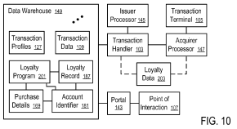 | 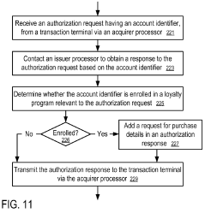

Claims (14)
What is claimed is:
1. A computer-implemented method, comprising:
receiving, in a computing apparatus from an electronic payment processing network, a first message having a plurality of fields including:
a first field providing a message header,
a second field providing a message type identifier,
a third field providing a bitmap specifying data fields that are present in the first message, and
fourth fields providing data corresponding to the data fields specified by the bitmap, including a first account and a second account;

determining, by the computing apparatus, whether the message type identifier provided in the second field of the first message is a first predetermined type identifier, a second predetermined type identifier, or a third predetermined type identifier;

in response to a determination that the message type identifier provided in the second field of the first message is the first predetermined type identifier, processing, by the computing apparatus, the first message as a first rewards transaction including a request for a redemption of reward points to transfer the rewards points to a reward account associated with the first account identified in the fourth fields from a reward account associated with the second account identified in the fourth fields;
in response to a determination that the message type identifier provided in the second field of the first message is the second predetermined type identifier, processing, by the computing apparatus, the first message as a financial transaction including a request for a transaction of funds to transfer the funds to the first account identified in the fourth fields from the second account identified in the fourth fields; and

in response to a determination that the message type identifier provided in the second field of the first message is the third predetermined type identifier, processing, by the computing apparatus, the first message as a second rewards transaction including a request for a crediting of rewards points to transfer the rewards points from the reward account associated with the first account identified in the fourth fields to the reward account associated with the second account identified in the fourth fields,

wherein the computing apparatus comprises a data warehouse for storing transaction data, and wherein the computing apparatus is in communication with an acquirer processor and an issuer processor of the electronic payment processing network, such that the computing apparatus is configured to process the financial transaction between the acquirer processor and the issuer processor in response to the determination that the message type identifier is the second predetermined type identifier and to process the first and second rewards transactions in response to the determination that the message type identifier is the first and/or third predetermined message type identifier.
2. The method of claim 1, wherein when the message type identifier provided in the second field of the first message is the first predetermined type identifier, one of the first account and the second account is a financial account provided in the first message as a proxy of a reward account.

3. The method of claim 1, wherein at least one of the first account and the second account specified in the first message is a financial account selected from:
a credit account;
a debit account;
a prepaid account;
a bank account; and
a stored value account.

4. The method of claim 1, wherein the issuer processor of the second account is different from an administrator processor of the reward account associated with the second account; and in response to the determination that the message type identifier provided in the second field of the first message is the first predetermined type identifier, the processing of the first message comprises communicating with the administrator processor of the reward account regarding the redemption of the reward points.

5. The method of claim 4, wherein in response to the determination that the message type identifier provided in the second field of the first message is the first predetermined type identifier, the processing of the first message comprises identifying the reward account associated with the second account based on the second account specified in the first message.

6. The method of claim 1, wherein when the message type identifier provided in the second field of the first message is the first predetermined type identifier,
the first message is configured to request the redemption of reward points, and
the processing of the message comprises:

identifying, by a transaction handler of the electronic payment processing network, a processor based on an identifier of the reward account associated with the first account or the second account; and

transmitting, by the transaction handler via the electronic payment processing network, the first message to the processor.

7. The method of claim 6, wherein the redemption of reward points includes
redeeming an amount of reward points from the reward account associated with the first account.

8. The method of claim 6, further comprising:
settling, by the transaction handler, funds for the redemption of reward points.
9. The method of claim 1, wherein the redemption of reward points comprises an authorization to redeem an amount of reward points from the reward account associated with the second account as a payment to a merchant.

10. The method of claim 1, wherein the crediting of reward points comprises an authorization to credit an amount of reward points from the reward account associated with the first account to the reward account associated with the second account.

11. A non-transitory, tangible computer storage medium storing instructions configured to instruct a computing apparatus to perform a method, the method comprising:
receiving, in the computing apparatus from an electronic payment processing network, a message having a plurality of fields including:
a first field providing a message header,
a second field providing a message type identifier,
a third field providing a bitmap specifying data fields that are present in the message, and
fourth fields providing data corresponding to the data fields specified by the bitmap, including a first account and a financial account selected from:
a credit account;
a debit account; and
a prepaid account;
determining, by the computing apparatus, whether the message type identifier provided in the second field of the message is a first predetermined type identifier, a second predetermined type identifier, or a third predetermined type identifier;

in response to a determination that the message type identifier provided in the second field of the message is the first predetermined type identifier,
identifying a reward account from the financial account specified in the fourth fields, and
processing the message as a first rewards transaction including a request for a redemption of rewards points to transfer the rewards points to a reward account associated with the first account identified in the fourth fields from the reward account from the financial account specified in the fourth fields;

in response to a determination that the message type identifier provided in the second field of the message is the second predetermined type identifier, processing the message as a financial transaction including a request for a transaction of funds to transfer the funds to the first account identified in the fourth fields from the financial account specified in the fourth fields; and

in response to a determination that the message type identifier provided in the second field of the message is the third predetermined type identifier, processing the message as a second rewards transaction including a request for a crediting of rewards points to transfer the rewards points from the reward account associated with the first account identified in the fourth fields to the reward account from the financial account specified in the fourth fields,

wherein the computing apparatus comprises a data warehouse for storing transaction data, and wherein the computing apparatus is in communication with an acquirer processor and an issuer processor of the electronic payment processing network, such that the computing apparatus is configured to process the financial transaction between the acquirer processor and the issuer processor in response to the determination that the message type identifier is the second predetermined type identifier and to process the first and second rewards transactions in response to the determination that the message type identifier is the first and/or third predetermined message type identifier.

12. The computer storage medium of claim 11, wherein when the message type identifier provided in the second field of the message is the first predetermined type identifier, the financial account is identified in the message as a proxy of the reward account.

13. A computing apparatus, comprising:
a transaction handler configured in an electronic payment processing network to receive a message having a plurality of fields, including:
a first field providing a message header,
a second field providing a message type identifier,
a third field providing a bitmap specifying data fields that are present in the message, and
fourth fields providing data corresponding to the data fields specified by the bitmap, including a first account and a financial account identifier of a financial account selected from:
a credit account;
a debit account; and
a prepaid account; and
a data warehouse having at least one storage device configured to store data recording transactions processed by the transaction handler in the electronic payment processing network;
wherein the transaction handler is further configured to determine whether the message type identifier provided in the second field of the message is a first predetermined type identifier, a second predetermined type identifier, or a third predetermined type identifier;
wherein if the message type identifier provided in the second field of the message is the first predetermined type identifier, the transaction handler is configured to:
identify a reward account from the financial account identifier specified in the message;
determine an administrating processor of the reward account; and
communicate the message to the administrating processor of the reward account to request a transfer of reward points to a reward account associated with the first account identified in the fourth fields from the reward account from the financial account identified in the fourth fields;
wherein if the message type identifier provided in the second field of the message is the second predetermined type identifier, the transaction handler is configured to:
communicate the message to an issuer processor of the financial account identified by the financial account identifier to request a transfer of funds to the first account identified in the fourth fields from the financial account identified in the fourth fields; and

wherein if the message type identifier provided in the second field of the message is the third predetermined type identifier, the transaction handler is configured to:
communicate the message to the administrating processor of the reward account to request a transfer of reward points from the reward account associated with the first account identified in the fourth fields to the reward account from the financial account identified in the fourth fields,

wherein the transaction handler is in communication with an acquirer processor and the issuer processor of the electronic payment processing network, such that the transaction handler is configured to process the financial transaction between the acquirer processor and the issuer processor in response to the determination that the message type identifier is the second predetermined type identifier and to process the rewards transactions in response to the determination that the message type identifier is the first and/or third predetermined message type identifier.

14. The computing apparatus of claim 13, wherein the administrating processor of the reward account is different from the issuer processor of the financial account.

IV. RELEVANCE AND SUMMARY OF WORK

The work of science – “VishuMoney Platform for Shopping and Reward Earning” was conceptualized based on realization that for anyone, money is the most crucial factor.

Globally, people encounter different problems with financial matters. Generally, classes in the below income level classes, particularly those in the below poverty, lower class and lower middle classes had a hard time making ends meet. As digital world has assumed a crucial role, these people are looking for opportunities at their fingertips to alleviate their income earnings. One of these is the online shopping which offers income generating and as the same time provides saving avenues for the benefit of the consumers. Online shopping has revolutionized the way people buy everything from smartphones, clothes, accessories to even groceries due to various benefits such as discounts, cash on delivery, cashbacks, etc.

However, there are various problems faced while doing the shopping. Most of the sites are focused to sell a product that may not meet customer’s needs such as but not limited to need for proper specification comparison which is vital but not omnipresent. Another issue is that each site prices products bases on different factors thereby limiting the benefits to a user. An aggregator acting as a channel can ensure user gets the best price in one place.

Likewise, with all sites promoting offers through coupons for optimizing the price, aggregators amassing & suggesting the best coupon is nonexistent.

Further, with sites needing sales use affiliates for marketing. Affiliates earn huge revenue through their users, but do not benefit users monetarily. And also a majority of essentials are purchased offline in brick & mortar stores to platform setups. The growth of Online shopping to surpass offline is inevitable but while that happens most of us do not find everything that we are looking for. Hence the need for platforms to support special requests is necessary which is the concept of Online to Offline(O2O).

Thereby, the work of science – “VishuMoney Platform for Spending and Reward Earning” focuses in two major areas:

- The New Gen Spending Platform:

The Vishumoney Platform for Spending ensures anyone shopping in this platform shall get the best of both worlds as Vishumoney have brought all shopping platforms in one place. Likewise, consumer’s inevitable expenses from paying bills, to shopping groceries or clothes can now be done smarter & easier by using our platform for all your needs effectively.

Salient features of this platform are as follows:
Product Comparison
Compare prices across the same product across multiple sites and buy at the lowest price with ease. Consumer can compare better and choose the best deals.

Price Comparison
No need to sweep multiple sites for the best price of a product. Find the product in the site with the details from all the stores offering the lowest prices.

Consumers who want to buy a product or service can easily visit the platform and able to find and compare all similar products as well as compare the prices for all the stores selling it.

Earn Every time Consumer Spend
Consumer who makes a habit to do everything with this platform and end up paying a few bills for free from time to time.

One Click Checkout
Visiting multiple sites is a chore and using sites to maximise benefits just complicates more. By using this platform, consumer will no longer go through such hassles.

Coupons & Special Offers
Consumers can choose the best offer or coupon as per the store, product category, price band and other factors to purchase the product at the lowest price.

Likewise, consumers can select the best deal available and aside from buying product it comes along with additional discounts. In addition, there will be cashback offer as a treat from using the Vishumoney Platform for Shopping.

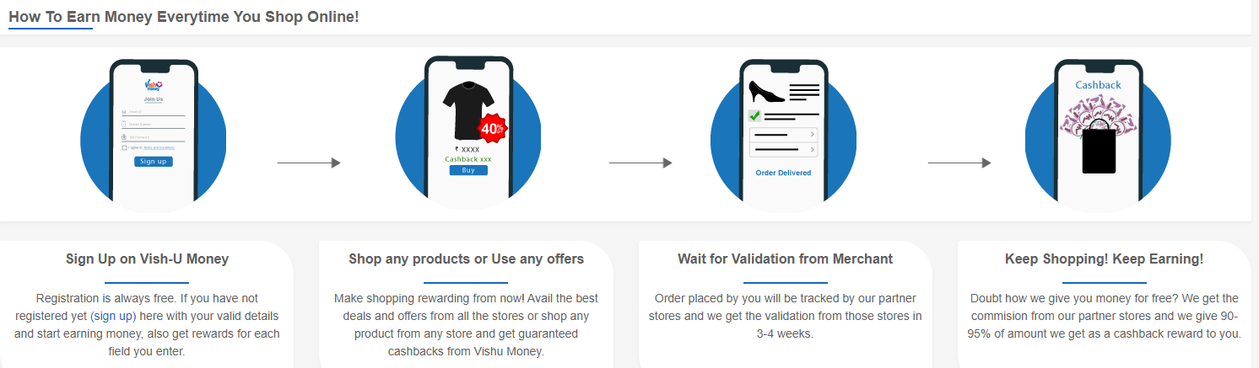

Furthermore, there are additional features coming down the lane for using the VishuMoney Platform for Shopping:

Offline Unlocked
Consumers will no longer miss out any in store deals or not online products anymore. Any item is made available at best deals with on and offline options by special requests.

Buy Now, Pay Later
Consumers can now enjoy the convenience of getting the product when they need it and pay when the consumer can later no matter what his/her credit capacity.
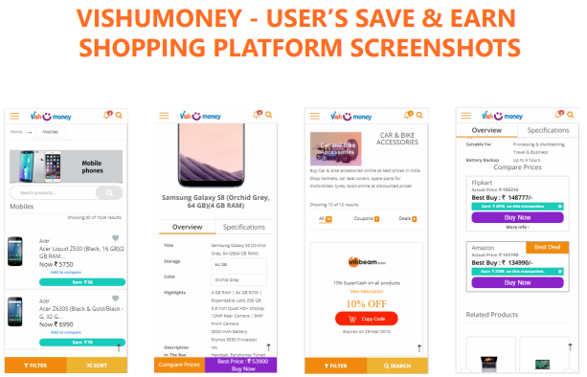

- The Next Gen Reward Earning Platform:

The VishuMoney Platform for Reward Earning helps anyone earn money instantly. All it must done is to explore and spend the time online but benefit from it whether it be making the most out of one’s social circle or earning some instant money.

Anyone can earn money instantly by performing certain fun tasks like while online, trying new apps or engaging with existing ones, watching one’s favorite videos, play games, use the apps, explore websites or just surfing the net, taking surveys and other simple tasks. or by completing carefully the simple curated tasks. Earning with this platform is easy and simple through mobile, tablet, or laptop.

USERS EARN BY:

1. Discovering New Apps
If the consumer is looking for an app for a specific purpose, say to book movie tickets or play a game to beat boredom; all the consumers must do is to just visit the VishuMoney store for the best app in every category and install not just to use the app but to get rewarded instantly.

2. Satisfying Needs using Services
From opening an account online to renewing one’s insurance everything is now better & easier online through websites.

So, when consumer plan to look and Sign Up for one, first browse through VishuMoney options. Consumer can choose one that’s most suitable, visit & Sign Up for their amazing service and receive awesome rewards.

3. Voicing out Taking up Surveys
Spending few minutes to be heard. Consumer who has used a product or service and wants to voice out his/her opinion for others to make an informed choice.

Likewise, sharing consumer’s genuine point of views in the survey section by choosing the appropriate one and get rewarded once consumer completed the survey.

4.Sign Up
Registration is also rewarding. Simply register and and earn money for each field the User enter, and once done with it, User earns money each time he/she shop through VishuMoney.

5. Do Simple Task
By trying an app through Vishumoney and rate it based on few metrics to get paid instantly for User’s input. Likewise, when inquiring a service with User’s valid details and rate it based on quality & experience, User will be get paid for the opinion provided.

6. Play Quiz and Win Points
Also, when consumer plays quiz to test his/her skills will also earn money.
- Play quizzes in over 25 categories like GK, sports, science, world, business, tech, nature & more
- Compete with thousands of other quiz enthusiasts
- Collect Qureka Lite coins in every quiz
- Played & trusted by over 20 million users

7. Redeem the Money
All the money earned will be added to the User’s wallet and can be used the same to recharge mobile phones or pay all the bills and. User can also transfer this money to the User’s bank account or use it as payment cash.
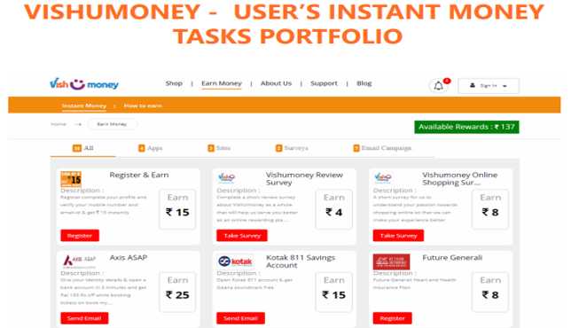

8. Share and Benefit

By making affiliate marketing personal to increase personal income, User can earn every time he/she networks. Equipping User with a dependable platform to extract the most from his/her social wealth. As the User socialize passively, provide the best of advice on experienced products and services that reduces the hassle of finding one for the other person whole such User get rewarded for it.

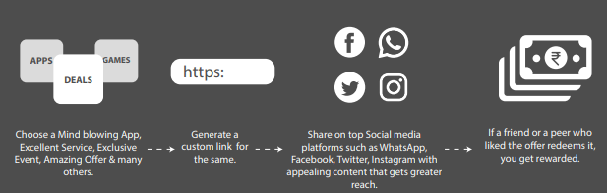
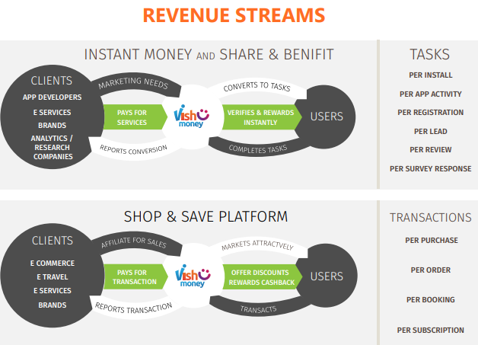

The work of science – “VishuMoney Platform for Shopping and Reward Earning” is the first website of its kind where people will be able to earn money by doing simple tasks. Likewise, it can be used using a mobile phone, desktop, laptop, and other devices with a graphic display with Internet access.

The significant features are as follows:
• Originality – mobile app for VishuMoney together with modern gadgets.
• Gamification – to give VishuMoney users in a light, playful way.
• Tokens – to reward users.
• Additional values – directing tokens to global charitable projects. Virtual assistant based on AI and machine learning.

The target audience of this work of science – “VishuMoney Platform for Shopping and Reward Earning” are people from different age groups who wants to make passive income everyday by using their mobile phone/ laptop.

V. LEGAL BASIS

Examination of the current the work of science – “VishuMoney Platform for Shopping and Reward Earning” was held by the Intellectual Property Expert Dr. Sandjar Muminov based on following international (WIPO) and the normative legal acts of the United Kingdom:

1. Berne Convention for the Protection of Literary and Artistic Works of 9 September 886 in Paris, complemented by 4 May 1896, revised in Berlin on 13 November 1908. Supplemented in Bern on March 20, 1914, and revised in Rome on June 2, 1928, in Brussels on June 26, 1948, in Stockholm on July 14, 1967, and in Paris on 24 July 1971, as amended September 28, 1979 (the UAE acceded to the Berne Convention in 2004).

2. The Federal Law Number 38 of 2021of the United Arab Emirates on " Copyright and Neighbouring Rights".

3. The Federal Law NUmber 7 of 2008 of the United Arab Emirates on "The National Centre for Documentation and Research".

4. The UAE Decree-Law number 5, 2012 "On the fight against cybercrime" (2012).

5. The Federal Law of the United Arab Emirates number 8, "On the commercial organizations of the United Arab Emirates' (1984).

6. The Federal Law of the United Arab Emirates number 3, "On the federal judiciary" (1983).

7. The Federal Law of the United Arab Emirates number 31, "On the regulations governing the protection of industrial property: patents, industrial designs" (2002).

8. The Federal Law of the United Arab Emirates number 18, "On the conclusion of commercial transactions" (1993).

9. The Ministerial Order № 133, "On copyright collective" (2004).

10. The Ministerial Order № 411 "On the control of protected works in accordance with the UAE Federal Law № 40, "On the protection of intellectual property and copyright" (1993).

11. United Kingdom Copyright, Designs and Patents Act (1988).

12. United Kingdom Copyright, Designs and Patents Act (1988) Part I 'Copyright' Chapter I, Article 1, and Article 143.

13. United Kingdom Arbitration Act 1996 (Chapter 23, updated up to January 27, 2021)

14. United Kingdom Competition Act 1998 (Chapter 41, updated up to March 26, 2021)

VI. SOURCES OF REFERENCES

1. PATENT NO. US20200051117A1 – SYSTEMS AND METHODS TO ENABLE OFFER AMD REWARDS MARKETING, AND CUSTOMER RELATIONSHIP (CRM) NETWORK PLATFORM

2. PATENT NO. US20150348083A1 – SYSTEMS, METHODS AND PROCESSES TO IDENTIFY CROSS-BORDER TRANSACTIONS AND REWARD RELEVANT CARDHOLDERS WITH OFFERS

3. PATENT NO. US10007915B2 – SYSTEMS AND METHODS TO FACILITATE LOYALTY REWARD TRANSACTIONS

4. WIKIPEDIA - www.wikipedia.org - a multilingual, web-based, free-content encyclopedia project supported by the Wikimedia Foundation and based on a model of openly editable content.

VII. INFORMATION ABOUT THE EXPERT

Dr. Sandjar Muminov has 25 years’ experience in intellectual property industry. His professional merits and achievements include:
- Eurasian Commissioner on Law Supremacy and Intellectual Property of EECO (Eurasian Economic Cooperation Organization), Head Offices in Russia, China and UAE, regional offices in 50 countries (www.eurasianeconomic.org)
- President of SANDJAR GROUP Business Consortium (GCC, Dubai, UAE)
- Expert of Dubai Silicon Oasis Authority
- Speaker of the University of Dubai (UAE)
- Authorized Expert of INTEROCO Copyright Office (Germany)
- Member of International Intellectual Property Law Association (USA)
- and others.

Expert Specializations of Dr. Sandjar Muminov:
- Private advisor on all issues concerning IP legal protection (patent, commercial
& Copyright law)
- Startup and investments projects
- Commercialization & capitalization of intellectual property
- Protection of copyright, know-how, trade secrets, etc.

In 2018 and 2019, Dr. Sandjar Muminov was recognized World TOP-5 Intellectual Property Expert (International Intellectual Property Law Association, US-UK).
