International Online Copyright Office
INTEROCO
(European Union, Germany, Berlin)

WORK OF SCIENCE

The Fields

Dubai Copyright Office – 2017
(Representative office of INTEROCO in UAE)

STRUCTURE OF DOCUMENT

I. ANNOTATION
II. BASIC DEFINITIONS
III. ANALYSIS OF CLOSEST ANALOGS
IV. RELEVANCE AND SUMMARY OF WORK
V. SCIENTIFIC NOVELTY
VI. LEGAL BASIS
VII. SOURCES OF REFERENCES
IX. INFORMATION ABOUT THE EXPERT

Works of science as a intellectual property (copyright) objects are stipulated in

1 | Berne Convention for the Protection of Literary and Artistic Works (1971)  " Article 2. Protected Works:  (1) (1) The expression “literary and artistic works” shall include every production in the literary, scientific and artistic domain, whatever may be the mode or form of its expression, such as books, pamphlets and other writings; lectures, addresses, sermons and other works of the same nature; dramatic or dramatico-musical works; choreographic works and entertainments in dumb show; musical compositions with or without words; cinematographic works to which are assimilated works expressed by a process analogous to cinematography; works of drawing, painting, architecture, sculpture, engraving and lithography; photographic works to which are assimilated works expressed by a process analogous to photography; works of applied art; illustrations, maps, plans, sketches and three-dimensional works relative to geography, topography, architecture or science.
2 | United Arab Emirates  Federal Law No. 7 of the Year 2002 Concerning  Copyrights and Neighboring Rights  Article 1. In applying the provisions of this law the following words denote the definitions explained before each one of them, unless the context denotes otherwise: “The Work” - any created compilation, in the scope of letters, arts, sciences, whatsoever is its type, mode of expression, value or purpose.

According to above mentioned laws in the UAE work of science, as an object of copyright, should:
- Be the result of creative activity;
- Exist in any objective form.

Considered a work of science - The Fields meets to the definition of an object of copyright according to chapter 1, "Scope of legal protection" (section 1 Scope of Protection) of the Federal Law of the United Arab Emirates number 7, 2002 "On Copyright and Neighboring Rights" of July 17, 2002

The result of creative activity, innovation, relevance, scope of work of science Online booking and advertising system Charterclick.com is listed in this publication, and confirmed by a certificate of deposit of copyright works.

The study of objective form of current work of science through materials research and examination of the object on the criteria for copyright eligibility held:

Patent expert, authorized  representative of INTEROCO  Copyright Office | Ph.D. Muminov  Sandjar

I. ANNOTATION

People around the country find some difficulties in finding an available indoor and outdoor football field that is near to their place.

This project will allow them to check for the availability of the field by time and location so that they don’t waste their time looking for an available place in order to practice the sport they like.

Through our application, users can organize and plan football tournaments throughout the year and reserve football fields in an easy, fast and hassle-free way.

The users will be able to proactively manage upcoming games and invite players.

Users will also be able to reserve a football field by searching nearby Fields, the app will retrieve the current location of the user using GPS coordinated and show nearby fields registered on the app or users may search a field by area or city.

Select date and time when the venue is available for reservation.

Referees and photographers who may join the game and take part in a sports event.

The app interface will be lively and interactive for easy navigation and usage allowing users to monitor their present status and stay updated for the latest information.

We will design a web admin console where we can manage or monitor the scheduled games where the field owners will be able to respond to field reserve request and approve or disapprove the users request to book a field in advance.

1) Purpose of the project
This project will allow customers to easily find the nearest available football field by location and time, join championships, it will also allow field’s owners to advertise for their fields, inform about their offers and championships they hold and allow customers to book for their fields online in which their productivity will increase.

2) Functionality of the project
The fields provide an online platform that allows the fields owners to advertise their fields and allow customers to view those fields, check the available fields by location and then choose the timings, date and the field size they wish to play in. By making a reservation through our mobile app, a confirmation email will be sent to the customer and the field owner.

The application will also allow fields owners to post notifications about championships that takes place in their fields and allow customers to register to challenge different teams. It will also allow them to post offers to inform their customers.

3) Target audience of the project
The Target audience of the project will obviously be anyone who would like to book a football field in UAE and the football field owners.

II. BASIC DEFINITIONS

Mobile app | an application software designed to run on mobile devices such as smartphones and tablet computers
Football field | is the playing surface for the game of association football
Online platform | is a specially developed platform using Internet technology for the design and development of teaching and learning purposes
Target audience | is the intended audience or readership of a publication, advertisement, or other message
Mobile device | A mobile device (or handheld computer) is a small computing device, typically, small enough to hold and operate in the hand and having an operating system capable of running mobile apps. These may provide a diverse range of functions. Typically, the device will have a display screen with a small numeric or alphanumeric keyboard or a touchscreen providing a virtual keyboard and buttons (icons) on-screen. Many such devices can connect to the Internet and interconnect with other devices such as car entertainment systems or headsets via Wi-Fi, Bluetooth or near field communication (NFC). Integrated cameras, digital media players, mobile phone and GPS capabilities are common. Power is typically provided by a lithium battery.

III. ANALYSIS OF CLOSEST ANALOGS

Analogue 1
System and method for hotel reservation and for automated check-in
Patent No. EP 2709045 A1
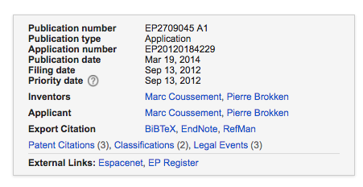
ABSTRACT
A system (1) for making a hotel reservation and for automatic check-in, comprising:
- a host server (24) with databases (25) for storing user data and biometric data of a guest (5), and adapted for allowing the guest (5) to select a hotel (7) and to make a reservation, and adapted for transmitting the user and biometric data to a hotel server (33);

- the hotel server (33) adapted for receiving the lodging reservation and the user data and biometric data, and for transmitting it to a kiosk (4);
- the kiosk (4) comprising a kiosk database (41) for storing the user data and biometric data, and a biometric identification module (42), and means for assigning a room, and a key dispenser module (43) for providing a key (61), and a guest categorization engine (48) and an information selection and presentation engine (47) to present highly personalized information, and optionally a review writer module (26) integrated in the system (1).
In an embodiment of the system, the host server further comprises a third database for maintaining via the host server a history log relating to a guest, the history log comprising at least one of the history of reservations made by the guest, the history of the guest's profile changes, the history of the guest's reservation options and/or preferences, the history of the guest's external reservations (e.g. for theatre, sports facilities, the zoo etc.).

Analogue 2
Open Mobile Online Reservation and Ordering Systems
Patent No. US 20090167553 A1

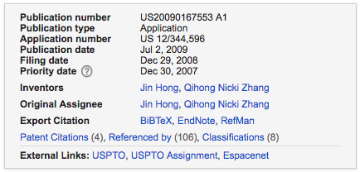

ABSTRACT
The invention relates to a new “mobile and online based ordering and reservation system” by integrating, synchronizing and utilizing the capability of wireless devices, Internet servers, business web sites and service aggregation portals, to automate the mobile and online ordering and reservation processes in real time, and therefore offering a plural of new mobile and online services and applications.
More specifically, the Internet server serves as the host to the service aggregation and as the intermediary device between customers and business. It automatically synchronizes all of the service requests and responses. Therefore, this invention takes full advantage of the flexibility, mobility, availability and convenience of the wireless devices, and the reliability, scalability, the huge processing power of the Internet servers, and the great broadband penetration of the computers into businesses and consumers.
A fully integrated comprehensive mobile and online service platform, comprising of mobile and online ordering, reservation and notification systems that can offer some or all of the above features described and claimed above, and applied to different business segments other than restaurant industry. It can be used for the other industries that may also touch on the daily life of people, on all activities such as the hair cut reservation, salons and spas reservation, massage reservation, sports facility reservation, public facility or private facility reservation, reservation for students or parents to meet the school teachers for any specific reasons, reservation for going to the bar, attending entertainment events or gatherings, or reservation for a child birthday party at certain places and facilities, and ordering of birthday party gift packages for the party reservations, and etc. The list can go on and is not limited to the ones mentioned above. The key is to utilize the new fully integrated platform to maximize the benefits it brings in to the customers and to the business owners alike.

Analogue 3
System and method for scheduling and reservations using location based services
US 8472979 B2

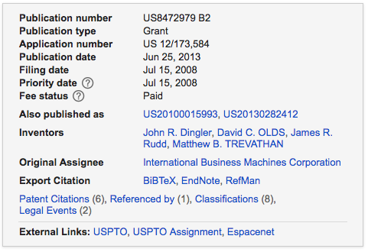

ABSTRACT
A system and method for providing reservation services to users of mobile devices. The system is implemented in a reservation computer device having computer executable code tangibly embodied on a computer readable medium. The reservation computer device is operable to prioritize a reservation schedule of a service establishment based on a route and projected arrival time of one or more subscribing users such that earlier arriving users and users that have already arrived at the service establishment are given priority in the reservation schedule regardless of prearranged reservations.

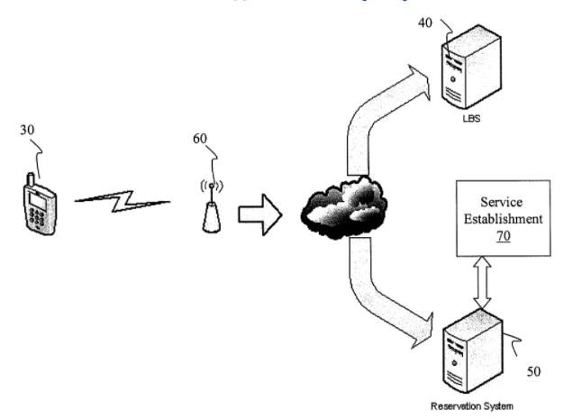

FIG. 1 shows a highly schematic architecture of the present invention. In embodiments, a mobile device 30 and a location based service 40 subscribe to a reservation service or system 50. In further embodiments, a service establishment 70 also subscribes to the services of the reservation system 50. The subscription can take on many different forms such as, for example, subscription, one time usage fee, periodic fee, etc. The service establishment 70 can be any service oriented venue such as, for example, a restaurant, but is equally applicable to other service venues such as theaters, sporting venues and other establishments which cater to patrons. In yet further embodiments, the mobile device 30 may also subscribe to the location based service 40; although this is not necessary in that mobile device 30 may have a resident agent (A-GPS) which can provide location based information directly to the reservation system 50.

Analogue 4
Online-reservation system and method with automatic canceling function
US 20030097284 A1

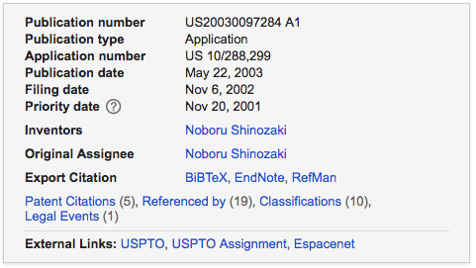

ABSTRACT
An online-reservation system is provided for managing an online-reservation offered from a terminal communicably connected through a commination network. In the system, information about a reservation for an event taken place in a facility is received from the terminal via the communication network. The reservation is made by a user. Also positional information comes from the terminal via the communication network so as to manage a current position of a user who made the reservation. Both the received reservation information and the received current position the user are managed. In cases where the user moves out of a predetermined area enclosing the facility, the reservation is automatically cancelled.
For instance, the above embodiment has been described about reservations for seats at the attractions taken place in the amusement park AP, but the present embodiment will not be limited to such a facility. For example, the facilities to which the present invention can be applied range over a variety of other performances or events, such as a concert, sports, and movies, which are taken place within a predetermined limited area.

Analogue 5
Method and apparatus for settling online prepaid transaction with optical disc
US 20020143702 A1

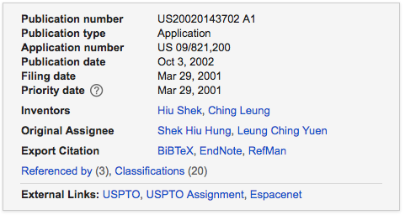

ABSTRACT
A system for settling an online purchase made via an Internet connection to a online purveyor includes a central account platform connected to the Internet and a prepaid optical disc for use in a cd rom drive of the purchaser's computer.

The account platform includes a database having multiple prepaid account records. Each of the prepaid account records has a unique prepaid account identifier and a monetary amount associated with the prepaid account identifier.
The prepaid optical disc has one of the prepaid account identifiers and software recorded thereon. The software includes means for initiating communication between the account platform and the purchaser's computer.
There are two types of conventional prepaid cards. The first is a fixed value prepaid card which has a pre-determined value. Once the user uses all the value stored in the account, the card becomes invalid and must be replaced with a newly purchased card.
The second is a rechargeable prepaid card which will accept deposits to the account. Generally, such cards do not become invalid so long as deposits are made to the account.
Prepaid transaction settlement systems employing cards of the type discussed above are employed in wide variety of applications for both personal and professional use. For example, some academic institutions issue prepaid card for students for use in purchasing school and living supplies, booking sports facilities, and booking school facilities.

Analogue 6
Stadium reservation management method
CN 105488578 A
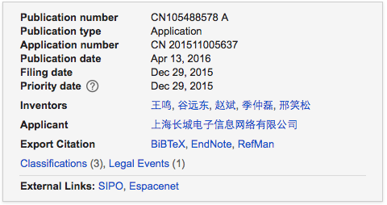
ABSTRACT
The invention discloses a stadium reservation management method, comprising steps of utilizing a stadium information management device which is arranged in the reserved stadium to register the member user information, utilizing the stadium information management device to input the member recharging information correlated with the member user information according to the member user payment condition, utilizing the stadium information management device to input the available place information of the reserved stadium, transmitting the inputted available place information of the reserved stadium to the server by the stadium information management device, using an electronic device terminal to transmit a request to a server by a member, transmitting the object available place information of the stadium in the available places of the reserved stadium to an electronic device terminal of the member user in order to respond to the query request of the member user, transmitting available place reservation information to the server by the member user on the basis of the received the available place information of the object stadium, and forwarding the available stadium reservation information to the stadium information management device by the server.

Analogue 7
System for booking a time period for utilizing a time based service or resource
US 20120203579 A1

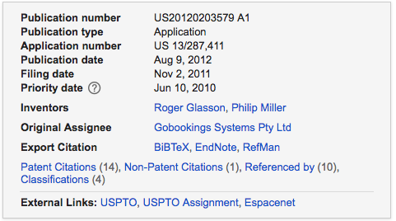

ABSTRACT
A system for booking a time period includes at least one provider arrangement on which a resource/service provider can indicate one or more available time periods within which they are able to provide a resource or service, and a plurality of user portals. Each user portal indicates which time periods of the service or resource provider/s are available to be booked on that portal by a user and facilitates booking of an available time period by a user.
A synchronization and communications arrangement facilitates direct communication between the provider arrangement and each user portal in real time over a communication network to communicate the booking of an available time period on a the portal by a user to the provider arrangement and the other portals.
This updates the available time periods on the provider arrangement and the user portals and removes each booked time period from the available time periods.
The invention has particular but not exclusive application to a system for booking an appointment on the world wide web with a service provider such as an accountant, a lawyer, or a medical service provider from a selection of available appointment times for that service.
The invention also has particular application to a system for booking a time period on the world wide web for utilising a resource such as a meeting room, a sports facility, or a piece of equipment from a selection of available appointment times for that resource. However at the same time it is to be clearly understood that the invention is capable of broader application.

Analogue 8
Apparatus and method for an internet based computer reservation booking system
US 20080010105 A1

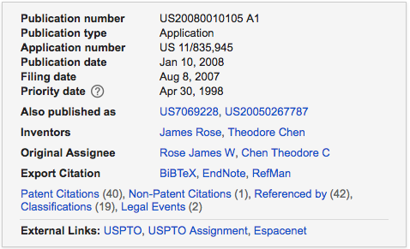

ABSTRACT
The present invention is a software product that provides merchants that sell time-slot inventories tools to capitalize on the Internet revolution.
The present invention enables the creation of web-sites for merchants with a built-in web-based reservation booking system.
This offers customers the on-line benefits of access, selection and immediacy in making real-time reservation/appointments over the Internet.
The software product also simplifies the merchant's booking process by providing a central web-based reservation/appointment management system that can be used for all bookings, regardless if made by telephone, by a walk-in customer, or by a customer via the Internet.
The software product also provides the merchant with a powerful direct marketing tool.
As a merchant uses the software product, user-customer profiles and demographics are captured in the database module, thus creating (in Web jargon) a “community” of customers specific to the merchant.
The merchant is thus empowered, using the mail module, to directly communicate with its customer base, using customer profiles and demographics to create a highly targeted and effective marketing and promotional ad campaign.
The software product also allows the merchant to auction off time-slot inventory over the Internet. Lastly, the software product enables the creation of Web “super-communities” consisting of the aggregate of all the individual merchant's customer-communities using the software product.
By way of example, the Applicants describe the present invention as it pertains to the restaurant industry. This description, however, should in no way be considered as limiting and the principles and features of the present invention could readily be used, with obvious modifications, for any industry where advanced bookings by customers is commonplace, including but not limited to the golf, bed and breakfast, salon, spa, cinema, sports, performing arts, medical industries, etc.

Analogue 9
On-line facilities management tool
US 20020059205 A1

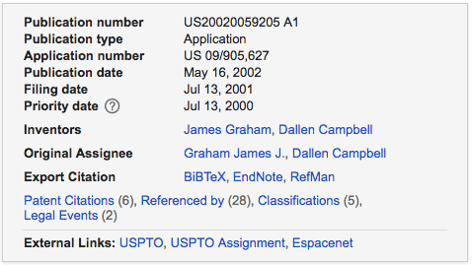

ABSTRACT
The present invention is a system for assisting a manager of a sporting event or sporting facility in scheduling and managing the event or facility.
The invention aids in scheduling league or tournament play and creates a website for helping registration, disseminating league or facility schedules or other information, keeping track of ongoing statistics, and adjusting schedules after the season or tournament starts.
The present invention overcomes the disadvantages and limitations of the prior art by providing a computer system for automatically scheduling a large sporting event and keeping track of all the scheduling for a sports facility. Further, the invention provides a method of accessing the scheduling computer worldwide and for easy dissemination and immediate updates for the participants in the events.
The computer system allows managers of sports leagues to book time from the sports facility, set up league play based on scheduling rules, and quickly create a schedule for each participant.
The computer system interface is through the World Wide Web, allowing the manager to perform this function from anywhere in the world.

Analogue 10
Method of sharing action highlights and a sports complex for providing shareable action
WO 2015155725 A1

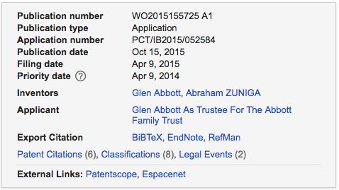

ABSTRACT
The invention relates to a sports complex comprising a compact golf course that includes a first discrete driving area and a second discrete fairway and green, complete in preferred embodiments with a plurality of bunkers, the areas being adapted so that, in combination, they functionally simulate a golf course.
Also disclosed is a method of capturing action by means of cameras on the course and compiling a video highlights package for individual players to share on social media.
This invention relates to the sharing of video recordings of events, in particular of action in an outdoor golf-like game, and to a sports facility for playing the game in a manner suitable for capturing and sharing footage of the action.
A further object of the invention is to provide efficient methods of enabling an end user to compile and share, such as via social media, a video record of an event, such as a game played at a sports complex of the invention.

IV. RELEVANCE AND SUMMARY OF WORK
Detailed Description of the idea:
The home page of the app will look like the figure shown below
Figure 1Home Page
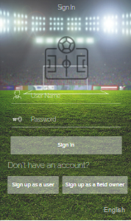
- Sign up as a user:
Splash:
The user will download and install the app on their device from respective stores (Itunes or Android Play store). Upon Launch, the splash screen will appear displaying the app’s logo. The splash screen is used for app branding and covers time for about 3 to 5 seconds while the app loads data in the background.
User Registration:
When the app is launched, users who are logging in for the first time would be prompted to create a new account or log in using their E-mail ID. Existing users will be directly led to the main home screen skipping the login/signup page.
To create an account, the user will be asked to provide:
- Personal information (name, contact number, email address, age)
- Login information (username and password)

- Sign up as a field owner:
Splash:
The user will download and install the app on their device from respective stores (Itunes or Android Play store). Upon Launch, the splash screen will appear displaying the app’s logo. The splash screen is used for app branding and covers time for about 3 to 5 seconds while the app loads data in the background.
User Registration:
When the app is launched, users who are logging in for the first time would be prompted to create a new account or log in using their E-mail ID. Existing users will be directly led to the main home screen skipping the login/signup page.
To create an account the field owner will be asked to provide:
- The name of the field/s
- The size/s of the field/s
- The location of the field/s
- Personal information of the owner, contact number and email address.
- Login information (Name and Password)

Note: The Field owners profile will go on pending status until the admin reviews all the documents and can ask to interview the candidate (optional) and approve them. Admin will approve each and every field owner’s sign up request manually through the admin console. Once the admin approves the profile it will be activated.
Benefit for Field owners:
- Marketing
- Inform customers about their offers and Championship
- Manage and increase their fields reservations
- Easier for the company to save its information in a database.
- Easier for the company to know the available Fields for the customers.
- Know the active customers
- Reduce the number of employees and so, reduce their costs.

- Sign up as a photographer:
- Splash:
- The user will download and install the app on their device from respective stores (Itunes or Android Play store). Upon Launch, the splash screen will appear displaying the app’s logo. The splash screen is used for app branding and covers time for about 3 to 5 seconds while the app loads data in the background.

- User Registration:
- When the app is launched, users who are logging in for the first time would be prompted to create a new account or log in using their E-mail ID. Existing users will be directly led to the main home screen skipping the login/signup page. To create an account, the users will be required to provide the following information:
- Personal information (name, contact number, email address, age)
- Login information (username and password)
- Experience in Photography

- Sign up as a referee:
Splash:
The user will download and install the app on their device from respective stores (Itunes or Android Play store). Upon Launch, the splash screen will appear displaying the app’s logo. The splash screen is used for app branding and covers time for about 3 to 5 seconds while the app loads data in the background.
User Registration:
When the app is launched, users who are logging in for the first time would be prompted to create a new account or log in using their E-mail ID. Existing users will be directly led to the main home screen skipping the login/signup page. To create an account, the users will be required to provide the following information:
- Personal information (name, contact number, email address, age)
- Login information (username and password)
- Experience in the field of football

- Log in as a photographer:
The Home screen will be the main screen for application from where the user will be able to navigate to all the key features. The application will entail intuitive and appealing user interface with an engaging user experience. The users will be able to navigate to the following sections:
- My Requests
- Notifications
My Requests
In this section, the photographers will be able to view all the requests send by field owners and the users of the application, they will have the option to either accept or decline the offer send by field owners and the users of the app. After the users or field owners approve the photographer for the match, they will be further able to view more information about the match such as venue, duration and all the necessary details about the match.
Photographers can:
- post offers that will be displayed for users and football field owners who would like to hold a championship.
- Add their payment Information so that they can receive their money. A percent of the money payed to the photographer will be given to the owner of the application

My Matches
In this section, the photographers will be able to view the list of all the upcoming matches.
Log out
Tapping on logout button will navigate the user out of the application and to the login screen. Users will need to sign in again by entering their registered credentials.

- Log in as a referee:
After logging in, referee can:
Home Screen:
The Home screen will be the main screen for application from where the user will be able to navigate to all the key features. The application will entail intuitive and appealing user interface with an engaging user experience. The users will be able to navigate to the following sections:
- My Requests
- Notifications

My Requests
In this section, the referees will be able to view all the requests send by field owners and the users of the application, they will have the option to either accept or decline the offer send by field owners and the users of the app. After the users or field owners approve the referee for the match, they will be further able to view more information about the match such as venue, duration and all the necessary details about the match.
Referees can:
- post offers that will be displayed for users and football field owners who would like to hold a championship.
- Add their payment Information so that they can receive their money. A percent of the money payed to the referee will be given to the owner of the application
- Through the application, the referees can register in workshops in which they can enhance their knowledge in football rules.

My Matches
In this section, the referees will be able to view the list of all the upcoming matches.

Log out
Tapping on logout button will navigate the user out of the application and to the login screen. Users will need to sign in again by entering their registered credentials.

Log in as a user(customer):
Home Screen:
The Home screen will be the main screen for application from where the user will be able to navigate to all the key features. The application will entail intuitive and appealing user interface with an engaging user experience. The users will be able to navigate to the following sections:
2.1 - Newsfeed
2.2- Create New Team
2.3 - Create new Game ( Friendly Match)
2.4 – Leaderboard

2.1 Newsfeed
In this section, the user will be able to view information regarding championships and friendly matches created by field owners and teams registered on the app. The users will be able to view the image of the different championships and matches listed on the newsfeed, which will display the information such as Championship name, match schedules, time, and venue along with the price of the match.

2.2 Create new team
In this section, the users will have the option to create a team, enter the team name and will have the option to search for players and send them a request to join their team. The user will have the option to add as many players as they want and will be able to remove the players from the team. In addition to this, users can also browse and search championships registered on the app and perform the following options:
- Send a request to join the championship
- Send request to challenge a team

2.3 Create new Game
For creating a game, the user will be required to provide the following information:
- Name of the Game
- Description
- Book or Reserve a Field
- Match Duration
- Date
- Opponent Team (Send request)
- Additional Note
- Invite Referee
- Invite Photographers

For the creation of each match, the users can invite the referees and/or photographers to participate in the match, after the referee and/or photographers accepts the offer, they will be able to view more information about the match. In case the user wants to cancel the agreement done with the referee and/or photographers after the payment process is done, they will pay penalty (percentage of the money they paid will be taken), and a message will be sent to the referee and/or photographers to inform him/them about the cancellation.

Match Management:
The users will be able to add the following information after the match is ended.
- Enter the Game Stats
- Record yellow/red cards for each player or Match
Note: All the payment in the app will be done via online payment. we will integrate a third party Payment API in the application. Cancellation policy In case if the users want to cancel the reservation after the payment process is done, they will have to cancel the match before 24 hours, if the user cancels the match before 3 hours of the match, no refund will be given to the user and all the amount will be taken. The users of the app are required to read the cancellation policy before creating a match or participating in the tournament. The admin of the app will have the option to change the cancellation policy from the backend.
Chat Module
- Registered Players can chat with
- Admin
- Referee
- photographers
- Field Owners / Managers
- Referee can chat with
- Admin
- photographers
- Registered Players
- Field Owners / Managers
- Field Owners / Managers can chat with
- Admin
- referee
- Registered Players
- photographers
- Admin can chat with
- Field Owners / Managers
- Referee
- Registered players
- photographers
- Photographers can chat with
- Field Owners / Managers
- Referee
- Registered players
- Admin

All messages will be text-based messages

  - Leaderboard
The most simple and accepted way of increasing acceptability of a soccer game is to create an attractive leaderboard. This teams will see their progress and compare it with other opponents. Rank teams in according to total points acquired in championships. It will show the total wins, loses, draw matches and total points. The users will be able to view the record of the best teams in UAE (registered through our application) which scores the highest number of winnings in soccer matches which are organized using the application.
Side navigation:
In the side navigation, the users will be able to navigate to the following app sections:
- My Profile
- My team
- Soccer Fields
- Soccer Fields Booking
- My Championship
- Settings
- Contact us
- About
- Log out

My Profile
‘Players’ will be able to maintain their profile in the app. Here they may add or edit the following information:
- Full Name
- Email
- Phone number
- Status: Players can choose their availability status such as Available-Not Available
- Upload profile image
- Position: Select play position such as - Forward - Right Back - Right Midfielder - Defensive Stopper - Goalkeeper - Striker - Left Midfielder - Defensive midfielder - Left back - Stopper – Sweeper

My team:
In this section, the users will be able to create their team by entering the following information:
- Team Name
- Short Bio
- Min Age – max age
- Location
- Manage players
- Image

Soccer Field:
For each of the soccer fields available on the app, users will be able to view appealing images of the soccer fields, when the user will click on any of the soccer fields, they will be navigated to the next detail screen of the field, where the user will be able to view the following information regarding the field:
- Name of the Field
- Description
- Facilities
- Open – Closing Timing
- Photo(s)
- Slots Available
- Location and Address
- Facilities
- Customer Rating out of 5
Note: the reservation for each soccer field duration will be for 60 minutes, 90 minutes or 120 minutes. The field owners can set a price for each duration reservation according to their preference

Book or Reserve a Field:
The users will be able to reserve a field by selecting following information.
Search a Field/ Venue Location: A list of fields will appear which the user can select. A user can search for a field by their availability status such as Available or Not Available.
Area: The users will be able to search nearby Fields the app will retrieve the current location of the user using GPS coordinated and show nearby fields registered on the app or users may search a field by area or city. Select date and time when the venue is available for reservation.

Payment:
The users will be able to make a payment through the app at the time of field reservation. we will integrate the payment gateway API, which will allow the users to make a payment using the most preferred payment gateway. The users will need to tap ‘Confirm button’ at the bottom of the screen to complete the payment process. A notification containing Booking ID and details will be forwarded by the admin in the notifications section of the app.

Booking Field Details:
In this section users, will be able to view the following information regarding the booking reservation.
- Full name
- Name of the service
- Location and Address
- Time Slot
- Price

Filter
We will implement one of the key features in the application, it is filtered. The basic principle of the filtration is to serve the results according to the user’s choices. Following filters will be available in the application to search for soccer fields accordingly:
- Available
- Distance
- Ratings
- Popular Fields
- City
Rate and Review
The users will be able to rate and review a soccer field on a scale of 1-5. 1 being the lowest ranking factor and 5 being the highest. Rating and reviews will help users know further about the soccer fields which will help them book a soccer field. Furthermore, users may write reviews about the soccer field.

Search Venue The users can search for a soccer field by filling the following information:
- Enter Field Name
- Area
- City
- Select Date
- Start Time
Soccer Fields booking:
In this section, users will be able to view the history of all the soccer fields booked in chronological order. The soccer fields reserved will be listed in this section with their dates, unique slot ID and price. This will help users to track history for all the previously soccer fields booked.

My Championships:
In this section, the user will be able to see the status of their team ranking participating in the championship tournaments.
Settings:
In this section, users will be able to change the password. Once users tap “Change Password” button, the following fields would need to be filled by them:
- Enter Current Password
- Enter New Desired Password
- Re-enter New Desired Password
Once these details have been filled, users will tap on “Submit” Button and the password will be changed successfully into the system.
In addition to this users will be able to update and modify the following fields:
- Notifications On-Off
- Mobile Number
- Profile Picture
Contact us:
Users will be able to contact the admin from this section. Users will need to select ‘Contact Us’ option from side navigation bar and a new screen will open. Users can contact the admin by entering necessary details in a text box. Users can place their queries, complaints, and feedback from this page. Once, the feedback has been entered, users will need to click ‘Submit button’ and the feedback will be received by the super admin from the web admin panel.
Notifications:
Push Notifications are a great way to engage users with the app on a more regular basis. The key to finding the right balance so that notifications are neither too sparse not too frequent. INGIC will integrate push notification services in the admin panel. Super admin will have the rights to send push notifications of any type based on the app’s principle. The users will receive notifications in the following scenarios:
- Booking Confirmation
- Booking Cancelation
About
In the about section, users will be able to view all the functional information of the app. We will add a section in admin from where the admin can add the content anytime and will also have the rights to edit it. After clicking on ‘Submit’ button from the admin panel, all the updated content will dynamically start displaying in the application.
Log out
Tapping on logout button will navigate the user out of the application and to the login screen. Users will need to sign in again by entering their registered credentials.

- Log in as an Admin:
We will have a separate web admin console where we will be able to manage:
Manage Users
Admin will be in charge of the App who can view and delete registered users, their profiles, and orders. Following features will be provided to Super Admin for managing users
- View Registered Users
- Delete Users
- View list of Deleted Users

Booking Soccer Field and Status:
In this section, the super admin will receive booking fields reserved by customers. The super admin will be able to update the status of the booking fields from this section such as ‘Reserved ‘or ‘processing’ or ‘canceled’ as per the situation.
Payment Section
In this section, the super admin will be able to see details such as payment confirmation, payment amount, and payment of history of customers.
View Rating and Comments
The admin will be able to view the rating and comments submitted by the users and modify them.
Content Management System:
The admin will have the access to add, update and delete the following pages:
- About
- Contact Us

Update App from anywhere
Update the App & the Web instantly from anywhere on any PC. Make corrections and changes quickly and easily, add text, insert pictures at the click of a mouse.
View Submitted Feedback by users
View any submitted feedback or comments by users
Approve Accounts
The admin of the app will be able to approve or disapprove profiles of field owners, photographers and referees
Cancellation policy
The admin of the app will be able to add cancellation policies.
Receipts & Earnings
Admin will be able to keep a record of all the receipts that have been generated after payment have been made by the user. Web-based admin panel will also keep a record of professional service user’s earnings and pending amounts (if any) that are yet to be paid.
- There will be several Databases:
- Users’ Database
- Fields owners’ database
- A Database for photographers
- A Database for referee
- A Database for each field owner in which reservations will be saved. The data source of these databases will be both users and field owners.

- Log in as a field owner:
The Home screen will be the main screen for application from where the user will be able to navigate to all the key features. The application will entail intuitive and appealing user interface with an engaging user experience. The field owners will be able to navigate to the following sections:
1.1- Organize Tournament
1.2- Add Fields
1.3- Field Bookings

1.1 Organize Tournament
The field owners can choose to organize a tournament where they will be required to define the following parameters:
- Enter Tournament Title
- Create Groups
- Enter group names and enter teams in groups
- Send invitations to already created teams – Invite users if teams are not created
- Invite Referees
- Invite Photographers
- Select Tournament style
- Add Book Field
- Choose Tournament Style
- Update Results
-Add offers
- Add their payment Information so that they can receive their money.
Tournament Privacy:
The field owners will have the option to make the tournament as private or public. If the championship is private the admin of the championship will have the option to make it visible to only specific teams. If the match is categorized as public, the players participating in the match will have the option to add other players in the match.
1.2 Add Fields:
The field owners will have to enter the following information while entering the field details:
- Name of the field
- Size of the field
- Location of the field
- Description
- Reservation services
- Timings
- Faculties
- Refund Policy
- Penalties
- Open – Closing Timing
- Photo(s)
- Slots Available
- Customer Rating out of

Cost of Hiring the Pitch:
The user will have to make a payment to reserve the ground. The field owners will have the option to choose the following options:
- Available
- Online Payment

Field Bookings
The field owners will be able to approve or disapprove reservation request by a user for each day throughout the year. The field owners will be able to mark the availability status for each day, during a week, month or year. The venue charges can be edit or modify, the field owners may proactively organize charges applicable through the year calendar.
Side navigation bar
In the side navigation, the users will be able to navigate to the following app sections:
- Settings
- Contact us
- About
- Log out
Settings:
In this section, users will be able to change the password and notifications from this section.
Contact us:
Users will be able to contact the admin from this section. Users can contact the admin by entering necessary details in a text box. Users can place their queries, complaints, and feedback from this page. Once, the feedback has been entered, users will need to click ‘Submit button’ and the feedback will be received by the super admin from the web admin panel.
Notifications:
The notifications sections will display both push notifications forwarded by admin and in-app notifications. The users will have the option to turn off push notifications from the settings screen.
About:
In the about section, users will be able to view all the functional information of the app.
Log out:
Tapping on logout button will navigate the user out of the application and to the login screen. Users will need to sign in again by entering their registered credentials.

V. SCIENTIFIC NOVELTY

The project will be completed over a period of time, after getting the approve for the project idea.
The project will help different range of people (both football fields owners and customers) in which measurable results will be achieved.
Сonnecting the football fields owners to their customers through a mobile app that can benefit both parties.

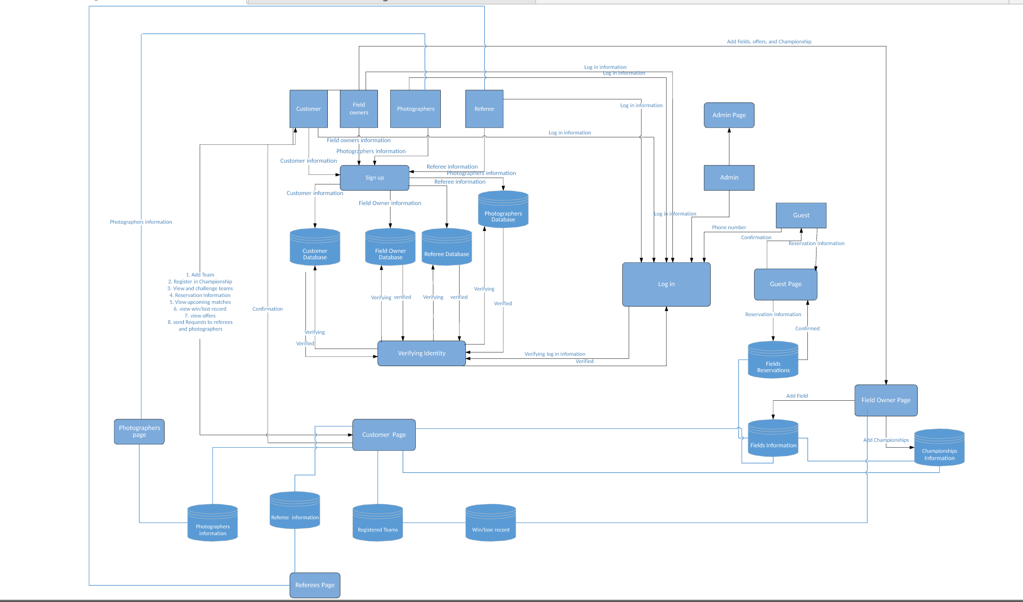

VI. LEGAL BASIS

Examination of the current work of science was held by the Patent expert Sandjar Muminov on the basis of following international (WIPO) and the normative legal acts of the United Arab Emirates:

1. Berne Convention for the Protection of Literary and Artistic Works of 9 September 1886 in Paris, complemented by 4 May 1896, revised in Berlin on 13 November 1908. Supplemented in Bern on March 20 1914., And revised in Rome on June 2, 1928 g ., in Brussels on June 26, 1948, in Stockholm on July 14, 1967, and in Paris on 24 July 1971, as amended September 28, 1979 (UAE acceded to the Berne Convention in 2004).

2. The federal law of the United Arab Emirates number 7 "On Copyright and Neighboring Rights" of July 17, 2002

3. Federal law of the United Arab Emirates, number 7, "On the National Centre for Documentation and Research" (2008)

4. UAE Decree-Law number 5, 2012 "On the fight against cyber crime" (2012)

5. The Federal Law of the United Arab Emirates number 8, "On the commercial organizations of the United Arab Emirates' (1984).

6. Federal Law of the United Arab Emirates number 3, "On the federal judiciary" (1983)

7. The Federal law of the United Arab Emirates number 31, "On the regulations governing the protection of industrial property: patents, industrial designs" (2002)

8. Federal law of the United Arab Emirates number 18, "On the conclusion of commercial transactions" (1993)

9. The Ministerial Order № 133, "On copyright collective" (2004)

10. The Ministerial Order № 411 "On the control of protected works in accordance with the UAE Federal Law № 40," On the protection of intellectual property and copyright "(1993)

VII. SOURCES OF REFERENCES

1. Patent No. EP 2709045 A1 - System and method for hotel reservation and for automated check-in, Pub. date 13.09.2012

2. Patent No. US 20090167553 A1 - Open Mobile Online Reservation and Ordering Systems, Pub.date 30.12.2007

3. Patent US 8472979 B2 - System and method for scheduling and reservations using location based services, Pub.date 15.07.2008

4. Patent No. US 20030097284 A1 - Online-reservation system and method with automatic canceling function, Pub.date 20.11.2001

5. Patent No. US 20020143702 A1 - Method and apparatus for settling online prepaid transaction with optical disc, Pub.date 29.03.2001

6. Patent No. CN 105488578 A - Stadium reservation management method, Pub.date 29.12.2015

7. Patent No. US 20120203579 A1 - System for booking a time period for utilizing a time based service or resource, Pub.date 10.06.2010

8. Patent No. US 20080010105 A1 - Apparatus and method for an internet based computer reservation booking system, Pub.date 30.04.1998

9. Patent No. US 20020059205 A1 - On-line facilities management tool, Pub.date 13.07.2000

10. Patent No. WO 2015155725 A1 - Method of sharing action highlights and a sports complex for providing shareable action, Pub.date 09.04.2014

11. Wikipedia - www.wikipedia.org - a multilingual, web-based, free-content encyclopedia project supported by the Wikimedia Foundation and based on a model of openly editable content.

12. Berne Convention for the Protection of Literary and Artistic Works of 9 September 1886 in Paris, complemented by 4 May 1896, revised in Berlin on 13 November 1908. Supplemented in Bern on March 20 1914., And revised in Rome on June 2, 1928 g ., in Brussels on June 26, 1948, in Stockholm on July 14, 1967, and in Paris on 24 July 1971, as amended September 28, 1979 (UAE acceded to the Berne Convention in 2004).

13. The federal law of the United Arab Emirates number 7 "On Copyright and Neighboring Rights" of July 17, 2002

14. Federal law of the United Arab Emirates, number 7, "On the National Centre for Documentation and Research" (2008)

15. UAE Decree-Law number 5, 2012 "On the fight against cyber crime" (2012)

16. The Federal Law of the United Arab Emirates number 8, "On the commercial organizations of the United Arab Emirates' (1984).

IX. INFORMATION ABOUT THE EXPERT

Ph.D. Sandjar Muminov has a 19 years experience and he is also:
- President of International Consortium Aston Alliance (headquarters in Dubai, UAE), www.aston-alliance.com;
- Chief Expert of Intellectual Property and Business Strategies Center (GCC);
- Member of International Intellectual Property Law Association (USA);
- Chairman of the Board of the Federation of Innovation and Technologies of Kazakhstan.

Expert Specializations of Sandjar Muminov:
- Private advisor on all issues concerning IP legal protection (patent, commercial & copyright law);
- Startup and investments projects;
- Commercialization & capitalization of intellectual property;
- Attracting of investors for business-ideas;
- Protection of copyright, know-how, trade secrets etc.

The total number of customers of Sandjar Muminov exceeded 3000 organizations worldwide, volume of intellectual property objects legally protected by Sandjar Muminov is more than 8000 units. Total amount of capitalized IP-assets exceeded 1.5 USD billion.

