Irina Vladimirovna GROSHEVA
Model of the object-spatial developmental environment
of preschool educational organization

Summary. The model of the object-spatial developmental environment presents its content, considering the holistic approach for the implementation of the State Standard of preschool education and upbringing of the Republic of Uzbekistan and the development of children of early childhood and preschool age, the establishment of key factors that determine its quality.

The object-spatial developmental environment ensures the maximum realization of the educational principle of the pre-school education system, the group, and the territory, adjacent to the given organization and the local community (mahalla) assigned to the implementation of "Ilk qadam" State educational program, materials, equipment and tools for the development of pre-school children in accordance with the needs of each age group. Object-spatial developmental environment should be understood as a natural comfortable environment, rationally organized in space and time, saturated with a variety of objects and game materials. In such an environment it is possible to include all children of the group in active cognitive and creative activity at the same time. After all, it is the child's development that takes place in the activity that determines the effectiveness of development at each psychological age, which is carried out in the conditions of a certain object-spatial developmental environment. The developmental environment is the source of formation of the child's subjective experience, and it is in this environment that the child realizes his or her right to freedom of choice of activity.
For preschool children, the developmental environment cannot and should not be limited to a particular preschool educational organization. Because everything around us can and should act as an educational space that promotes not only intellectual but also physical and aesthetic development.
Fulfillment of the State requirements for the development of the early and preschool children of the Republic of Uzbekistan, it is not possible without the use of innovative technology and the development of the object-spatial developmental environment, which should be focused on the development of each child's artistic nature.
With the adoption of the State standard for preschool education and upbringing, the system of preschool education of the Republic of Uzbekistan presents minimum requirements for the equipment of preschool educational organization, taking into account the State requirements in the areas of child development. Taking this document into account, it is possible to build a conceptual model of the object-spatial developmental environment of a preschool educational organization (Figure 1).
The model of the object-spatial developmental environment provides for a change in time of play, and the child can also act with the educator and independently. The subject content should be provided in the space in such a way as to provide children with active mastering of the educational program.
Each block (design-organizational, content-targeted and result-oriented) is a single content of the object-spatial developmental environment of the preschool educational organization that meets the requirements of the Standard of preschool education and upbringing of the Republic of Uzbekistan.
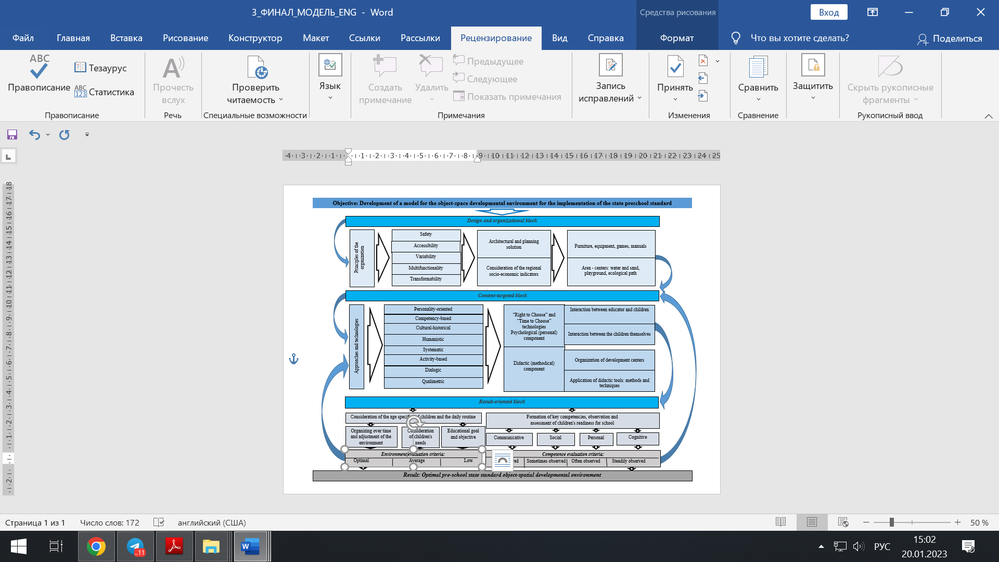
Figure 1. Model of the object-spatial developmental environment of preschool educational organization.

The design and organizational block presents the basic principles of the organization of the objective-spatial development environment: safety, accessibility, variability, multifunctionality, transformability, which must be taken into account in the architectural and planning solution, considering the regional socio-economic indicators. The architectural and planning solutions must also consider structural and hygienic standards and regulations, as well as the age and individual needs of the children. The equipment of the preschool educational organization also has a great impact on the psychological and emotional well-being of children.
Equipping is also understood to mean not only equipping the group rooms of the preschool educational organization, but also the territory.
In the content-targeted block presents the main approaches and technologies to the education and upbringing of preschool children, where the following are defined as the main approaches to realize the movement from "goal" to "result": personality-oriented, competency-based, cultural-historical, humanistic, systematic, activity-based, dialogic, and qualimetric. These approaches will make it possible to implement the "Right to Choose" and "Time to Choose" pedagogical technologies, in which the psychological (personal) component is represented, which relates the interaction between the educator and the children and the interaction between the children themselves.
The personality-oriented approach is aimed at creating conditions for the child's development in accordance with his/her age and individual characteristics, development of abilities and creative potential of the child as a subject of relations with himself/herself, other children, adults and the world.
The competency-based approach is aimed at developing key competencies of the individual in preschool children.
The cultural-historical approach combines education, upbringing and training in a holistic educational and pedagogical process based on spiritual, moral and socio-cultural values and socially accepted rules and norms of behavior in the interests of the child, the family, and society.
The humanistic approach, which recognizes the value of the child as an individual, ensures full development during preschool childhood regardless of place of residence, gender, nation, language, social status, psychophysical and other characteristics.
The systematic and activity-based approach, from the perspective of which the educational and pedagogical process is considered as a flexible system, creates conditions for the child's development, opens up opportunities for positive socialization, personal development, development of initiative and creative abilities based on cooperation with adults and peers, age-appropriate types of educational activities.
The dialogic approach allows considering the educational relations of subjects of the educational process as equal partners. The adult and child are in interpersonal communication with a dialogic focus on the child's development in one or more educational areas, activities, or cultural practices. The key concept here is dialogue, which means personal and equitable communication, joint acquisition of experience in the child's social situation of development.
The qualimetric approach involves assessing the quality of the educational and pedagogical process organized in a preschool educational organization. From the perspective of qualimetry, quality assessment is aimed at implementing the standard of preschool education.
The didactic (methodical) component includes: the organization of development centers and the use of didactic tools, including methods and techniques: visual - observation, demonstration; practical - exercises, experiment, simulation, games; verbal - storytelling, reading, conversation.
The result-oriented block is represented by the organization of time in the day and changes made in the environment and educational goals and objectives. In this block the primary role is given to the creation of an optimal object-spatial developmental environment, where the evaluation criteria are defined: optimal, average, low. Also in this block a role is given to supervision and evaluation of the child's development. The result of the activity in this model is the creation of an optimal object-spatial developmental environment, which results in the formation of four key competencies - communicative, social, personal, cognitive in accordance with the State Educational Program. In this block, the child's development map and school readiness map are a tool for the educator. With the competent construction of the object-spatial developmental environment according to this model, an optimal developmental environment will undoubtedly be created, which will contribute to improving the level of key competencies of preschool children in accordance with the State standard of pre-school education and upbringing of the Republic of Uzbekistan.
Thus, this model will make it possible to create an optimal object-spatial developmental environment for the implementation of the State standard of preschool education and upbringing of the Republic of Uzbekistan and to ensure the quality preparation of the child for primary education and a smooth transition to the next level of education.

