KAIF Brand Name, Logo and Domain
(www.kaif-platform.com)
Composite Copyright Work

Basic Option

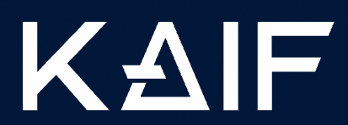

www.kaif-platform.com

Schlemmer Waldemar | Maksym Holovakhin
________________________ | __________________________
(signature) | (signature)

Option # 2

PLATFORM

Option # 3

TOKEN

Option # 4

DAO

DAO PLATFORM

Option # 5

MARKETPLACE

Option # 6

PAY

Option # 7

METAVERSE

Option # 8

WALLET

Option # 9

STREAMING

Option # 10

NFT

Option # 11

ATM

Option # 12

APPLICATION

Option # 13

EXCHANGE

Option # 14

DAO MEMBERSHIP PASSPORT

Option # 15

BETTING

